April 2019 – Newsletter

Thank you to everyone who attended the ‘Working B’ on Sunday. Your help was most appreciated.

In the next couple of months we will be holding some sausage sizzles as fundraising events to assist with supplementing our Christmas function as well as donations and sponsorships to worthwhile causes, within the district. We will notify you of the dates as soon as possible. If any members can spare some time to help man any of these stalls, we would be most appreciative.

Local identity Ralph Provan has agreed to be a Guest Speaker at one of our future meetings. Ralphs knowledge of all vehicles is vast and we know this event will be of great interest to all members and one not to be missed. We will advise you of the relevant date as soon as possible.

The recent open day at the Puckapunyal Tank Museum was of great interest with approximately 350 people attending.

Past Events.

Bob and Judi McGrath took their 1927 Chevrolet Tourer on the RACV Golden Oldies Tour of North East Victoria last week. 65 vehicles, all aged between 1919 and 1930 took part.
It was a great sight to see so many of the old cars, in wonderful condition, travelling around the area.

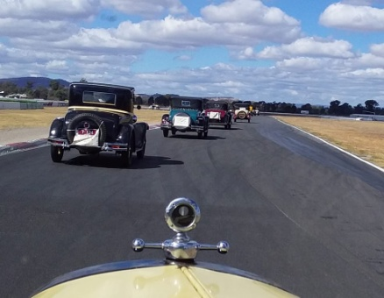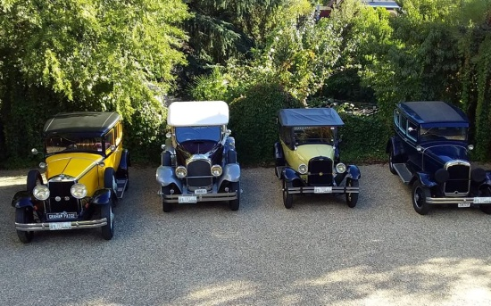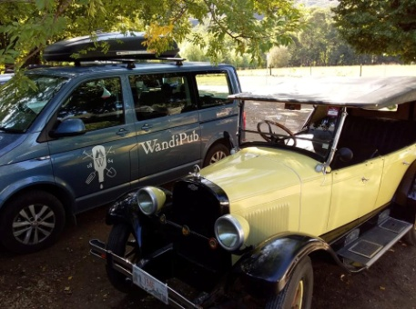

The trip around Winton was a wee bit slow = 4 mins plus. Race car times are usually about 1 min 14 sec. Oh well...
Four lovely vehicles in a row. 1929 Graham Paige, 1930 Chrysler 77, 1927 Chevrolet Tourer and a 1929 Reo Flying Cloud.
And, of course, you just have to stop at the Wandi Pub......

Thank you to Kym for standing in as Assistant Secretary for the April Meeting while I was away.

Future Events

Sunday 14th April, 2019. Lancefield Car Show and Swap Meet. Lancefield Recreation Reserve, Chauncey Street. From 7am. Vehicle judging at 11am. $6.00 entry.

If any members want to attend this event as a group, then please meet at 9am in Chauncery Street, just around the corner from the Romsey/Lancefield Road. The Lancefield Football and Netball clubs are providing the bbq stall, so please support them. The weather should be great and this is always a well attended day. The bargains at the swap meet have been good in the past as well.
2019 Broadford Swap Meet – Easter Monday, 22nd April, 2019.

Historic Winton – 17th, 18th & 19th May, 2019. This is always a good weekend.

Yea Railway Market is Saturday 6th of July, 2019.

Kings Park, Tallarook Street, is now the home of the Seymour Market each month. There was some interest as to holding a ‘car boot sale’ at some stage. What do you think?

Next Meeting. The next meeting will be General Meeting, to be held on Wednesday the 1st of May, 2019 at 7.30pm, at the clubrooms, lower end of Howe Street, behind the tennis courts.
All members are welcome. Tea and coffee will be available.
Happy Motoring,
Judi McGrath – Secretary – 0407 562003
************************

Stormy Daniels and Queen Elizabeth went to the Pearly Gates on the same day. They both met with an angel to find out if they would be admitted to Heaven.
The angel said: “Unfortunately, there is only one space available in Heaven today so I must decide which one of you will be admitted.”
The angel asked Stormy if there was some particular reason why she should go to Heaven. Stormy took off her top and said: ”Look at these, they’re the most perfect breasts ever created.”
The angel thanked Stormy, and asked Her Majesty, Queen Elizabeth the same question.
The Queen walked over to the toilet, pulled the lever and flushed it without saying a word.
The angel immediately said: “Okay, your Majesty, you may go into Heaven.”
Stormy was outraged and asked, “What was that all about? I showed you two perfect creations and you turned me down. She simply flushed a commode and she got admitted to Heaven! Would you explain that to me?”
“Sorry, Stormy.” said the angel, “but even in Heaven, a royal flush always beats a pair.

