August – Newsletter

Recent Events

8th 9th & 10th July 2016 – Weekend Away – East Gippsland.
Judi reported on the Gippsland weekend away. The weather was good to us with cold days but no rain. A few motoring hiccups on the first day but these were all rectified without too much trouble. The Tyabb Packing Sheds were an eye opener as most of our group hadn’t been there before, and most people saw something that they had used in their youth. The visit to Colin’s Collection in Mirboo Nth was again very interesting. A small collection but with numerous cars, some of which are very rare. Our Saturday morning drive to Walhalla was in sparkling sunshine but it had clouded over by the time we walked around the township and had our trip on the little train, which hugs the side of Stringers Creek. In the afternoon we visited the Trafalgar Holden Museum which has about 30 cars at the moment. Most are owned by the Museum but they also have many General Motors exhibits that many people are unaware of, consisting of a Port Phillip Bay workboat, kitchen white goods, horse harness and saddlery, bren gun carriers and even trams. On Sunday morning we drove the short distance in the fog, to Maffra. As it was the initial opening of their new ‘barn find’ exhibit, we joined the Show and Shine they were hosting. As we had on our new S&DCC jackets many locals approached us and congratulated us on coming so far to support them on the day. After viewing the interesting exhibits we left for another museum in Sale. This particular museum is only opened to pre arranged groups and none of us could believe the huge amount of ‘stuff’ on display. The home cooked lunch was pretty good as well. Our last stop was the Armed Forces Museum and then everyone made their own way home. Judi thanked all who attended as we all had a great time and made good memories.
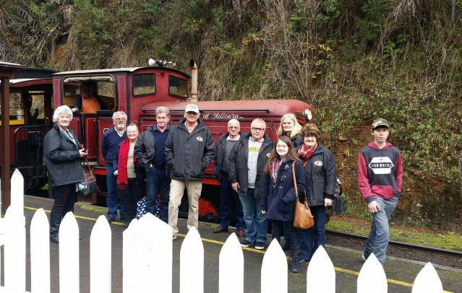

Future Events.

Sat & Sun – 6th & 7th August, 2016 – Festival of Speed – Winton Raceway – Benalla.
Sat & Sun – 6th & 7th August, 2016 – Rare Trades Exhibition – Ballarat.
Sunday 28th August, 2016 – Swanpool Memorial Hall – the ‘Bald Archy’ Exhibition. The exhibition is controversial, critical and above all very, very comical. It has been described as the irreverent alternative to the Archibald Prize and Australia’s most audacious comic art prize and showcases comical and satirical images of well known Australians.
We will leave Seymour at 10am from Seymour Industrial Supplies in Emily Street, and stop in Euroa for morning tea. We are booked in to see the exhibition at the Swanpool Memorial Hall at 1pm. The cost is $20pp, which includes a light lunch. I do need to know how many members will be attending so please contact me.
Wednesday 7th September, 2016 – S&DCC Committee Meeting – 7.30pm at the Clubrooms.
Sat & Sun 10th & 11th September, 2016 – Wangaratta Spring Rally. Entries close 26th August, 2016.
Sunday 11st September, 2016 – Shepparton Swap Meet.
Sunday 11th September, 2016 – Corowa Car Show & Safety Expo – Corowa RSL.
Sunday - 18th September, 2016 – Nagambie Cranksters.

Sunday 2nd, October, 2016 – Euroa Show and Shine.
Wednesday 5th October, 2016 – S&DCC Committee Meeting – 7.30pm at the Clubrooms.
Saturday 16th October, 2016 – Joint Club and Family Day at the S&DCC clubrooms.
21st to 23rd October, 2016 – Motorclassica – Melbourne Exhibition Buildings.

Wednesday 2nd November, 2016 – S&DCC Annual General Meeting – 7.30pm at the Clubrooms.
12th to 13th November, 2016 – Bendigo Swap Meet.
25th to 27th November, 2016 – EJ-EH Holden Nationals – Shepparton Showgrounds.
Sunday 4th December, 2016 – S&DCC Christmas Party at the Clubrooms.
Wednesday 7th December, 2016 – S&DCC Committee Meeting – 7.30pm at the Clubrooms.
2017
Australia Day 2017 – Kings Park Seymour.
? April, 2017 – Proposed ‘Journey along the Old Hume 31’ Tour. Details to come.

S&DCC Jackets, Caps and T-Shirts
Jackets are black in colour, a unisex style with our club logo embroidered on the front left hand side and on the back = $110.00.
Embroidered cap. = $25.00.
T-Shirts = $55.00.
Next Meeting.
The next meeting of the S&DCC is a Committee Meeting to be held on Wednesday, 7th September, 2016, at 7.30pm at the clubrooms, lower end of Howe Street Seymour, behind the tennis Courts. All members are welcome to attend. Tea and coffee available.
Safe Motoring - Judi McGrath -
Secretary – 0407 562003.
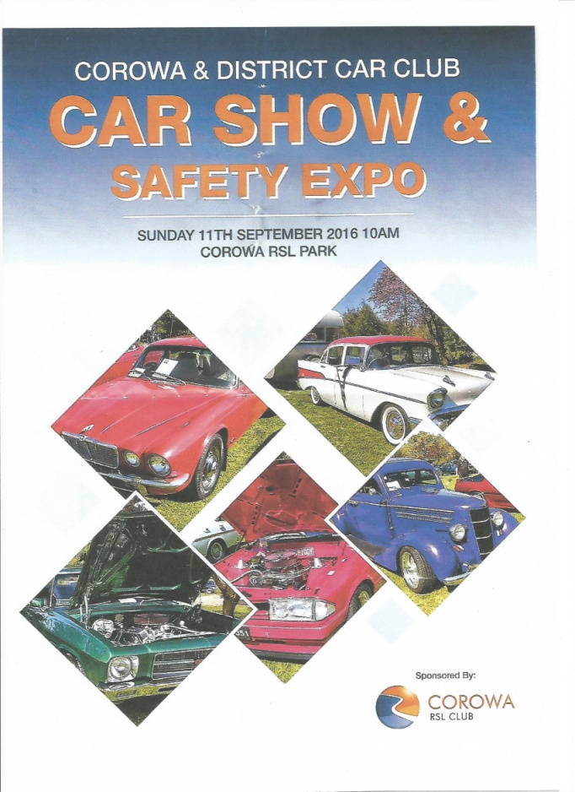

I was out walking with my four year old grand-daughter.
She picked up something off the ground and started to put it in her mouth. I took the item away from her and then asked her not to do that.
‘Why?’ my grand-daughter asked.
‘Because, it’s been on the ground. It’s dirty, and probably has germs,’ I replied.
At this point, my grand-daughter looked at me with total admiration and asked, ‘Grannie, how do you know all this stuff?’
I was thinking quickly, ‘All Grannies know this stuff. It’s on the Grannie Test. You have to know it, or they don’t let you be a Grannie.’
We walked along in silence for two or three minutes, but she was evidently pondering this new information.
‘Oh! – I get it!’ she beamed. ‘So if you don’t pass the test, you have got be the Grand-dad.’
‘Exactly,’ I replied.

