August 2019 – Newsletter

Membership Renewals.

S&DCC annual membership renewals were due on the 1st July, 2019.

If you have a vehicle permitted on the Club Permit Scheme through the S&DCC, it is imperative you renew your membership now as your vehicle is ‘not permitted’ and it is illegal to drive it on the road. It is also a pre requisite that the S&DCC has to notify Vic Roads of any vehicle whose owner is not a financial member.

If you are not renewing your car club membership, this will be the last newsletter you will receive, so we do hope you enjoy whatever you pursue in the future.

Clubrooms.

John Phoenix was advised by Mitchell Shire that we are unable to host future meetings at the clubrooms. The insurance company for the Shire, after inspection of the premises, declared the building was unsuitable for use because of the asbestos risk. At the moment we are only able to use the building for storage. The Shire has allocated a community building at Chittick Park for our meetings on the first Wednesday of the month for the rest of 2019. This is only a temporary venue until a more permanent building becomes available.
Joint Lions Club and S&DCC Show and Shine.

At the July meeting of the S&DCC John Phoenix advised the members present of the possibility of the Lions Club and the S&DCC hosting a Joint Car Show and Shine and Swap Meet. Representatives of the S&DCC have attended a couple of meetings with Lions Club members to discuss this venture and holding it on the Labour Day Monday holiday in 2020 at Kings Park. Further discussions have been held, together with the Kings Park representative and the Monthly Market Day representative and the feedback has been extremely positive.
A raffle is being organised to raise funds to go towards the printing of advertising leaflets. These are to be distributed at any car show events to be held, in the next few months. Raffle ticket books will be available asap, to be distributed to all car club members and representatives of the Lions Club will be selling them in the Seymour area, within the next few weeks.
Sausage Sizzle at Safeways.
A joint sausage sizzle with Lions and the S&DCC will be held on the 9th November, 2019 where funds raised will go towards the Car Show and Shine and Swap Meet, and the raffle will be drawn on the day. We may be able to section off some of the car park and have some cars on display as well.
Past Events.

Yea Railway Market.

Judi McGrath thanked all the members who braved the cold to help out at the BBQ stand and the entrances to the market, on the first Saturday in July.
Seymour may have been sunny but it didn’t take long to realise the road to Yea was a bit of a ‘pea souper’. Eventually the sun came out and the toes thawed out, and we had collected $427.15 to add to our bank balance.

A medal for endurance must go to Kevin Hall for braving the elements and taking his ’28 Chevrolet over to Yea for the car club display.
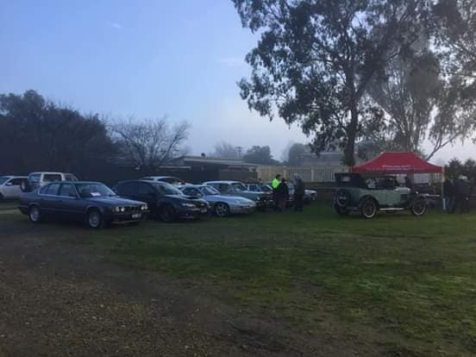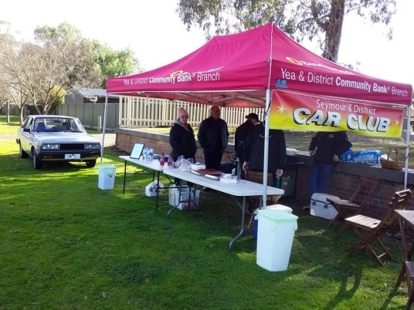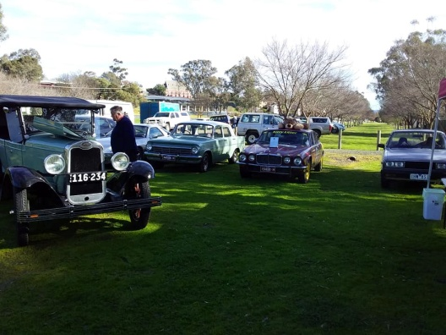

Future Events
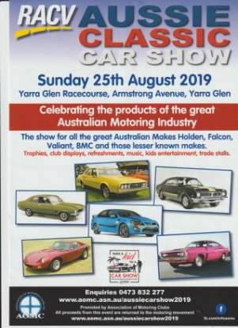

Sunday 25th August, 2019. RACV Aussie Classic Car Show to be held at Yarra Glen Racecourse.

Gates open at 9am. $15.00 per vehicle.

If any members are going to attend this event and want to travel to Yarra Glen together then please let me know and we will organise a meeting place and a time.

Annual Weekend Away – September, 2019.

Judi McGrath brought to the attention of the members present the opportunity to join the Veteran, Vintage & Classic Vehicle Club of Wangaratta on their 50th Anniversary Spring Rally to be held on Saturday and Sunday, the 14th & 15th of September, 2019.

This rally is titled ‘Wheels & Wings’ and highlights Meals at the Historic Vine Hotel in Wangaratta – Super Trucks at Winton Motor Raceway – Car Display at Winton and a chance to participate in the

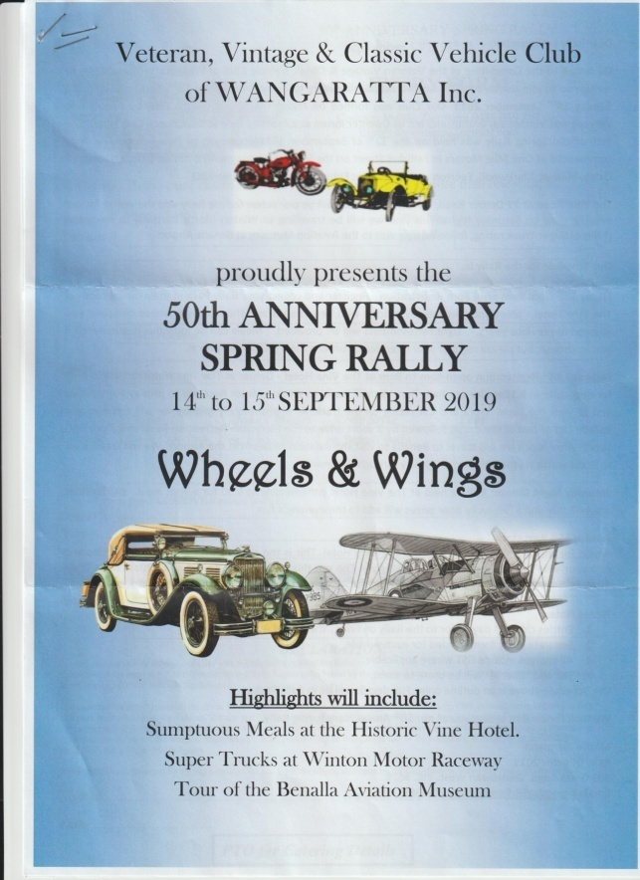
Grand Parade around the track during the lunch break – BBQ Lunch at Molyullah – Tour of the Benalla Aviation Museum - Trivia run on the Sunday and maybe even a chance to win a trophy or two.

I have supported this Rally numerous times and it is very well run. Approximately 100 vehicles of all years, makes and models have been involved in the past, so it makes for a very interesting weekend.

The costs are = Registration of $90, which includes a rally badge, entry to Winton and the Aviation Museum at Benalla, rally pack, name badges and a vehicle display card.

Saturday lunch ($20), Saturday dinner ($30) and Sunday lunch ($25) are charged at $75.00pp, but these are optional. Entries close on August 30th, 2019. Accommodation is available in Wangaratta.

Please contact me if you are interested and I can forward all details on to you.

Nagambie Cranksters – Sunday 22nd September, 2019.

National Euroa Show and Shine – Sunday 6th October, 2019.

The Yea Railway Market - The MAD Billycart Derby Festival - Saturday 2nd November, 2019.

Yea Railway Market hosts the 2019 Mad Billycart Derby Festival. This is fun for the whole family – big kids or little kids alike. The day involves billy cart racing from 10am. Market and car boot stalls. Included is assorted entertainment for the kids as well as Trophies, competitions, prizes and giveaways. Also, a chance to display our vehicles. What more could you ask for?
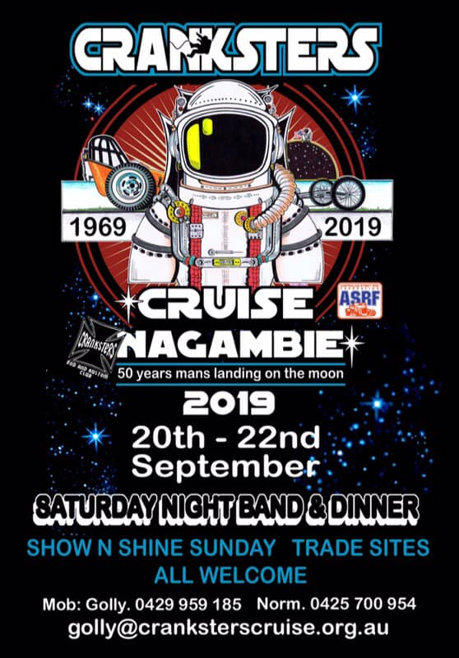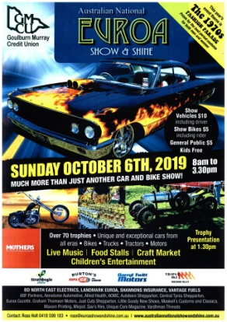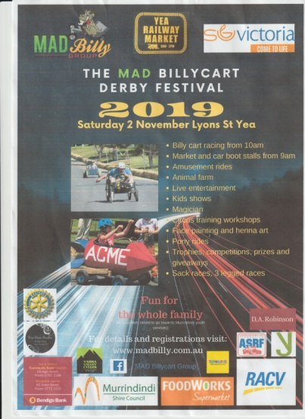
North Eastern Silo Art Trail.

It was suggested, as a day run, to do a run to see the Silo Art Trail starting at Benalla and including Goorambat, Devenish and St James and stopping en route to have a BBQ lunch. The members present agreed and it will be organized during better weather.

Next Meeting.

The next meeting will be a General Meeting, to be held in the Community Room at Chittick Park, between the Seymour Indoor Pool and the Cricket Clubrooms, on Wednesday 4th September, 2019, at 7.30pm.
All members are welcome to attend. Tea and coffee will be available.
Happy Motoring,
Judi McGrath – Secretary – 0407 562003
*******************************

ED AND LINDA FALL IN LOVE
Ed and Linda met on a singles cruise and Ed fell head over heels for her. When they discovered they lived in the same city, only a few miles apart, Ed was ecstatic. He immediately started asking her out when they got home.
Within a couple of weeks, Ed had taken Linda to dance clubs, restaurants, concerts, movies, and museums. Ed became convinced that Linda was indeed his soul mate and true love.
Every date seemed better than the last. On the one-month anniversary of their first dinner on the cruise ship, Ed took Linda to a fine restaurant. While having cocktails and waiting for their salad, Ed said, "I guess you can tell I'm very much in love with you. I'd like a little serious talk before our relationship continues. So, before I get a box out of my jacket and ask you a life changing question, it's only fair to warn you, I'm a total golf nut. I play golf, I read about golf, I watch golf on TV. In short, I eat, sleep, and breathe golf. If that's going to be a problem for us, you'd better say so now!"
Linda paused, then responded, "Ed, that certainly won't be a problem. I love you as you are and I love golf too; but, since we're being totally honest with each other, you need to know that for the last five years I've been a hooker."
Ed said, "It's probably because you're not keeping your wrists straight when you hit the ball."
(Thank you Murray)

