August, 2017 – Newsletter

Clubroom Break-in. As has been reported last month, the Police, who arrived at the time of the last break in at the Clubrooms, said our security needed to be up graded. We feel we have been diligent with adding further deterants but as John Phoenix has been trialling a new security system, he thinks it could be very useful at the clubrooms. After discussion, John Blackwell moved we buy one of these security systems. The motion was seconded by Christine Sheather, and all members were in favour.
New Baby Congratulations . Michael Street informed us he and his wife Jess are now the very proud parents to another little girl. Harriet has arrived during the past month and all the family are well and happy.
Future Events

Wednesday, 9th August, 2017 – 7pm. Our Guest Speaker will be David Mills. This is to be held at the Clubrooms. Lower end of Howe Street, Seymour, behind the tennis courts.
Dave will speak on his restored Humber FV1601A, 4x4, 1 ton Cargo Truck. It was used by the Australian Army between 1955 to 1965. He will include the vehicles history and restoration story. He also has some workshop manuals to view. The vehicle will be on display. This will be a very interesting night so please come along and support your fellow car club members who have a story to tell. The fire will be going and we will once again supply pizza for supper.
Sunday, 20th August, 2017. Unfortunately Mitchelton have their Festival of Chocolate on over the whole weekend so we are unable to visit Gerry Ryan’s Car Collection, at this time. (That doesn’t mean you can’t go and just eat chocolate though.)
SO, I thought we may have a less busy day and just have lunch at the Lancefield Hotel, instead. Make your own way there and we will meet at 12 noon. Please let me know if you are able to join us so I can let the Hotel know.
August or September, 2017. Harold Joyce spoke to the meeting suggesting we have a Trivia Night at the clubrooms, in the coming month or so. More details to come.
Thursday, 14th September, 2017 – Rare Spares, Roxburugh Park are having a car club night. 20% off store wide excluding already discounted items, vouchers and Rubber Kits. The store will be providing food and refreshments plus each car club member will have a chance to win some fantastic prizes. Plus, they have John Bowe as their special guest. Please let me know if you wish to attend.
Sunday 17th September, 2017 – Nagambie Cranksters.

Saturday 23rd & Sunday 24th September, 2017 – Wangaratta. We received an invitation from the Vintage & Veteran Car Club of Wangaratta asking if any of our members wish to join them on their 47th Annual Spring Rally. Highlights of the Rally will include meals at the Historic Vine Hotel. View an impressive collection of Early Model Holden’s and a visit to Winton Motor Raceway, with a lap of Honour around the track.
These weekends have proved very popular in the past with approximately 100 cars involved.
Entries close on the 1st September, 2017. Contact me and I can provide you with all the details.

Sunday 1st October, 2017 – Euroa Show and Shine.

Wednesday 1st November, 2017 - Monthly Meeting, as well as our Annual General Meeting.

Sunday 24th November, 2017 – EJ/EH Holden Nationals at Shepparton.

Sunday, 3rd December, 2017. - Christmas Party at the Clubrooms.

February, 2018. David Bell brought to the attention of the members present, the 2018 Spirit of the Hume display in Broadford in February, this year. 2017 was the inaugural year and where it was a very good display, the organisers are sure it can only get ‘bigger and better’. David thought the S&DCC could get on this ‘band wagon’ and showcase our car club at this event. As it is promoted by the Historic Commercial Vehicle Club of Australia, our car club can offer to help out and will benefit from the organisation of a bigger club. More details at a later date.

PAST EVENTS
Saturday 22nd & Sunday 23rd July, 2017 – ‘Travelling the Old Hume 31 Highway.
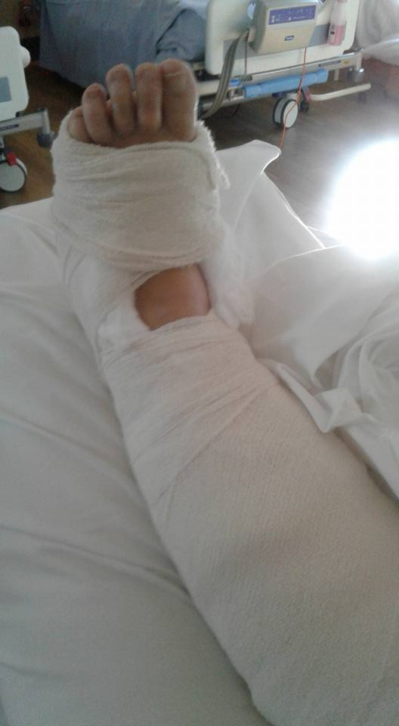
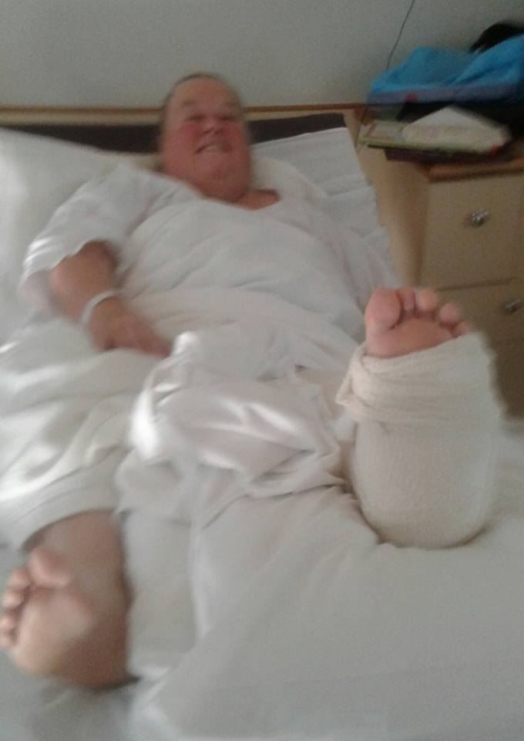
Our little band of travellers met at the Seymour Vietnam Veteran’s Walk early on the Saturday morning. Ian and Eileen’s green Holden arrived with Eileen sitting in the back seat. After initially thinking she was pretending to be ‘Lady Carpenter’ Ian informed us she had slipped over in the icy conditions, and had hurt her ankle. Her weekend then differed a bit from what she was expecting as Ian took her to Seymour Hospital, then by ambulance to the Northern. Eileen had broken her ankle and after a week in hospital is now at home. We wish her a speedy recovery. (Not sure how Ian will look in a nurses’ uniform though.)
After regrouping, we left Seymour and after driving through Avenel, Locksley and Longwood we stopped in Euroa for a walk around town and morning tea (?). We then headed on through Violet Town and Baddagginie, to Benalla. We stopped to look at the many murals around the town and instead of having lunch, drove on to Glenrowan. We again stopped to look at some interesting shops but ended up at the Glenrowan Pub for refreshments. (Way way too much morning tea.......). Getting into our vehicles, we then drove onward to the township of Chiltern. Again there were too many little shops but we did our best to look in every one of them. Purchases were made, and although the guys didn’t seem to find too many treasures, they were happy to just meander. The ‘old highway’ from Chiltern to Barnawartha was very interesting and comments were made as to how the traffic, especially all the trucks in times past, would have found the travelling quite hazardous. On arriving at our caravan park, we all partook of refreshments and then decided the ‘local’ was close enough for us to have dinner there. A bit warmer as well.
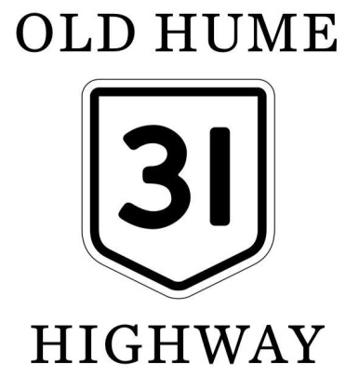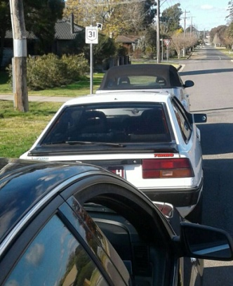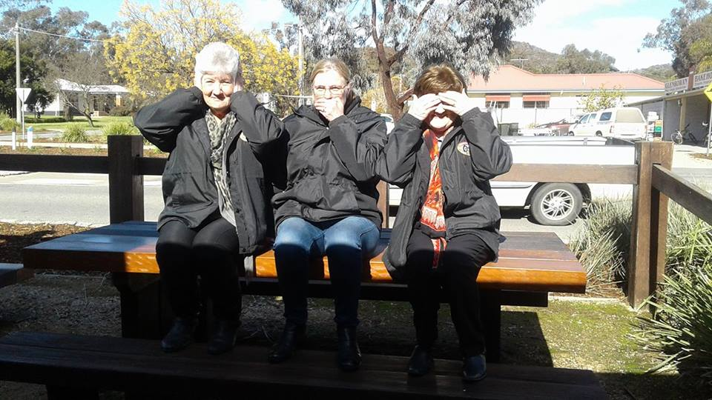
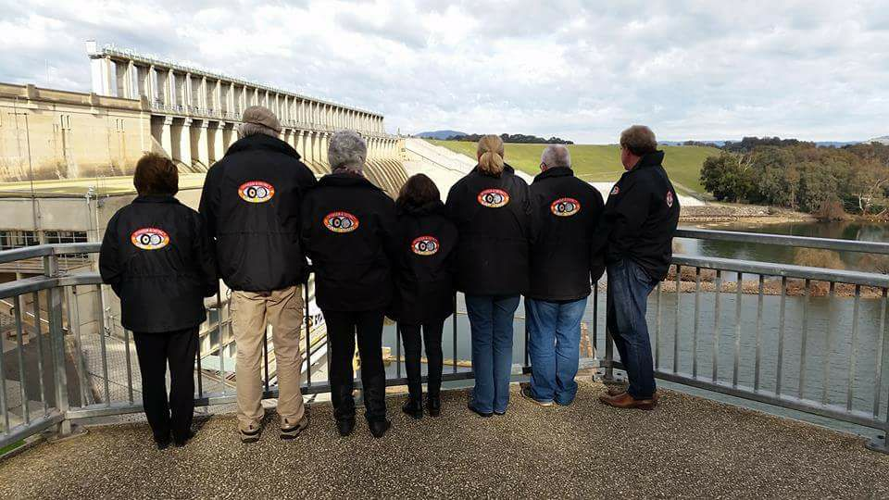
On Sunday morning we left our accommodation and drove through Albury to the Hume Weir. As it was early and not too many people around, we walked down to the hydro building and then up the stairs, onto the wall of the dam. It was very interesting reading about the Hume Dam and marvelling at the engineering for its time. Christine decided to show us all up by running along the wall and counting all the gates. 29 in all. Unfortunately none of the gates were open releasing water at the time of our visit.
We then drove the couple of kilometres to the old Bonegilla Migrant Centre. They have now installed an interpretive centre at the entrance to the buildings and have some volunteers available to give visitors a ‘history lesson.’ We all spent a very interesting hour or so, reliving how it must have been for these migrants coming to a new country. Not only did they leave behind family, but also the horrendous way of life they had endured during and after the 2nd World War.

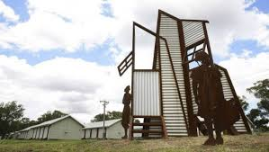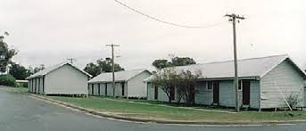
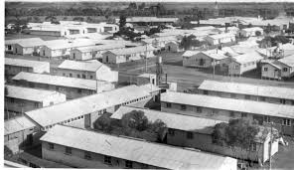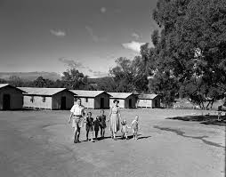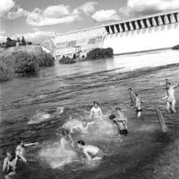
It was a very reflective group who then drove into Yackandandah, you guessed it, for ‘morning tea’ which turned into lunch at the local pie shop. Again, we strolled the shops before driving onto Beechworth. The weather had been very good to us up till then so after a walk around and ‘afternoon tea’ at the Bakery, we made for home. A good weekend enjoyed by like-minded people reflecting on how easy it is to travel the ‘new Hume Freeway’ but still able to appreciate how pleasant, picturesque and un-hurried the ‘old Hume 31 Highway’ is.
Next Meeting.

The next meeting is a General Meeting, to be held on Wednesday 6th September, 2017 at 7.30pm, in the clubrooms, lower end of Howe Street, behind the tennis courts. All members are welcome to attend. Tea and Coffee will be available.

Safe Motoring - Judi McGrath - Secretary – 0407 562003.
*************************
Grounds for Divorce.
A lady walks into a Solicitors office.
“Well, Mrs O’Connor, so you want a divorce?’ the solicitor questioned his client. “Do you have a grudge?”
“Oh, no,” replied Mrs O’Connor, “shure now, we have a carport.”
The solicitor tried again. “Well, does the man beat you up?”
“No, no,” says Mrs O’Connor, looking puzzled. “Oi’m always first out of bed.”
Still hopeful, the solicitor tried once again. “Well, does he go in for unnatural connubial practices?”
“Shure now, he plays the flute, but I don’t think he knows anything about the connubial.”
Now desperate, the solicitor pushed on. “What I’m trying to find out are what grounds you have?”
“Bless ye, Sor. We live in a flat – not even a window box, let alone grounds.”
“Mrs O”Connor,” the solicitor said in considerable exasperation, “you need a reason that the court can consider. What is the reason for you seeking this divorce?”
“Ah, well now,” said the lady, “shure it’s because the man can’t hold an intelligent conversation.”

