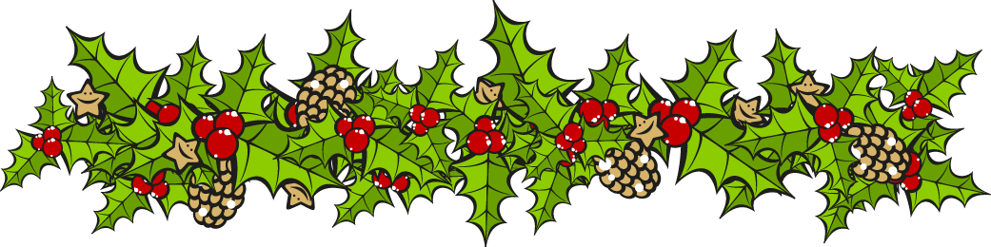
December 2015 – Newsletter

We would like to take this opportunity to thank all the members of the Seymour and District Car Club for their support over the last 12 months and hope we can achieve bigger and better things in 2016.
6th December, 2015.
S&DCC Christmas Party at the Clubrooms.

The weather has played a huge part of the activities and events we have planned though
out the year and the day of the Christmas Party was no different.
Even though it was an extremely hot day, the cloud cover saved us all and we only had the
humidity to contend with.
Even with these conditions, we had about 30 members and their families enjoy our last
event for 2015.
The Clubrooms again looked very festive, and we thank the group who helped with the
decorations.
Our catering staff took on the challenge of making sure everyone enjoyed their meal, with a
choice of meats, salads and vegetables. A selection of desserts were provided and at the
end of the day, no-one could have said they went home hungry.
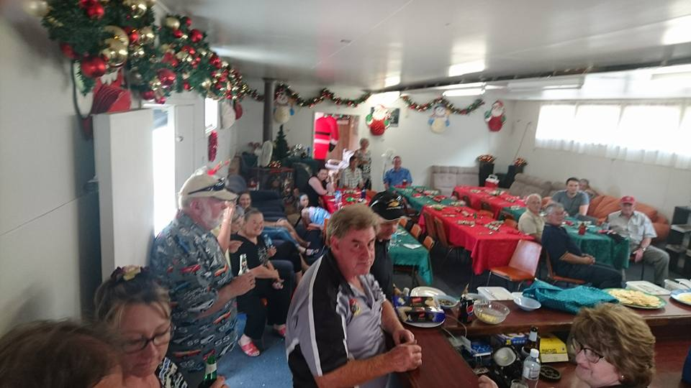
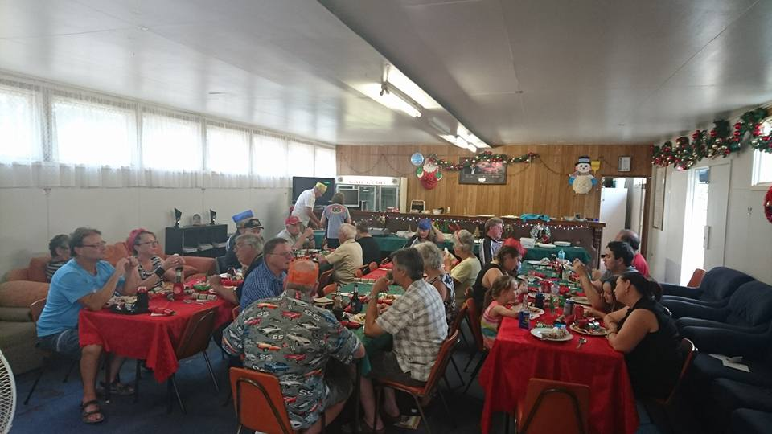

Future Events
2016

17th January, 2016 RACV Great Australian Rally – Mornington Racecourse
(Entry form attached).
Please contact me by email or phone if you want to join us.

26th January, 2016 Rotary Australia Day Festivities in Seymour.
Members and cars need to assemble at Kings Park by 9am.
Entry is by the swimming pool gate.
There will be plenty of activities for the family, as well as food and drink stalls.

3rd February, 2016. Committee Meeting. 7.30pm, at the Clubrooms.
First meeting for the year.
All members are welcome to attend.

20th & 21st February, 2016 Seymour Expo at Kings Park. Classic Ute Display.
More details to follow.

2nd March, 2016 General Meeting. 7.30pm. All members welcome to attend.

20th March, 2016 Yea Bushrodders – Racecourse Reserve, Yea.
Flyer attached.

The Committee would like to wish all the car club members and their families, a very Merry Christmas and a Safe New Year. Happy Motoring.
Judi McGrath. Secretary – 0407 562003

