**December 2016 – Newsletter**

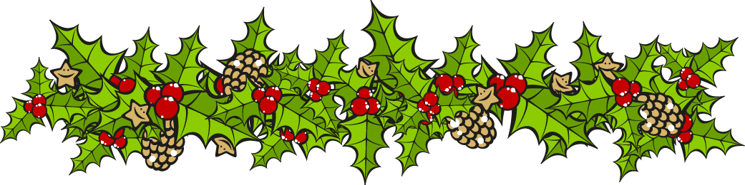

**Past Social Events**

25th to 27th November, 2016 – EJ-EH Holden Nationals – Shepparton Showgrounds.

Five members participated at this event. There were approx 60 vehicles on display but considering it was a National Day, the number of vehicles was very disappointing. This was maybe due to the display being included with the ‘Spring Nats’ and the cost of entry was quite expensive. Nevertheless, there were quite a few very nice Holden’s entered and a few modified vehicles that were very well done, and well worth being on display.

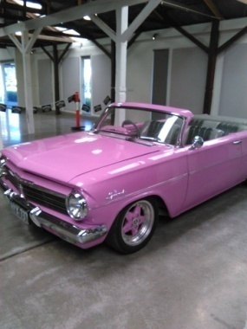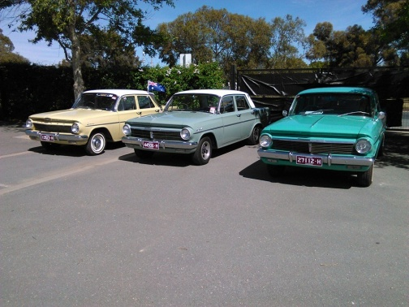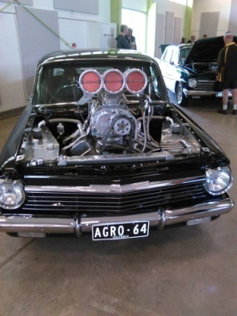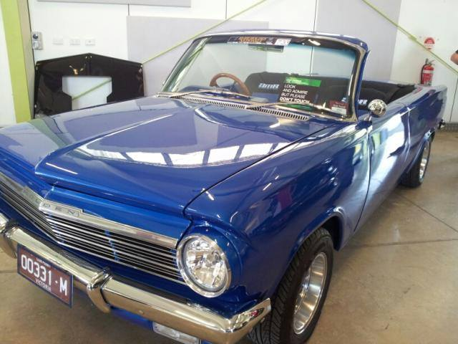

27th November, 2016 – Wallan Classic Show & Shine – Kilmore Football Ground.

A few hardy souls braved the wind and cold in Kilmore, to display their vehicles.

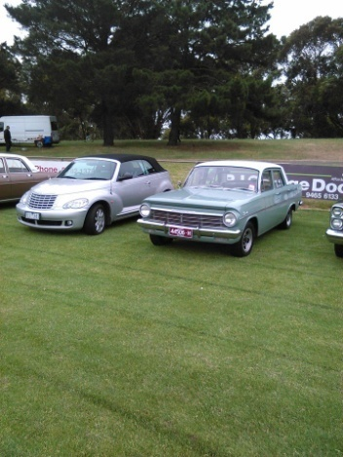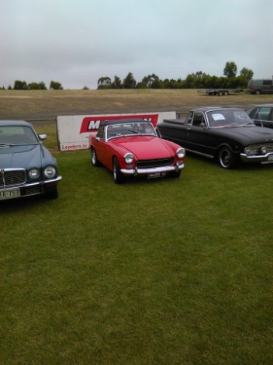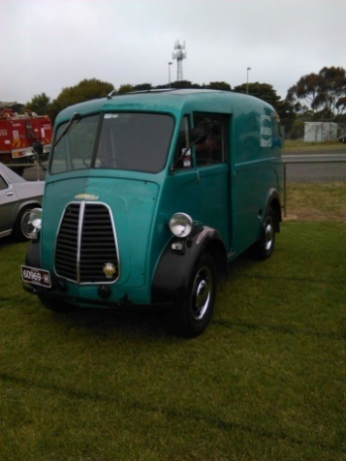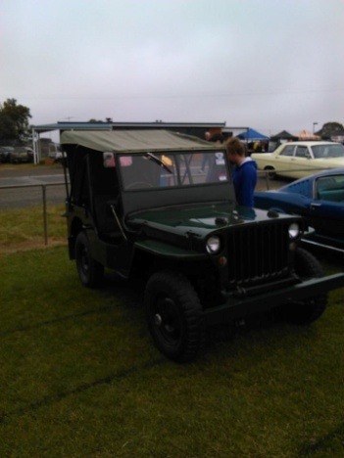

Club Christmas Party – Sunday 6th December, 2016.

A very good day and enjoyed by all members present. Thank you to everyone who helped in any way, which contributed to making this day such a success.

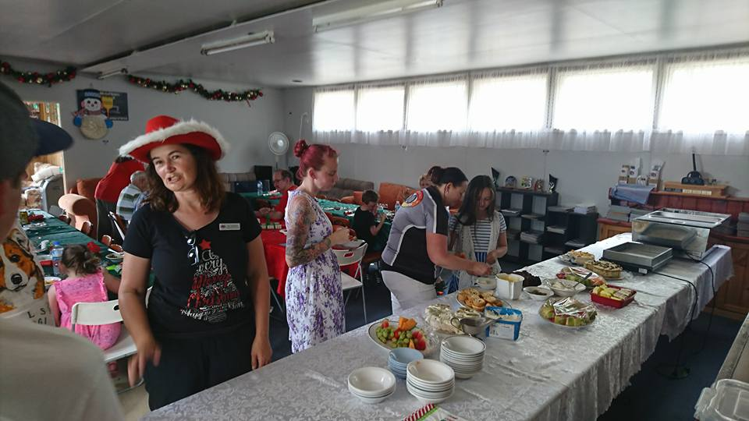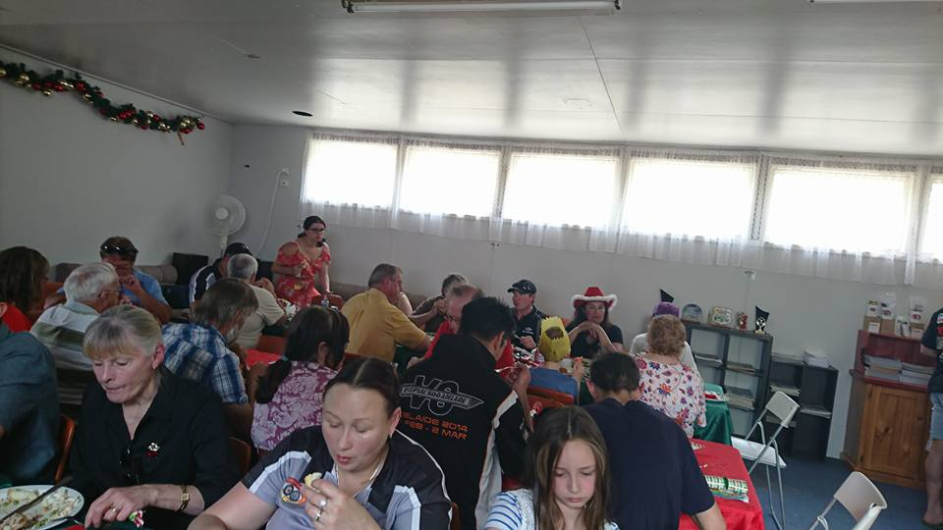

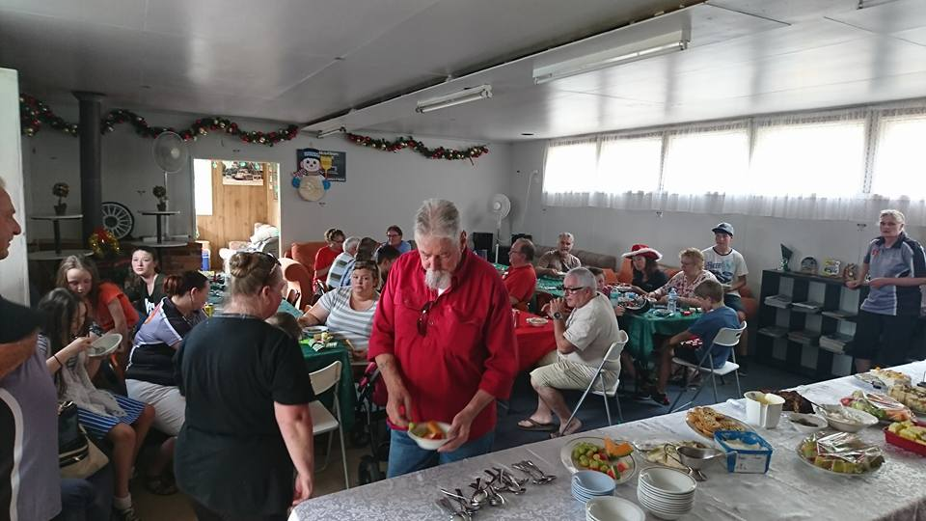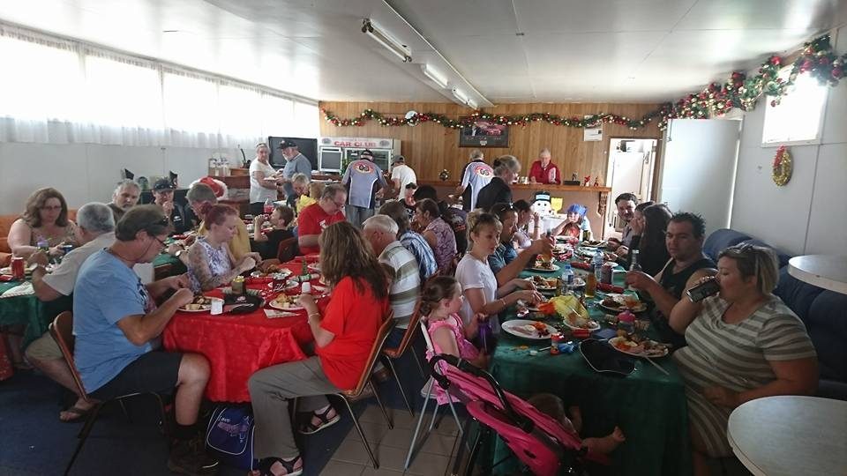

**Future Events - 2017**

Thursday 26th January, 2017. 9am – Rotary Australia Day at King’s Park, Seymour.

Entry is by the side gate near the swimming pool. No cost involved. Food and drink available.

Wednesday 1st February, 2017 – Committee Meeting. 7pm at the Clubrooms.

Wednesday 15th February, 2017 – Guest Speaker and Social Event at the Clubrooms.

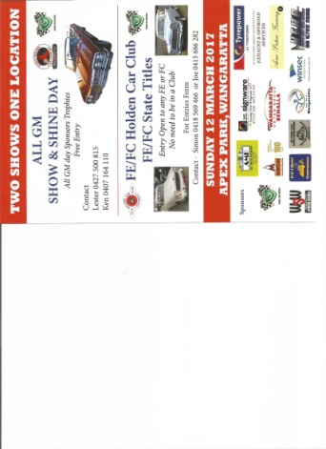

Sunday 12th March, 2017.

All GM Show & Shine, incorporating the FE/FC Holden Car Club State Titles. Apex Park, Wangaratta. Free Entry.

This event may be incorporated into a “Travelling Highway 31” weekend trip we are planning for 2017.

Sunday 19th March, 2017 – Yea Bushrodders Event.

Saturday and Sunday 27th & 28th March, 2017 – 41st Historic Winton Weekend.

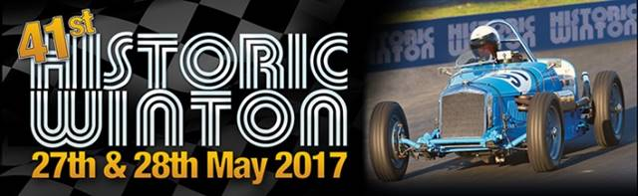

**Some other events to consider -**

Sunday 5th February, 2017. – RACV Great Australian Rally – Mornington Racecourse.

Sunday 19th February, 2017 – All American Car Display – Gembrook Sports Ground.

Sunday 19th February, 2017 – RACV Classic Showcase –Flemington Racecourse.

Sunday 5th March, 2017 – Shannons American Motoring Show – Flemington Racecourse.

Sunday 12th March, 2017 – Yarra Glen Swap Meet – Armstrong Avenue, Yarra Glen.

Picnic at Mitchelton Winery, as well as a guided tour of Lindsay Fox’s Museum.

Brochures of these 2017 Events.

If you are interested in any of these events, please contact me for further details

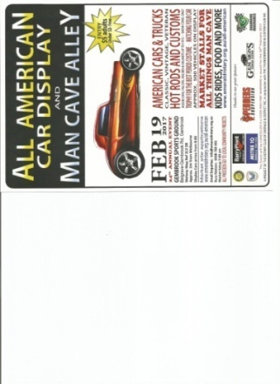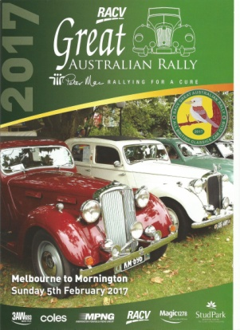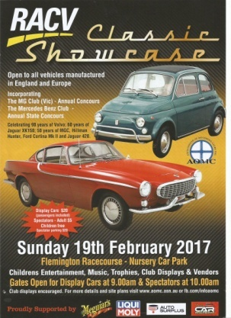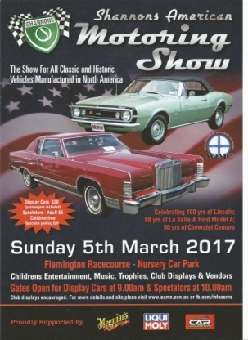 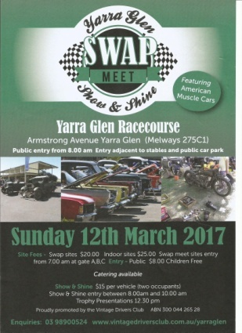

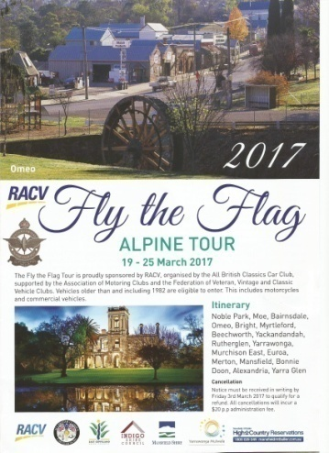 Sunday 19th to 25th March, 2017 – RACV Fly the Flag Alpine Tour.

Travelling through Bairnsdale, Beechworth, Yarrawonga & Mansfield.

Sponsored by the All British Classics Car Club.

Vehicles older than and including 1982 are eligible to enter.

This includes motorcycles and commercial vehicles.

Tour is limited to 200 vehicles.



The Committee would like to wish all its members a Merry Christmas and a Safe New Year, and hope you will be able to join us on some of the Social Events we have planned during 2017.



Safe Motoring

Judi McGrath - Secretary – 0407 562003.

**************************************

A guy stands over his tee shot for what seems like an eternity: looking up, looking down, measuring the distance, figuring the wind direction and speed.

Finally, his exasperated partner says, “What’s taking so long?” “Hit the damn ball!”

The guy answers, “My wife is up there watching me from the club house, and I want to make sure this is a perfect shot.”

“Forget it, man,” says his partner. “You’ll never hit her from here.”