December 2017 – Newsletter

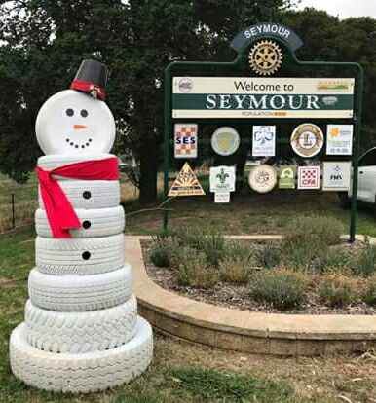

Seasons Greetings to all our members and their families.

Wishing you all a Merry Christmas and a Safe and Happy New Year.

The Committee would also like to take this opportunity to thank all the S&DCC members who have participated throughout the year by coming to meetings, guest speaker evenings, lunches and display days.

This is your ‘car club’ and your participation is very important in helping to make it a success.

Kilmore Show and Shine – 28th November, 2017
Unfortunately the 2017 Kilmore Show, Shine and Swap-meet had very limited participation from the public because of the very wet weather conditions. It was such a shame as the organisers had put a lot of effort into it being a good day. Our small group arrived early but left about 12ish as the weather deteriorated.
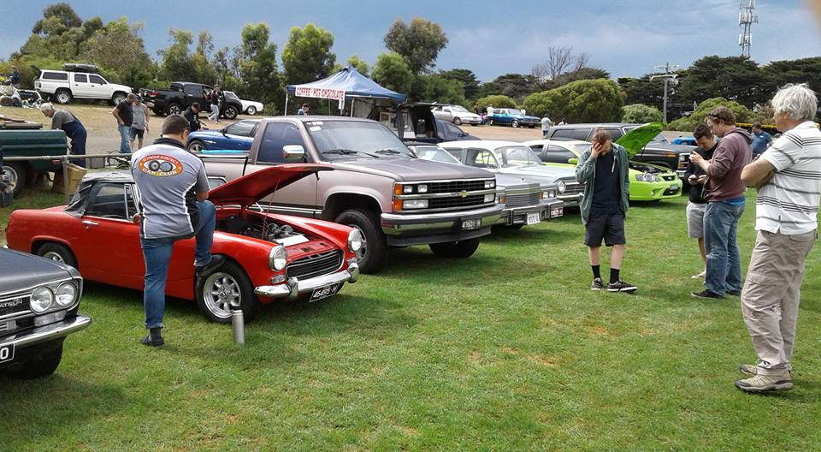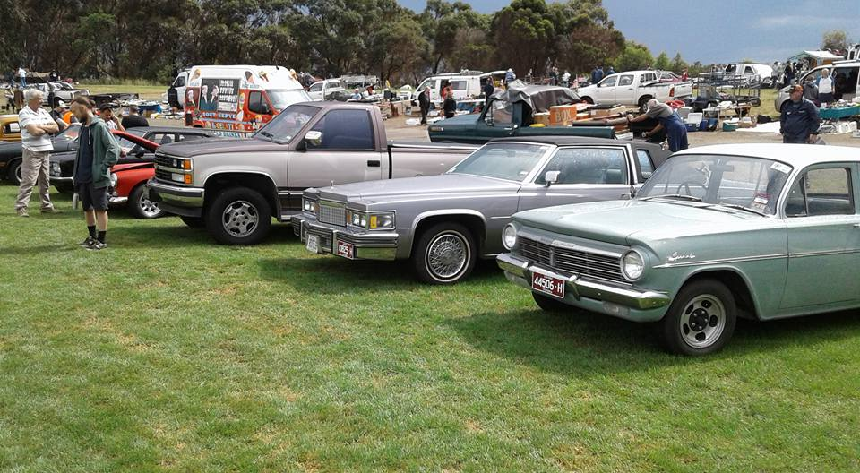
November Working ‘B’
The working ‘B’ at the clubrooms was really well attended and our thanks are extended to all those members.

Annual Christmas Lunch 10th Deccember, 2017
Thank you everyone who attended the S&DCC Annual Christmas Lunch.
The club provided a very extensive menu and our President, John Phoenix, extended his thanks to everyone who helped out in any way, to make it such a successful day.

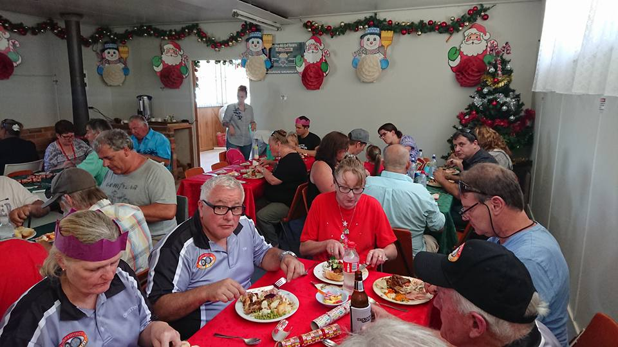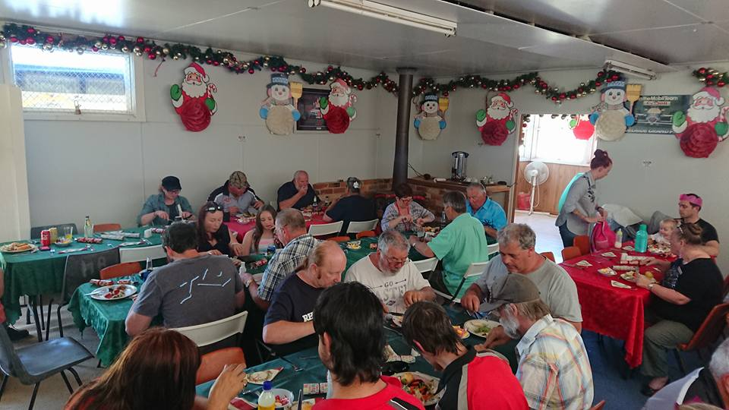

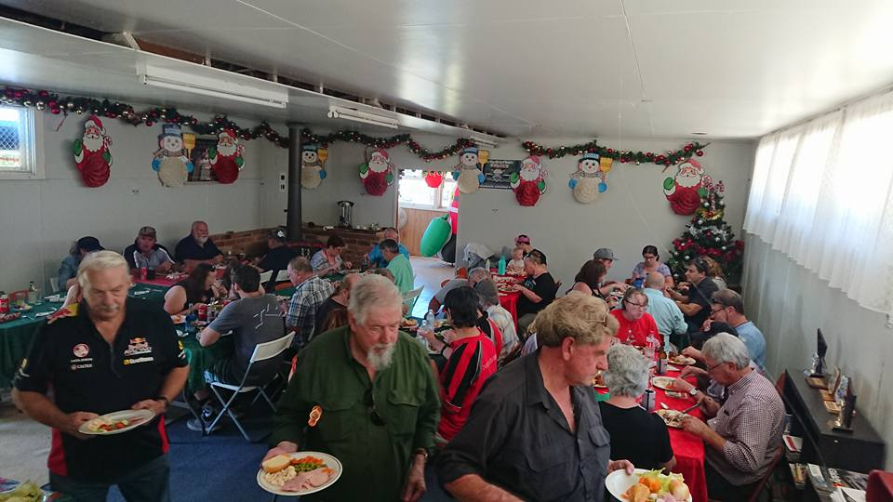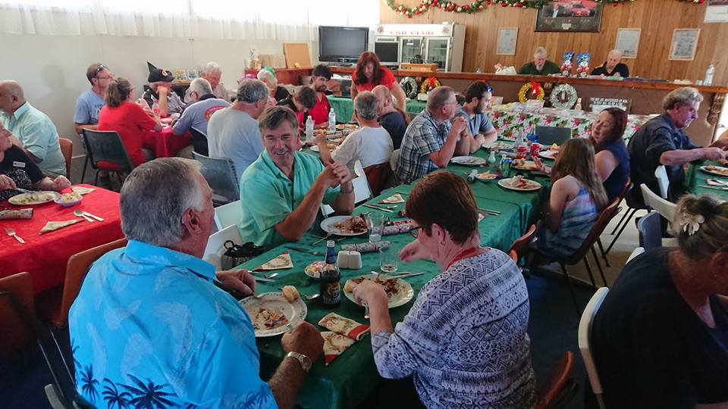

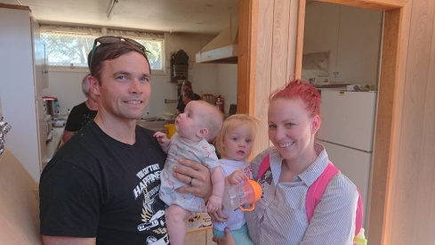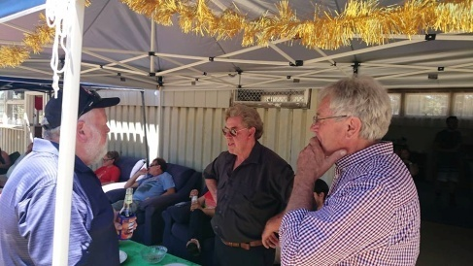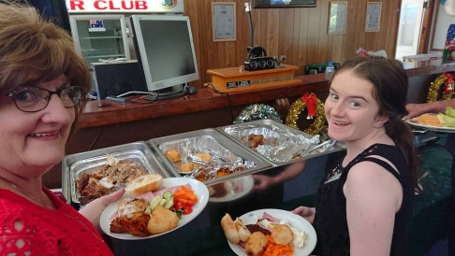

New Members.

The Committee, on behalf of all the members, would like to offer our congratulations to Greg and Kate Phoenix on the arrival of baby Austin. Also, to Luke and Angela Trim on the arrival of baby Indie.

Events for 2018.

Australia Day - Friday 26th January, 2018. Kings Park, Tallarook Street, Seymour.

Saturday & Sunday 17th & 18th February 2018 – Spirit of the Hume - Broadford Truck Show.
More details when they become available.

Next Meeting.
The next meeting will be a Committee Meeting, to be held in the clubrooms, Howe Street, Seymour, behind the tennis courts, on Wednesday 1st February, 2018, at 7.30pm.
All members are welcome to attend. Tea and coffee will be available.
Safe Motoring - Judi McGrath - Secretary – 0407 562003.
****************************
“Women are Ruthless

The CIA had an opening for an assassin. After all of the background checks, interviews, and testing were done there were three finalists, two men and a woman.

For the final test, the CIA agents took one of the men to a large metal door and handed him a gun. We must know that you will follow instructions, no matter what the circumstances.

Inside of this room, you will find your wife sitting in a chair. Kill Her!!!
The man said, You can't be serious. I could never shoot my wife. The agent said, Then you are not the right man for the job.

The second man was given the same instructions. He took the gun and went into the room. All was quiet for five minutes. Then the man came out with tears in his eyes. I tried, but I can't kill my wife. The agent said, You don't have what it takes. Take your wife and go home.

Finally, it was the woman's turn. She was given the same instructions, to kill her husband. She took the gun and went into the room. Shots were heard, one shot after another. They heard screaming, crashing, banging on the walls. After a few minutes, all was quiet.

The door opened slowly and there stood the woman. She wiped the sweat from her brow and said, You guys didn't tell me the gun was loaded with blanks. I had to beat him to death with a chair.

