December 2019 – Newsletter

Merry Christmas to all our members and their families
We hope you all have a Happy and Safe Festive Season

Christmas Lunch
Thank you to all car club members and their families for attending our Annual Christmas Function, and helping to make the day a great success. The committee would like to thank the RSL for allowing us to use their clubrooms once again, and also to JBL Catering of Wandong, for supplying us with a delicious and plentiful array of food, as well as cleaning up afterwards. We really do appreciate your thoughtfulness.
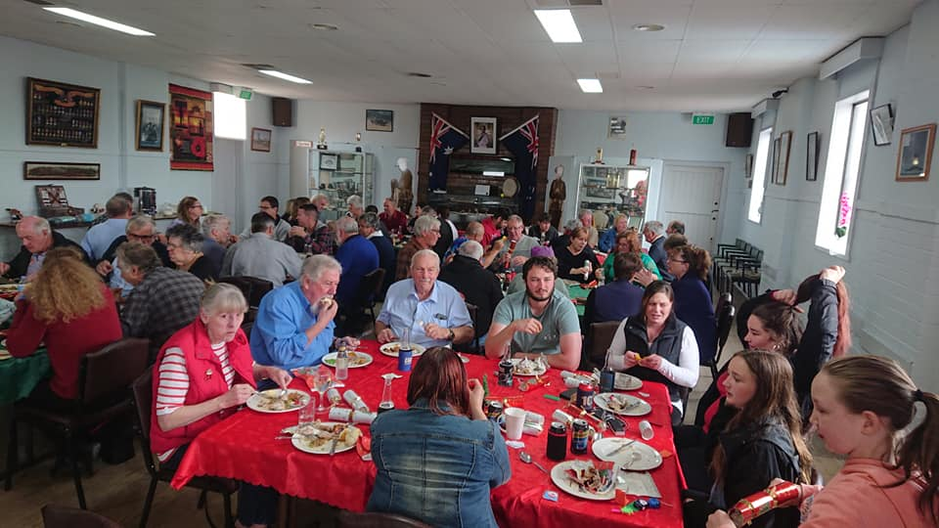

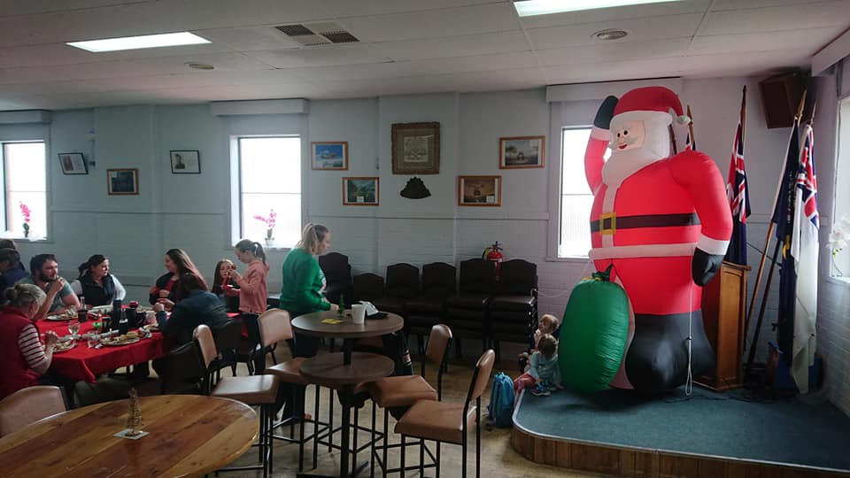

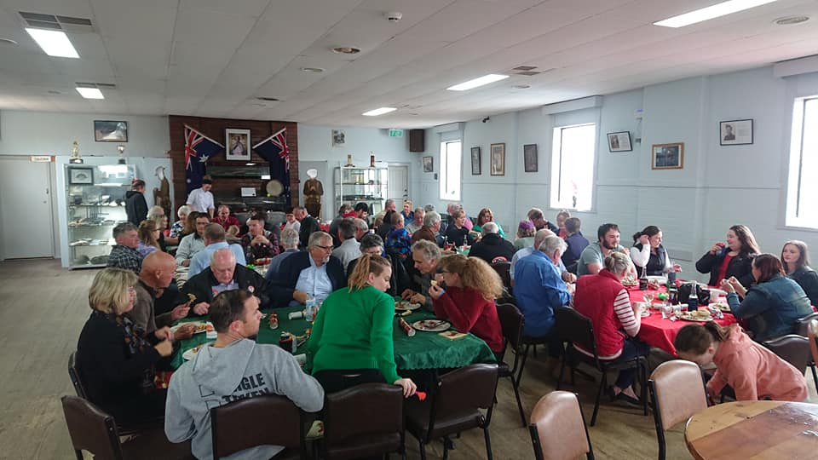

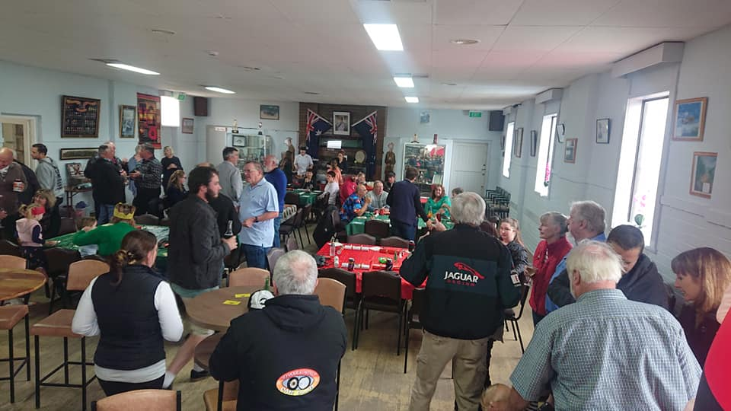

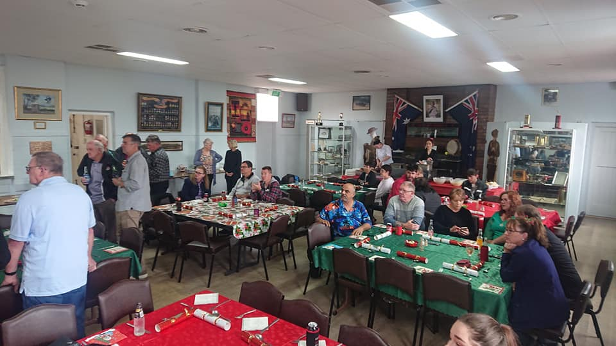

Farewells. The Committee, on behalf of the S&DCC, would like to wish Michael and Jess, Celeste and Harriet, all the very best wishes on their move to Adelaide. We have enjoyed your company at events while you have been posted to Puckapunyal and hope you will keep in touch and maybe visit us if you are passing by this way, at any time in the future.
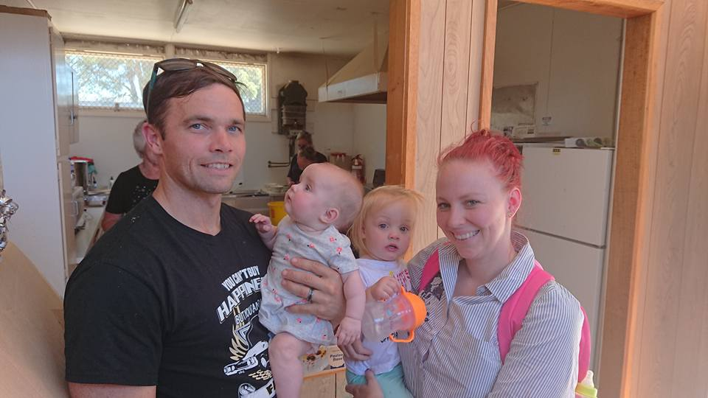

Seymour 1st Annual Show and Shine. Labour Day Monday, 9th March, 2020.
There will be more information available in relation to the Show and Shine after the next sub-committee meeting between the S&DCC and the Seymour Lions Club, to be held early in the New Year. Information will be included in the next Newsletter.
Also, please support the Seymour Lions Club if you see them selling raffle tickets around town. They provide support to many organisations locally and all their members are volunteers too, and give there time freely.

Future Events for 2020.
Australia Day at Kings Park, Seymour.
Swanpool Motor Festival. Sunday 2nd February, 2020.
Spirit of the Hume Truck Show at Broadford, Saturday 8th & Sunday 9th February, 2020.

Seymour Alternative Farming Expo at Kings Park, Friday 14th to Sunday 16th February, 2020.
Craigieburn Car, Truck & Bike Show. Sunday 23rd February, 2020
Yarra Glen Swap Meet and Show and Shine. Sunday 8th March, 2020.
All GM Day 2020 at Wangaratta. Sunday 8th March, 2020.
Seymour’s 1st Annual Show and Shine. Monday 9th March, 2020.

Next Meeting.
The next meeting will be a General Meeting to be held on Wednesday 5th February, 2020 at 7.30pm at a venue to be advised.
Happy Motoring,
Judi McGrath – Secretary – 0407 562003.

************************************

A farmer in Alberta wakes up one morning to find a bear on his roof. So, he looks in the yellow pages, and sure enough, there’s an ad for “Alberta Bear Removers.” He calls the number and the guy says he’ll be there in 20 minutes.
The bear remover arrives and gets out of his van. He’s got a ladder, a baseball bat, a 12 gauge shotgun, and a mean, heavily scarred old pit bull.
“Exactly, what are you going to do?” the puzzled farmer asks.
“Well, I’m going to put this ladder up against the eaves, then climb up there and knock the bear off the roof with this baseball bat. When the bear lands on the ground, the pit bull is trained to chomp down hard on his “privates” and not let go. The bear will immediately be subdued long enough for me to put him in the cage in the back of my van.”
He then hands the shotgun to the farmer.
“What’s the shotgun for?” asks the farmer.
“Well, sometimes the bear knocks me off the roof; and if that happens, then shoot the dog.”

