**February 2018 – Newsletter**

Welcome to 2018.

We hope you enjoy the events organised for you.

This is your car club and your participation is very important in helping to make it a success.

Future Events

Saturday 17th & Sunday 18th February, 2018 – 2nd Annual Spirit of the Hume Truck Show – Broadford.

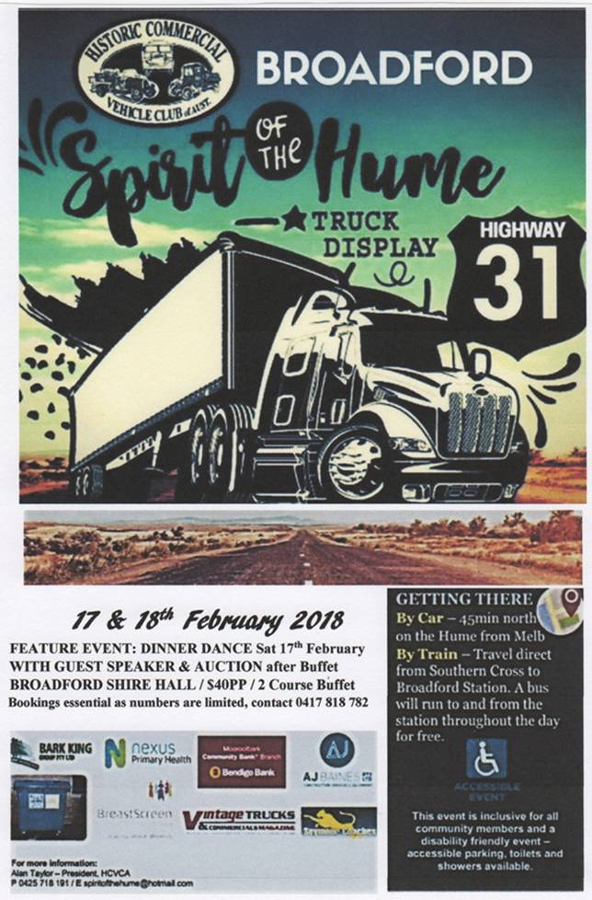

This display is to be held on the Broadford Common, Piper Street, Broadford. Gates open 9am.

(Turn into Murchison Street towards the Cemetery, and then right into Piper Street).

The Historic Commercial Vehicle Club have asked us to provide some vehicles and help support them in this display.

The S&DCC will have a designated display area and the Committee are asking for as many members as possible to attend this event and support one of the townships in our district.

Even though the event is held over two days, Saturday may be the busier day, as vehicles will probably be leaving after lunch on the Sunday.

It is only the second year this event has been held and the venue in Broadford is very important as it is significant in the history of heavy vehicles using the ‘iconic Old 31 Hume Highway’.

Future Events

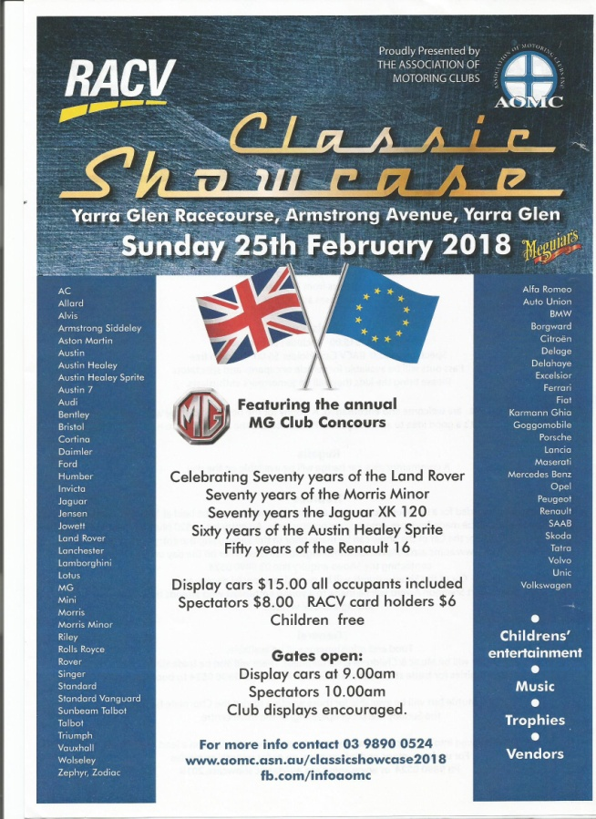 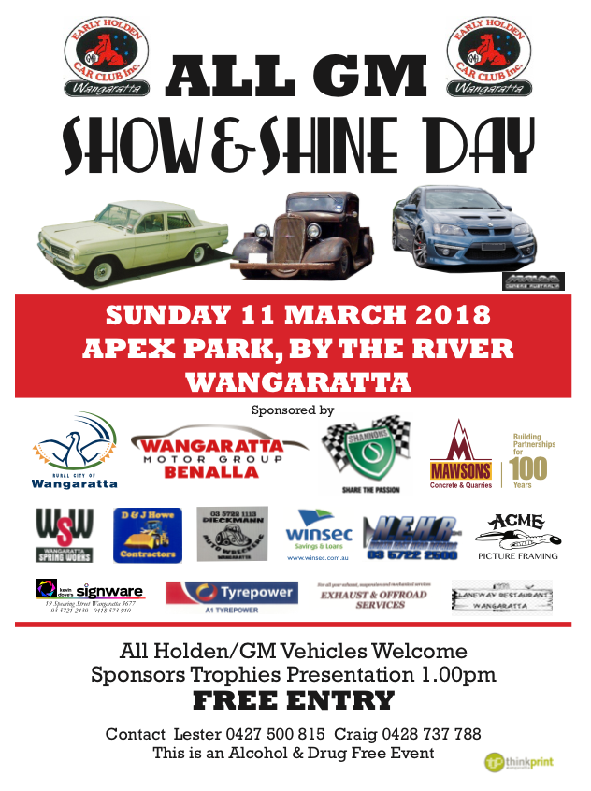

Sunday 11th March, 2018. Yarra Glen Swap Meet – Yarra Glen Racecourse.

Historic Winton Saturday 26th & Sunday 27th May, 2018.

 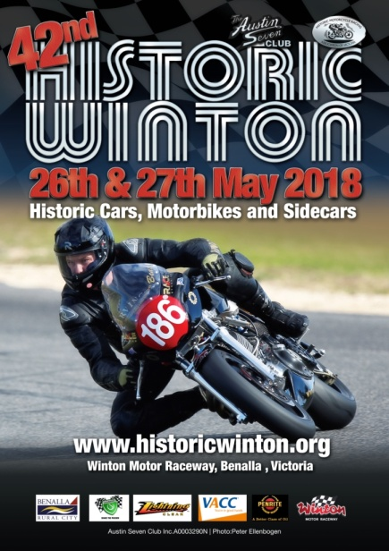 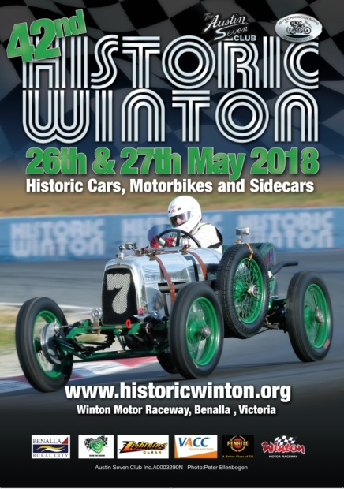

Complimentary tickets may be available for any members who have a vehicle they wish to display. (Is 2018 an anniversary year for a vehicle you own?) If you wish to stay the whole weekend there is accommodation available in Benalla, or there are camping facilities at the track.

Past Events - 2018 Rotary Australia Day Event at Kings Park in Seymour.

As it was going to be a very hot day the S&DCC Committee were very pleased to see so many members and vehicles attend this event. There were about 40 vehicles and it was a very impressive display with all the utilities lined up on the first row. Thank you to Rob and Carolyn for the photos.

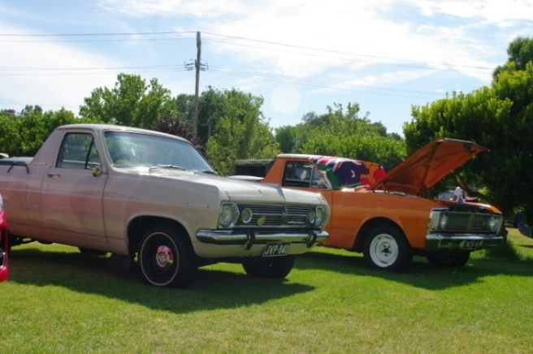 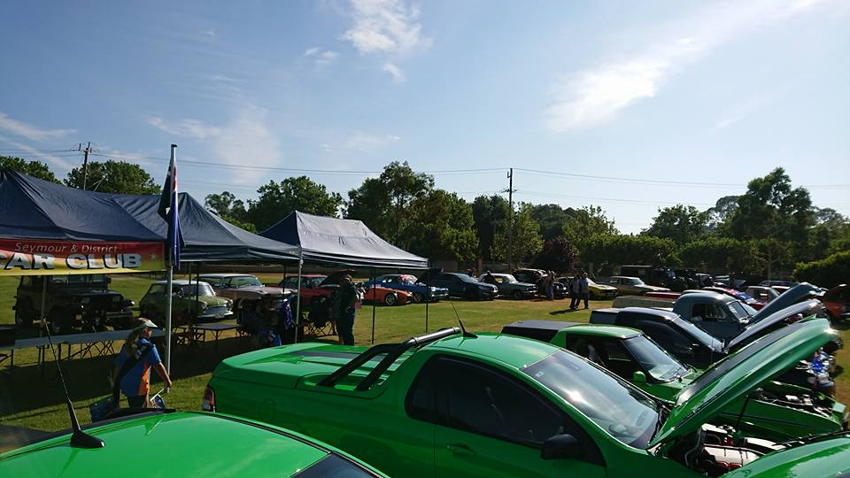

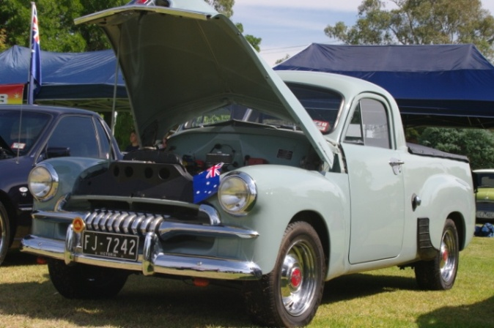  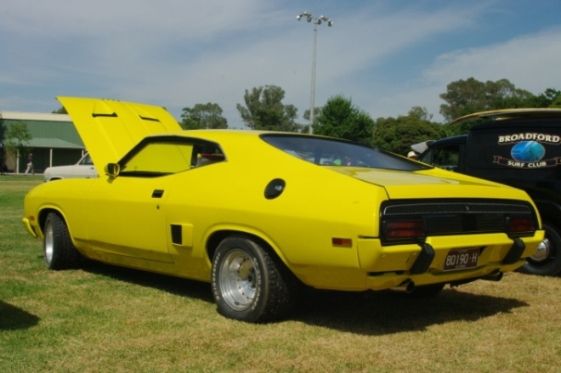

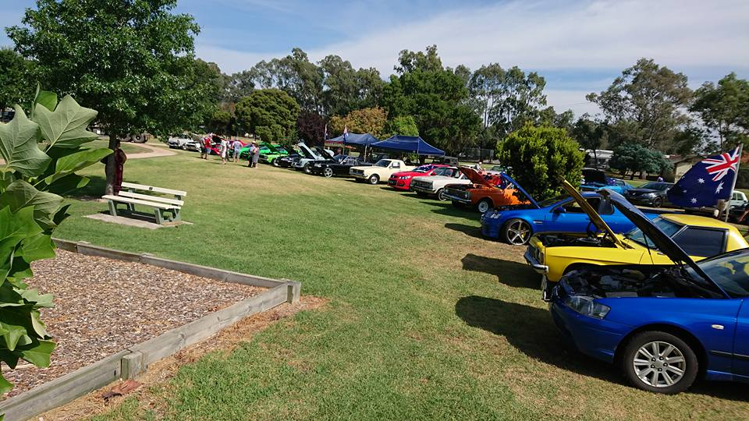 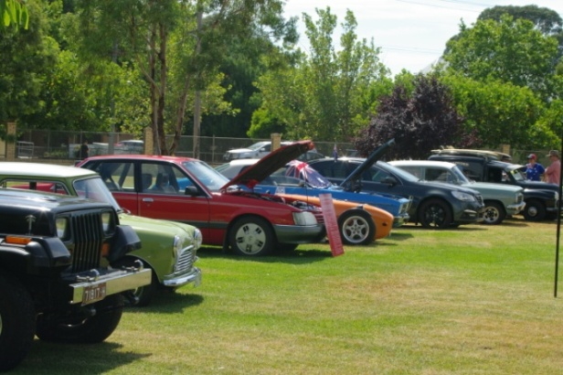

CPS Vehicle Photographs.

As per our obligations, we were busy during the end of 2017 organising the required photographs of vehicles permitted through the CPS with Vic Roads.

We did catch up with many members but the few who we didn’t, the secretary will contact them and organise how we can rectify the situation.

Next Meeting.

The next meeting will be a General Meeting, to be held in the clubrooms, Howe Street, Seymour, behind the tennis courts, on Wednesday 7th March, 2018 at 7.30pm.

All members are welcome to attend. Tea and coffee will be available.

Safe Motoring - Judi McGrath - Secretary – 0407 562003.

****************************

|  |
| --- |
| **FROZEN CARBURETOR**    People often complain about the police, but you rarely hear about the positive things they do, such as this incident involving a biker and a frozen carburetor.   On a bitterly cold winter's day, a Scottish Motorcycle Patrol Officer came upon a motorcyclist who was stalled by the roadside. The biker was swathed in heavy protective clothing and wearing a full-face helmet to protect the face from the cold weather.         “What’s the matter?” asked the Officer.      "Carburetor's frozen," was the terse reply.           "Pee on it. That'll thaw it out."           "I can't," said the biker.  "OK, watch me closely and I'll show you." The Officer unzipped and promptly warmed the carburetor as promised.      Moments later the bike started and the rider drove off, waving.      A few days later, the local Police Station received a note of thanks from the father of the motorcyclist.      It began: "On behalf of my daughter Jill."    From Murray. |
|  |