February 2019 - Newsletter

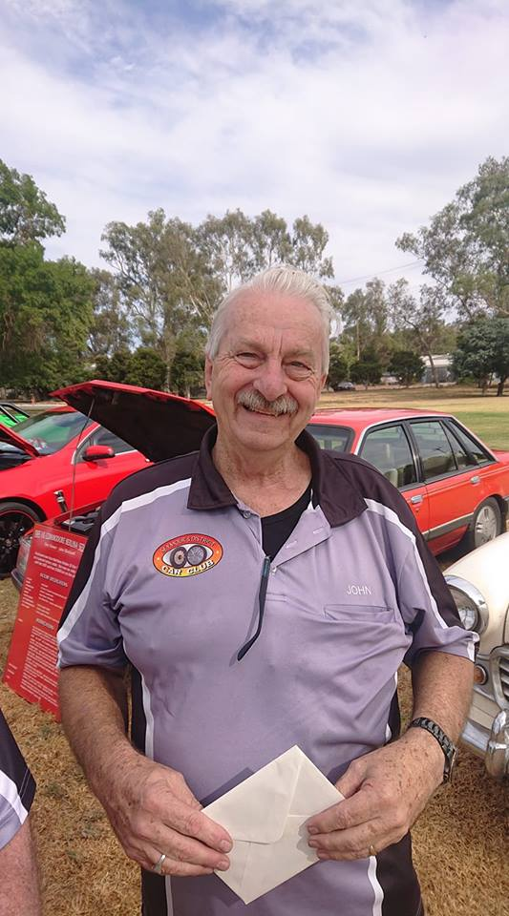
John Phoenix OAM

We are very proud to acknowledge our President John Phoenix, was awarded an Order of Australia medal in the recent Australia Day Honours List.
John has volunteered tirelessly in Seymour working on the Vietnam Veterans Walk, the Memorial at the Seymour Hospital and the Seymour Memorial Outdoor Swimming Pool, amongst many other projects.
John, we congratulate you and know you are a fitting recipient of this award.

The Committee hope all members had a relaxing Christmas break and are ready for another busy car club year.
Past Events.
Yea Railway Market – Judi would like to thank the car club members who helped out at the market either at the sausage sizzle tent or at the entrances to the market. Their help was greatly appreciated. We were aware the first market for the year can be a slow day so we were very pleased with the result.

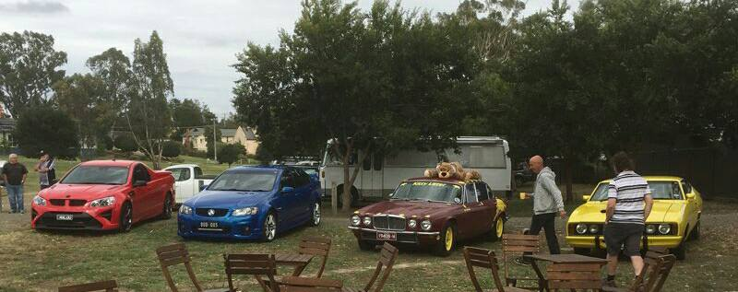

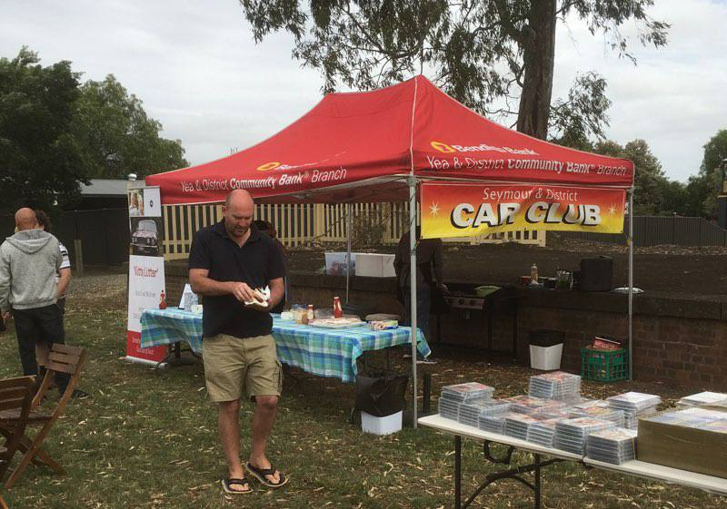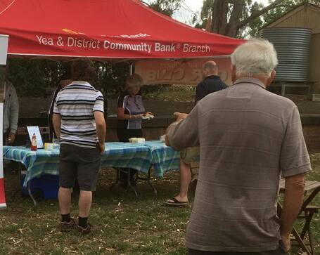

Rotary Australia Day in Kings Park, Seymour.

We were very pleased to see how many car club members came along to the display in Kings Park. There were a great array of vehicles displayed, from trucks, military vehicles, classics and the every-day drive. All of which provided a spectacle for residents of Seymour to view, and therefore showcase how varied our club is.
‘Thank you’ to everyone who came and joined us on our first social day for the year.

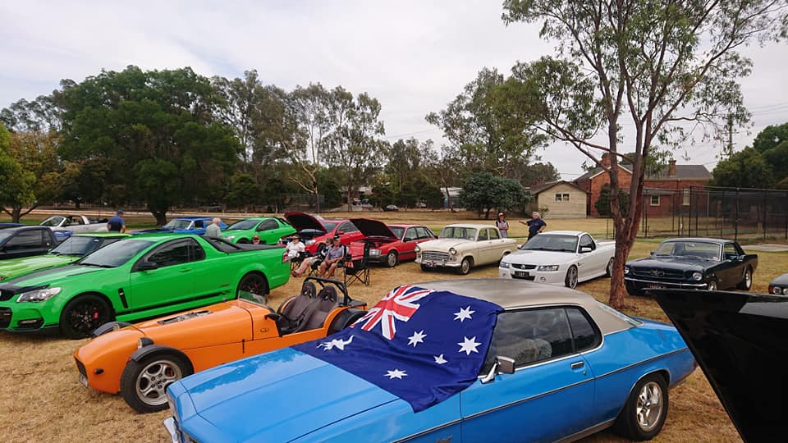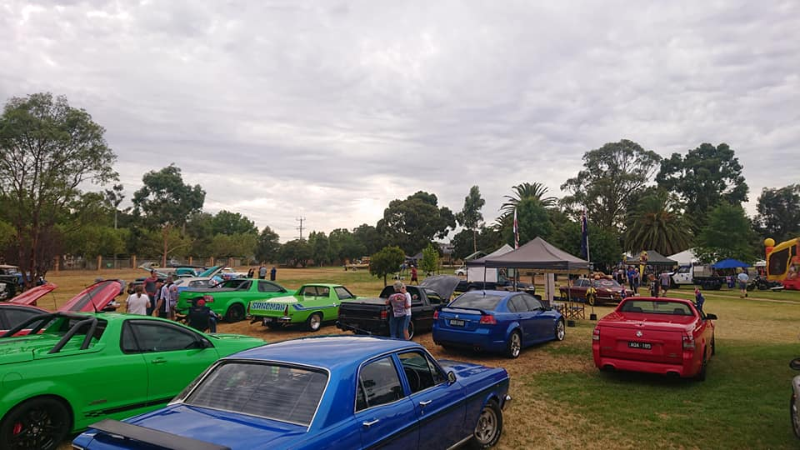

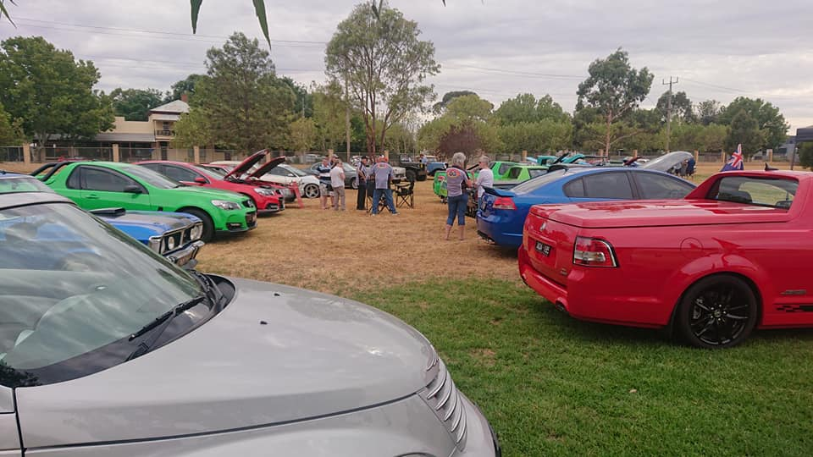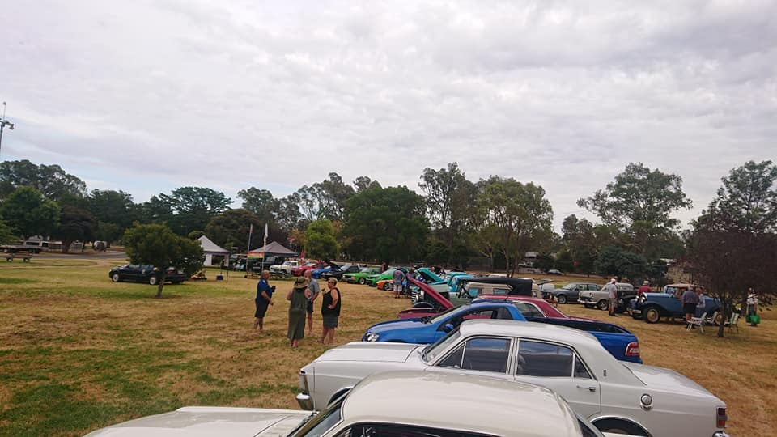

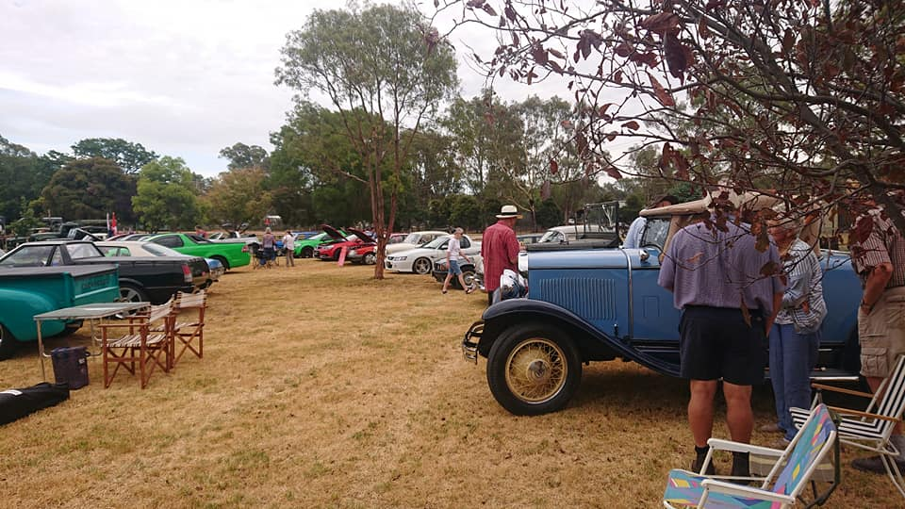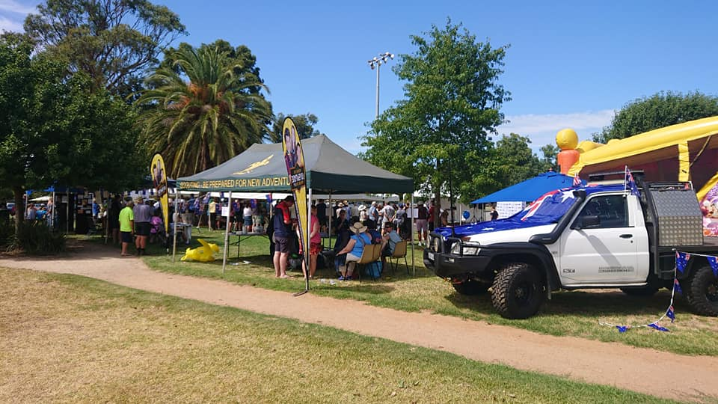

Swanpool Car Show - Christine and Tim Sheather went to the Swanpool Car Show last Sunday. It was extremely hot but there were lots of things to entertain the crowd. They reported it was very enjoyable and well worth the trip for the club next year.

Bathurst 12hr - Rob Collyer spoke to the members present about his recent trip to Bathurst for the 12hr race. Rob stays up on the mountain at McPhilamy Park which is a great vantage point to view the race.

Future Events
Sunday, 10th February, 2019 – Picnic at Hanging Rock.
If any car club members are interested in going to Hanging Rock and park as a group, we will be meeting outside the swimming pool in Chauncey Road in Lancefield at 8am, and we will travel onto the Hanging Rock Reserve together. There are food and drink venues available during the day, or bring a picnic lunch. Make sure you bring along comfortable walking shoes as there are many, many vehicles and it will take you quite a while to get around to view them. Entry is $20.00 per vehicle.
The weather looks as though it is going to be a perfect summer’s day.
Please contact Judi on 0407 562003 and we will make sure to wait for you.

Friday, Saturday & Sunday, 15th, 16th & 17th February, 2019 – Seymour Alternative Farming Expo at Kings Park in Seymour.
We have been invited to exhibit our vehicles over the three days of the Expo but you will need to contact me so we can obtain your exhibitors passes for entry. We have also been allocated some one day family passes. It is your choice as to whether you want to display your vehicles for one, two or three days. Be reminded though that you need to be at Kings Park by 8am and are not able to leave until the Expo closes for the day at 5pm.
Therefore, please contact me on 0407 562003 by Monday night, 11th February, as we need to advise the organisers of our participation. Your Passes can then be collected from Seymour Industrial Supplies in Emily Street, Seymour.

Friday & Saturday, 16th & 17th February, 2019 – Broadford Truck Show – Murchison Street.

The Truck display this year will be held on Saturday and Sunday in the reserve on Murchison Street. Signage will be visible from the main street. There is no set time to arrive so you can turn up when it suits you. Entry is free.
Some of the smaller towns in our district benefit from these shows so it you have some free time then please come along and support the Broadford community.

Sunday, 17th February, 2019 – 1st Annual Daylesford Motorfest – Victoria Park, Daylesford.

Sunday, 24th February, 2019 – British & European Motor Show at the Yarra Glen Racecourse.

Sunday 10th March, 2019 – 9am to 2pm - All GM Day at Apex Park, Wangaratta.
All Holden and GM Vehicles are welcome.

Sunday 10th March, 2019 – Yarra Glen Swap Meet – Yarra Glen Racecourse.

Sunday 24th March, 2019 – 64th RACV Kalorama Rally.

Sunday, 27th April, 2019 – 3rd RACV Florence Thomson Tour - Cobram.

This tour celebrates the indomitable Florence Thomson, who was the only female entrant in the 1905 Dunlop Reliability Motor contest from Sydney to Melbourne, a 920-kilometre journey over what was then essentially a horse track between the two cities. She was one of only 16 contestants to finish the five-day trial. This tour is for lady drivers only, and is restricted to 200 vehicles. For further details contact RACV Florence Thomson tour 2019.

Next Meeting. The next meeting will be Committee Meeting, to be held on Wednesday the 6th of March, 2019 at 7.30pm, at the clubrooms, lower end of Howe Street, behind the tennis courts.
All members are welcome. Tea and coffee will be available.
Thank you - Judi would like to thank Kym for being Assistant Secretary at the Meeting on Wednesday night.
Happy Motoring. Judi McGrath – Secretary.

***********************

A child asked her father “How were people born?”
So her father said, “Adam and Eve made babies, then their babies became adults and made babies, and so on.”
The child then went to her mother and asked the same question, and she told her, “We were monkeys, then we evolved to become like we are now.”
The child ran back to her father and said, “You lied to me!”
Her dad replied, “No, your mum was talking about her side of the family.”

