July, 2017 – Newsletter

Membership Renewals.

Annual Subscription renewal invoices have been posted and emailed out to all members. If you haven’t received your renewal then please contact me and I will rectify the problem immediately. Renewals do need to be paid by the beginning of July. If your renewal hasn’t been received by the end of July then you will have to pay a rejoining fee of $30 plus your subscription fee of $40.
Please remember - If you have a vehicle permitted on the CPS through the S&DCC you need to be financial as of the 1st of July, 2017, or your vehicle is deemed to be ‘not permitted’ by Vic Roads and it is illegal to drive it on the road. We then have a duty to report your lased membership to Vic Roads.
We did have a member pay a cheque for their subscription renewal into the Goulburn Murray Credit Union on Wednesday July 5th but unfortunately they omitted to list their name as a reference. If this was you, please contact us so we can list your payment against your name.
Donations to Local Organisations.
At the last 2 meetings of the S&DCC, member’s present showed interest in making donations to several local organisations and these motions were passed.
A donation was made to the local radio station. They then invited our President John Phoenix, to speak about our car club during one of their motoring programs.
Donations have been made to the Seymour and Kilmore Hospitals and will be used to help with fundraising for specific pieces of equipment.
We have also made a donation to Avenel Primary School to help with their fundraising for their annual Energy Breakthrough Program.

Saturday 22nd & Sunday 23rd July, 2017 – ‘Travelling the Old Hume 31 Highway.

Please contact me if you want to join us for this weekend. Each vehicle participating will receive a route map.

We plan to leave the Vietnam Veterans Walk, High Street Seymour, at 9am, on the Saturday morning.
We will stop for morning tea and lunch along the route.
You can buy supplies along the way or you are welcome to pack a thermos and a picnic basket. (The weather may dictate this decision).

You will need to book your own accommodation, which is at the Secura Lifestyle Borderland Big 4 Holiday Park.
65 McKoy Street, Wodonga. Phone Nicole on 02 6024 3906 and book whatever suits you best.
There are numerous styles of cabins available.
They have a BBQ area which we can utilize for our BYO evening meal. Breakfast will be BYO as well.

On our way home, if time permits, we will stop in Yackandandah and Beechworth. Both these towns are quirky and very interesting.

Past Events

Saturday, June 24th, 2017. Fox Classic Car Collection at Docklands.

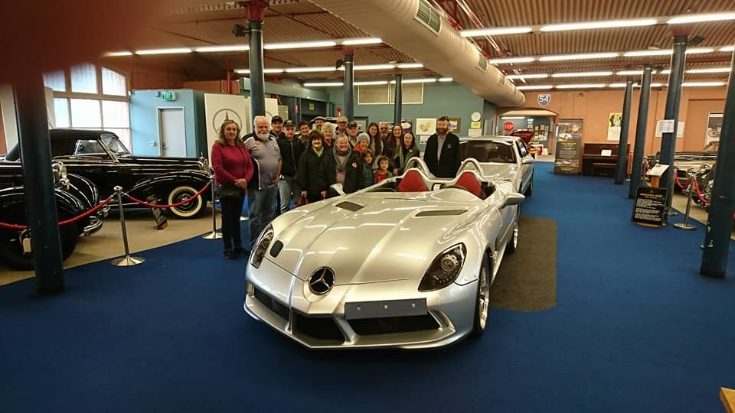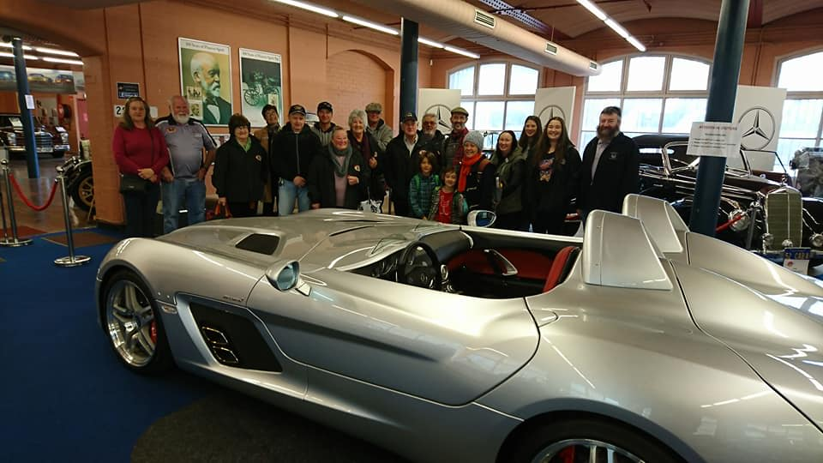

We had 20 members and their families join us for the tour of the Fox Vehicle Collection. It was an early morning start with most members travelling down to Melbourne by train. As it was early, we were the first group visiting for the day, therefore there was time for one of the volunteers to spend some time with us explaining the history of the building as well as some of the vehicles. It was very interesting to hear how Lindsay Fox started his career and the opportunities that came his way. The collection is manned by volunteers and a big proportion of the donations received from the public are directed to many charities. The ground floor is reserved for the more expensive and valuable vehicles and many of them would not be seen at many personal collections.
On the second floor we were able to view numerous older sports cars, as well as quite a few different Jaguars.

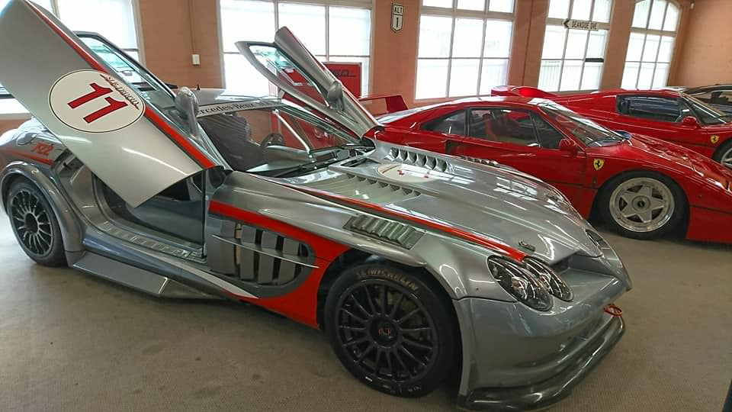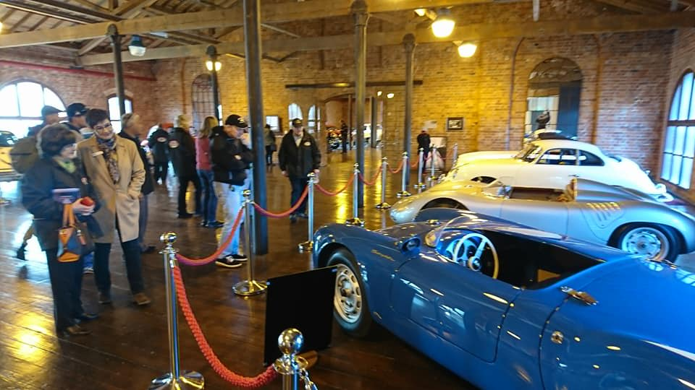

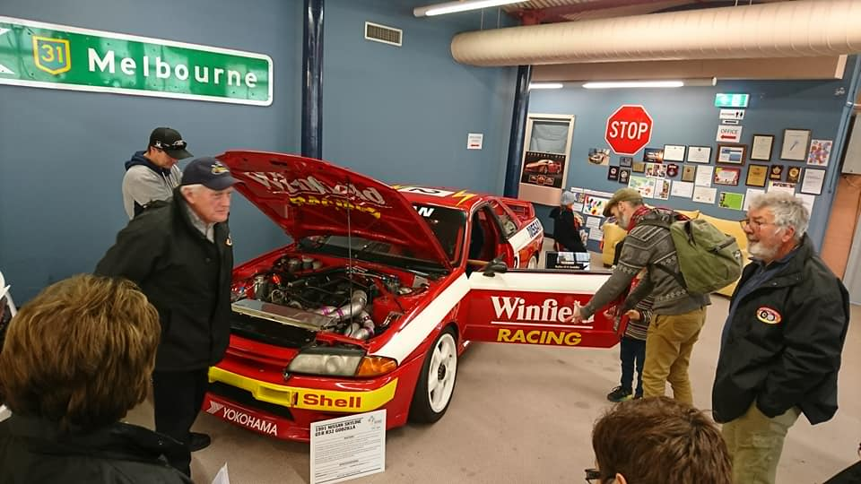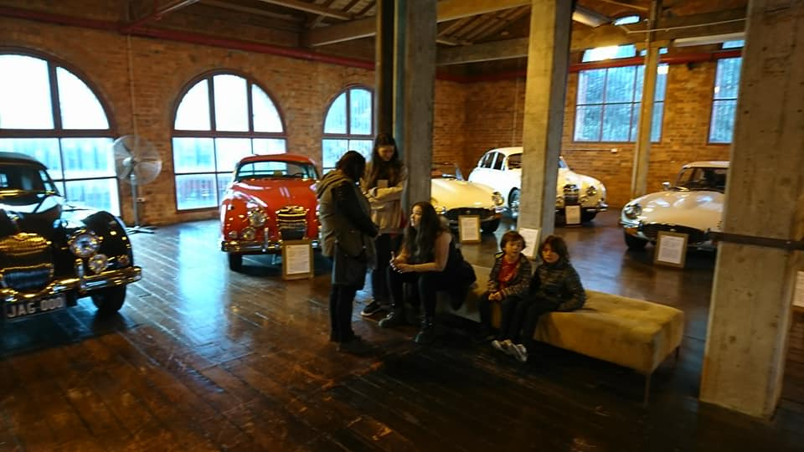

Future Events
Saturday, 22nd July, 2017. 8.30am.

The AOMC are holding a Restoration Seminar at the Jaguar/Healey Clubrooms – 23 Rosalie Street, Springvale. The 2017 topics and speakers are new and will be related to vehicle restoration and maintenance.
You will need to register by Friday 14th July. It is free to attend. Enquiries to secretary@aomc.asn.au

Sunday, 20th August, 2017.

We are making arrangements to view another vehicle collection which is housed locally. Further details will be provided as soon as possible.

Sunday 17th September, 2017 – Nagambie Cranksters.

Saturday 23rd & Sunday 24th September, 2017 – Wangaratta.

We received an invitation from the Vintage & Veteran Car Club of Wangaratta asking if any of our members wish to join them on their 47th Annual Spring Rally.

Highlights of the Rally will include meals at the Historic Vine Hotel. View an impressive collection of Early Model Holden’s and a visit to Winton Motor Raceway, with a lap of Honour around the track.

These weekends have proved very popular in the past with approximately 100 cars involved.
Entries close on the 1st September, 2017. Contact me and I can provide you with all the details.

Sunday 1st October, 2017 – Euroa Show and Shine.

Wednesday 1st November, 2017 - Monthly Meeting, as well as our Annual General Meeting.

Sunday 24th November, 2017 – EJ/EH Holden Nationals at Shepparton.

Sunday, 3rd December, 2017. - Christmas Party at the Clubrooms.

Next Meeting.
The next meeting is a Committee Meeting, to be held on Wednesday 2nd August, 2017 at 7.30pm, in the clubrooms, lower end of Howe Street, behind the tennis courts. All members are welcome to attend. Tea and Coffee will be available.

Safe Motoring - Judi McGrath - Secretary – 0407 562003.
*********************************
A man was stopped by police around 2am.
The Officer asked him where he was going at that time of night.
The man replied, “I’m on my way to a lecture about alcohol abuse and the effects it has on the human body, as well as smoking, and staying out late.”
The Officer replied, “Oh really...........and who’s giving that lecture at this time of at night.”
The man replied, “That would be my wife.”

