July 2018 – Newsletter

Club Membership Renewals

By now you should all have received your renewal invoice for the 2018 – 2019 financial year.
Please contact me as soon as possible if you have not received your invoice yet.
The annual subscription is $40.00, and payment details are included on the invoice.

If you have changed your email address during the year, then please let us know. Some of the emails we send out are not reaching the intended members, but are not bouncing back to us either.
Maybe it’s a case of them going into hyperspace.......

Please, please, please, remember to include your surname as the reference on the deposit slip or in the relevant position when you use internet banking. We have received a payment of $40.00, for the annual renewal but unfortunately there is no surname to confirm whose payment this is. It was a cheque, banked at the Seymour branch of the GMCU on June ??. It is too expensive for us to ask the GMCU to check the depositor, so if you think this is your payment then please contact us

Also please be aware that your renewal is due by 1st July, especially if you have a vehicle permitted on the Club Permit Scheme. If you do not pay your renewal by this date then your vehicle is classified as ‘not permitted’ and it is illegal for you to drive the vehicle on the roads.

Past Events

Queen’s Birthday – June 2018. Steam Festival at Echuca

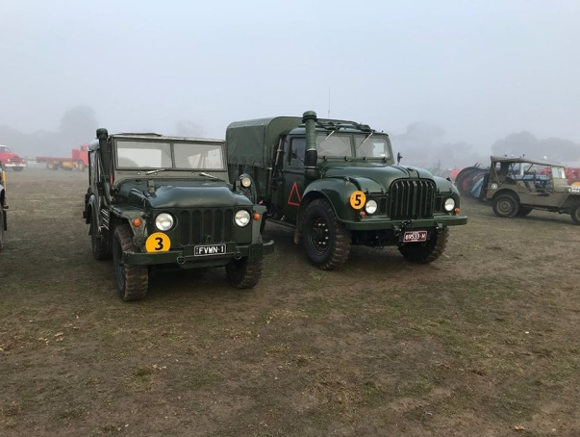
As you cans see it was just a tad foggy for the vehicle display held in Echuca at Rotary Park, for the Steam Festival.

Our thanks go to Dave and Kathy for braving these conditions to showcase their very impressive vehicles on behalf of the S&DCC.

The immaculate attention to detail on these vehicles is a credit to them both.

June – Guest Speakers – Sunday 24th June.

The members present thanked our Guest Speakers for the day at Puckapunyal. Tony Crooks, John Phoenix, John Blackwell and Michael Street. We had some new members attend so it was also very enjoyable to socialise as we had our picnic lunch.
About 30 members and their families attended the day and everyone enjoyed the visit. All who attended were very impressed to be able to see ’behind the scenes’ at the Museum as some of the areas we visited are not available to the general public.
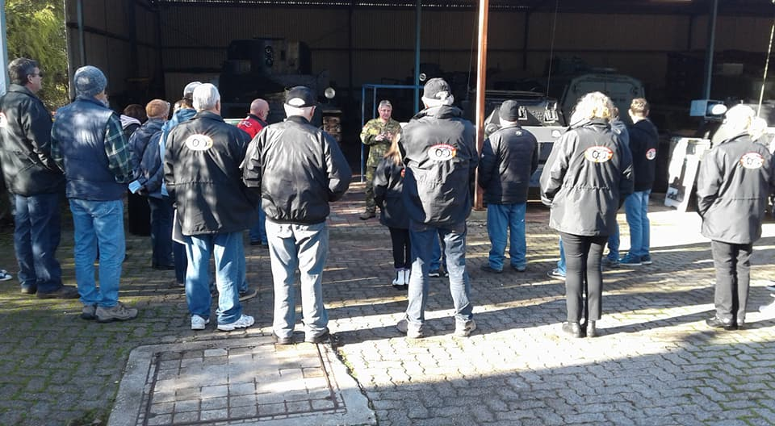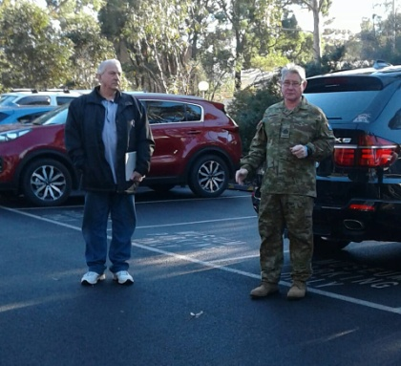

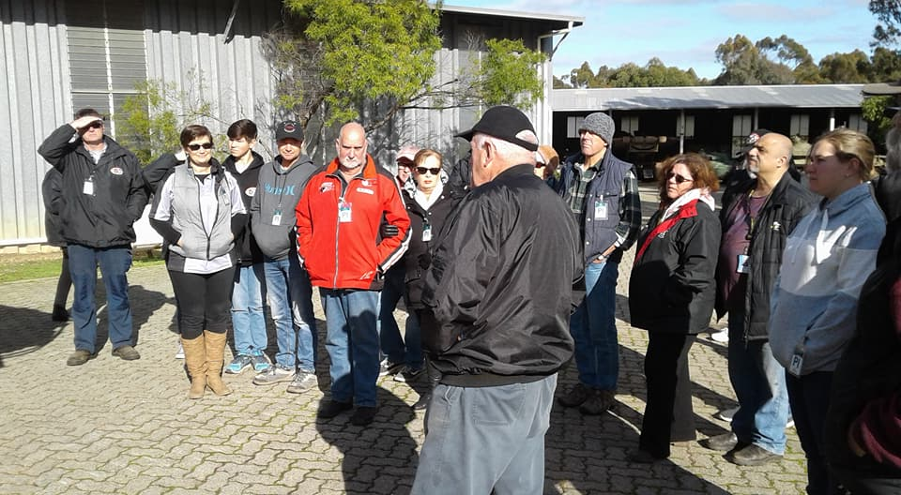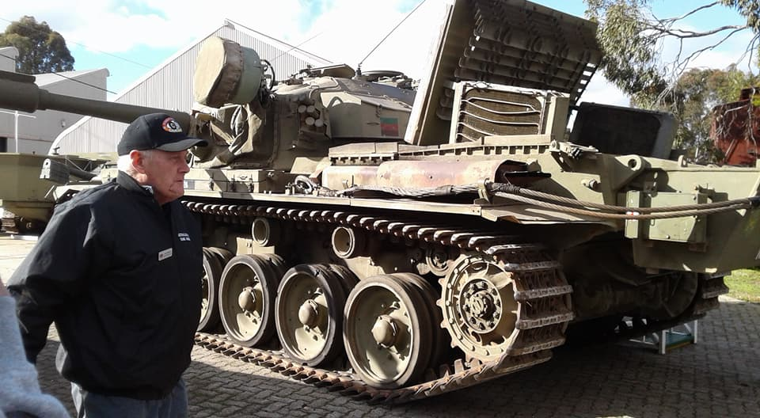
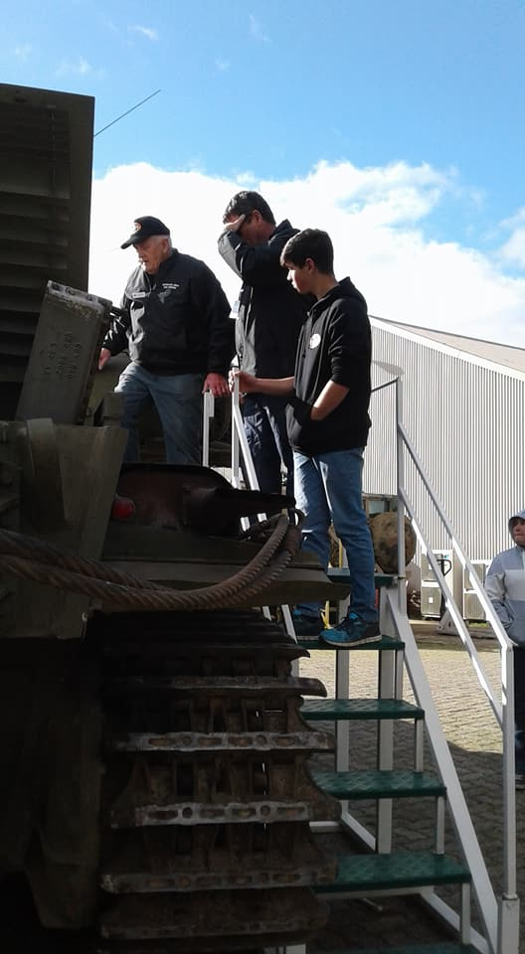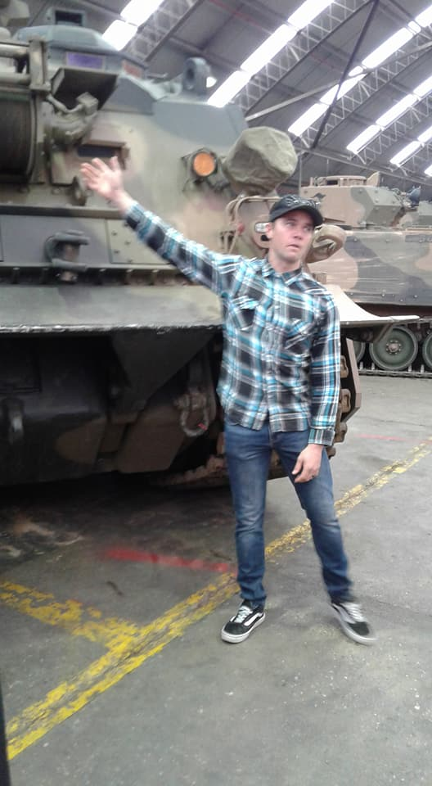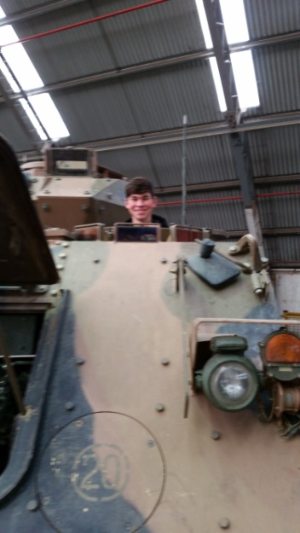

Future Events
Sunday 29th July, 2018 – Lunch.
As we did last year, we have decided to just go out for a Sunday Lunch, as the weather this time of year can sometimes not be relied upon. We will visit the new diner at the Red Lion Hotel in Kilmore. Contact me by Wednesday 26th July, then we will be able to enjoy a few hours social time together.
Saturday or Sunday 11th or 12th August, 2018 – Craft Day
Christine has also suggested another craft/cardmaking day at the clubrooms. This time we can focus on any men who reside in the local Aged Care facility, and help to make their Father’s Day, a little bit brighter for them. If you are able to spare a couple of hours to join us, then contact me and indicate which day will suit you best. The merry little group who met in May for the Mother’s Day craft day, really enjoyed the camaraderie.
Annual Club Run – Weekend Away – 25th & 26th August, 2018
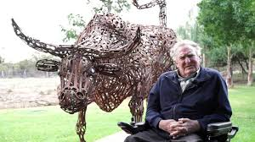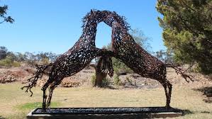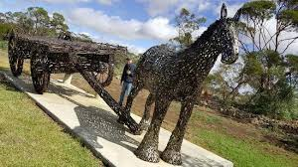

This display is well worth a visit as you cannot possibly understand how spectacular these sculptures are until you stand beside one.

At this stage we will make arrangements for Saturday the 25th and Sunday the 26th of August, staying at a motel in the area, on the Saturday night.
If you want to join us then please register your interest so we can make all the necessary arrangements.

‘Pick a Project’ Funding Initiative.

Bernadette Bell advised the meeting of the chance for the car club to apply for funding through the ‘Pick a Project’ funding initiative for the Goulburn Region. At this stage we will apply and maybe, if we are successful, use the funding for the repair of the clubrooms. We needed to send our submission in by the 6th of July so we will advise members of any more information when it becomes available.
The next meeting will be a Committee Meeting, to be held on Wednesday 1st August, 2018 at 7.30pm, at the clubrooms, lower end of Howe Street, behind the tennis courts. All members are welcome. Tea and coffee available.
Happy Motoring.
Judi McGrath – Secretary.

The Prime Minister walks into a local bank in Point Piper to cash a cheque. He is surrounded by Protective Security Officers. As he approaches the teller he says, "Good morning, could you please cash this cheque for me?"
Teller:
"It would be my pleasure sir. Could you please show me your ID?"
Prime Minister:
"Truthfully, I did not bring my ID with me as I didn't think there was any need to. I am the Prime Minister of Australia !!!!"
Teller:
"Yes sir, I know who you are, but with all the regulations and monitoring of the banks because of the war on terror, imposters, forgers, money laundering, the GFC, etc., I must insist on seeing ID."
Prime Minister :
"Just ask anyone here at the bank who I am and they will tell you. Everybody knows who I am."
Teller:
"I am sorry Mr. Prime Minister but these are the bank rules and I must follow them."
Prime Minister:
"I am urging you, please, to cash this cheque. I need to buy a gift for my wife for Valentine's Day"
Teller:
"Look Mr. Prime Minister, here is an example of what we can do. One day, Greg Norman came into one of our bank branches without ID. To prove he was Greg Norman he pulled out his putter and made a beautiful shot across the bank into a coffee cup. With that shot, we knew him to be Greg Norman, and cashed his cheque.
Another time, Pat Rafter came into the same place without ID. He pulled out his tennis racquet and made a fabulous shot, where the tennis ball landed in a coffee cup. With that shot we cashed his cheque.
So, Mr. Prime Minister, what can you do to prove that it is you, and only you, as the Prime Minister of Australia?"
Prime Minister:
The Prime Minister stands there thinking, and thinking, and finally says, "Honestly, my mind is a total blank...there is nothing that comes to my mind. I can't think of a single thing. I have absolutely no idea what to do and I don't have a clue.
Teller:
Will "50's and 20's be OK, Mr. Prime Minister?

(Thank you Murray)

