July 2019 – Newsletter

Membership Renewals.

S&DCC annual membership renewals were due on the 1st July, 2019.
Invoices were emailed and posted to all members at the end of May. Paid invoices have now been emailed and posted out to advise members we have received your payment. Please advise us if you haven’t received your notification.

If you have a vehicle permitted on the Club Permit Scheme through the S&DCC, it is imperative you renew your membership now as your vehicle is deemed ‘not permitted’ and it is an offence to drive it on the road.

If you are not renewing your car club membership, this may be the last newsletter you will receive, so we do hope you enjoy whatever you pursue in the future.

Past Events.

Guest Speaker - Ralph Provan.
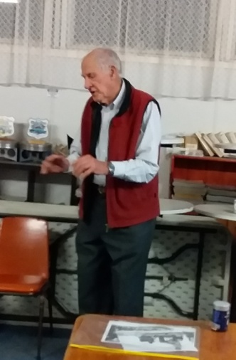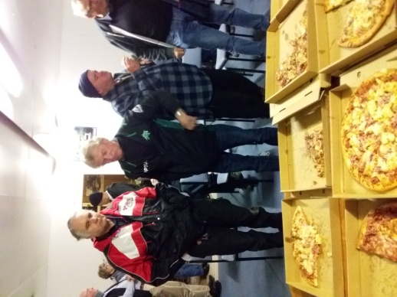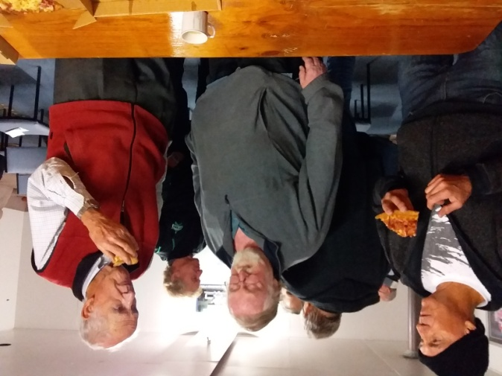

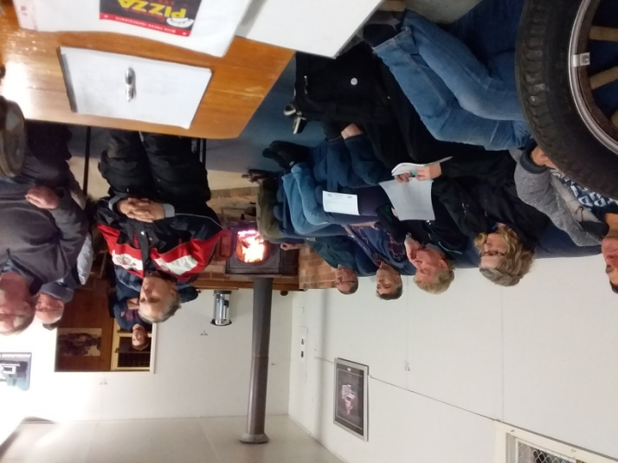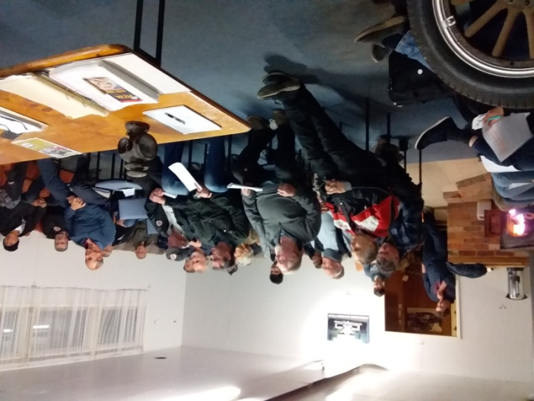

Our thanks are extended to Ralph Provan who attended our meeting on Wednesday and then spoke to the members present afterwards. Ralph presented a DVD of the Dodge Brothers factory and assembly line. This showed us how the assembly line worked during the pre World War 1 era. There were many questionable practices adopted during those times and we were all amazed with what we were seeing. After our pizza supper Ralph spoke about some of his own vehicles and the history behind them. Ralph also paid tribute to Lois and her support of his motoring adventures during their married life. We are very lucky to have such a knowledgeable man within our midst.

Swanpool Theatre. A small group met in Seymour on Sunday 30th June. We drove up to Benalla and had lunch before going onto the theatre to see the documentary ‘Spitfire.’ The documentary was very well done and a good day was enjoyed by all.

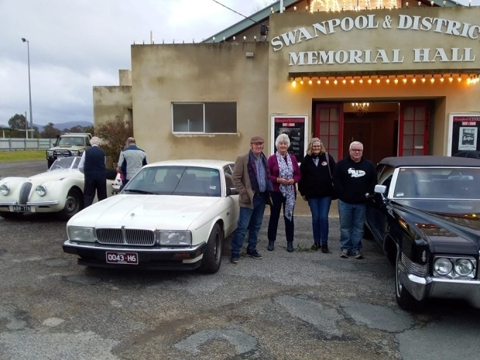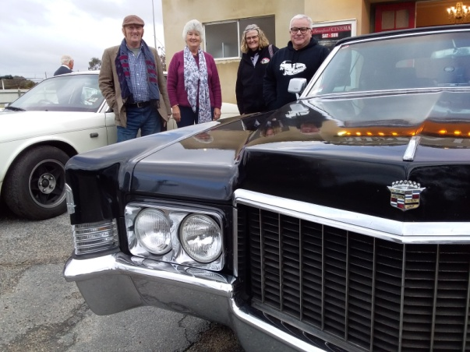

Future Events

Sunday 21st July, 2019, from 10am. Tank Museum
John Blackwell advised us of another open day at the Puckapunyal Tank Museum. Entry is $5.00.
Sunday 25th August, 2019. RACV Aussie Classic Car Show.

Yarra Glen Racecourse. Gates open at 9am. Entry is $15 per vehicle.

Nagambie Cranksters – Sunday 22nd September, 2019.

Euroa Show and Shine – Sunday 6th October, 2019.

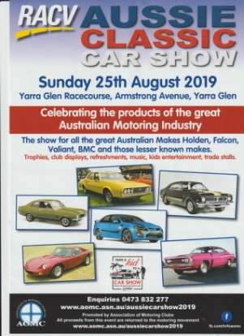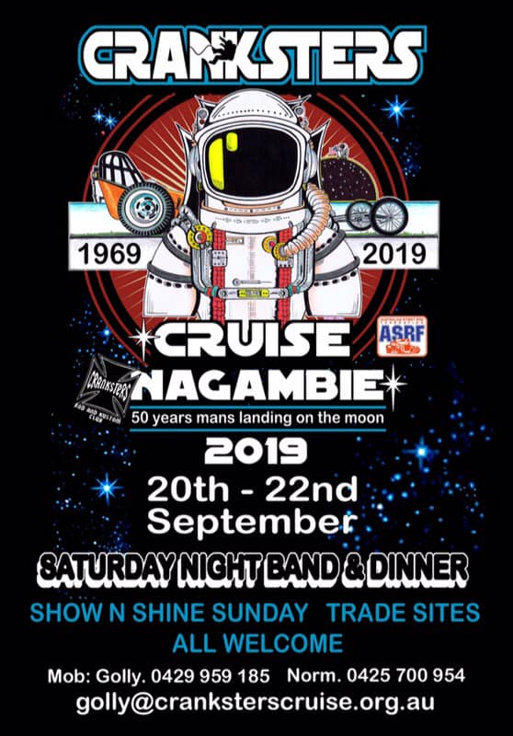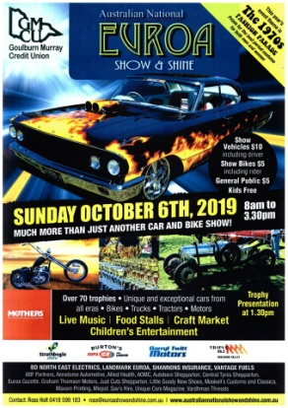
The next meeting will be a Committee Meeting, to be held in the clubrooms, on Wednesday 7th August, 2019, at 7.30pm.
All members are welcome to attend. Tea and coffee will be available.
Happy Motoring,
Judi McGrath – Secretary – 0407 562003
*******************************
In a high school level advanced Biology exam, the last question was,
'Name eight (8) advantages of Mother's Milk'. This final question was worth 70 points or zero/none at all.
One male student, in particular, was hard put to think of eight advantages. However, after some serious contemplation, he wrote this:
1) It is a perfect formula for the child.
2) It provides immunity against several diseases.
3) It is always the right temperature.
4) It is inexpensive.
5) It bonds the child to the mother and vice versa.
6) It is always available as needed.
... And then, the student was dumb struck for two more answers. In desperation, just before the bell rang, indicating the end of the exam, he wrote:
7) It comes in two quite attractive containers, and
8) it's high enough off the floor where the cat can't get to it.

He got an A+

(Thanks Murray)

