June 2016 – Newsletter

Recent Events
Sunday – 15th May, 2016. - Smith’s of Kyneton
Judi reported on another very successful day at Ivan and June Smith’s private motoring collection in Kyneton. Some of the group had seen the collection before whereas we did have some prospective members attend as well, and everyone was in awe of what was on display. June welcomed us with morning tea and then Greg Smith gave the members present, an introduction to the memorabilia we were going to see. Some of the exhibits have been shown at a few display days recently, as well as a tractor and bailer being used as a working exhibit. It was with reluctance, we had to leave after our visit.
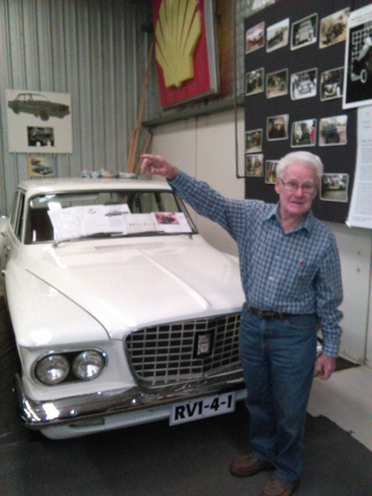
Queen’s Birthday Weekend – Sunday 12th June, 2016.

Our June run is to the Shepparton Motor Museum and then onto the Shepparton Go-Kart Complex.
The museum is focusing on the ‘Legends of Bathurst’ so plenty of Holden’s and Ford’s on display
Saturday is a ticketed day and all tickets have been sold, but the Sunday is open to the general public and there will be some of the famous driver’s of the era there to sign autographs. It is expected to be a very busy weekend but there is plenty of parking at the rear of the museum.
We will be meeting at the Seymour Industrial Supplies car park in Emily Street, Seymour, at 8.30am or at the Shepparton Motor Museum at 9.30am.

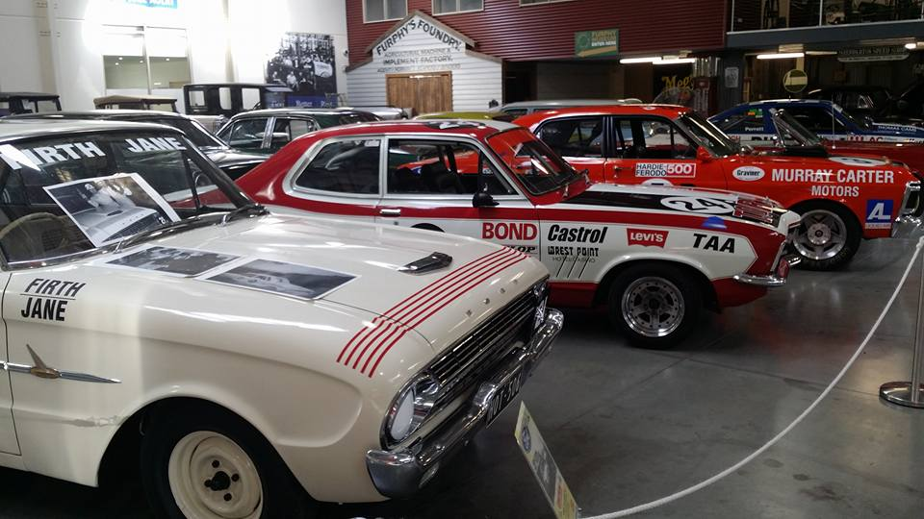

After the museum, we will visit the Shepparton Go-Kart Complex and you can try your hand at your own racing adventure.

We do need to know who is going to join us for the day so, can you please, email, phone or text me, as soon as possible.

8th 9th & 10th July 2016 – Weekend Away – East Gippsland.

Weekend away in East Gippsland visiting the Tyabb Packing Sheds, a motoring collection in Mirboo North, the gold mining township of Walhalla, the Trafalgar Holden Museum, the Maffra Shed, Timeless Memories in Sale and the Gippsland Armed Forces Museum at the West Sale airport, on the way home. See attached program of events for more details.
Future Events.

Activities for August, September, October, November & December.
We are at present organising our activities diary for the rest of the year and will notify members in the next newsletter.

S&DCC Jackets – At the last meeting the members discussed having winter jackets available for the members. We have been able to obtain these locally and will have a few available at the July meeting. They are black in colour, a unisex style with our club logo embroidered on the front left hand side and on the back. Embroidered caps will also be available. Jackets = $110.00. Caps = $25.00.
T-Shirts – We have ordered 5 more T-Shirts from the company in Shepparton. One has been pre ordered and the others will be held in stock for future purchase.
Name Tags – We will order the next batch of name tags during the next week, and they should arrive before the next meeting.
Annual Membership Fees.
Membership renewal invoices will be printed then posted, or emailed to all current members within the next week.
All Membership Fees are due on 1st July, 2016, irrespective of your joining date. Renewals need to be received by the club by the 7th July, 2016. If you have a vehicle on Club Plates (CPS) you must renew by 1st July. The club has an obligation to notify Vic Roads within 7 days of any member on the CPS, who becomes un-financial (i.e .from 8th July if unpaid). On receipt of this notification Vic Roads will cancel your permit and request that you return your M, SR, CH or H plates. You will then be required to re-apply and submit a new CPS application, including a RWC and the prescribed 6 photographs if you wish to continue on the CPS.
SO PLEASE pay the $40.00 renewal fee before 7th July, 2016. Send a cheque to PO Box 404, Seymour. Vic. 3660 or EFT:
PLEASE put your SURNAME on the bank deposit as we need to identity the payment received.

CPS Handbooks
The updated Club Permit Scheme Handbooks are now available from the AOMC. The S&DCC are obtaining bulk copies so if members with a car on the CPS would like a copy, they will be available from the clubrooms.

Next Meeting – The next meeting of the S&DCC is a General Meeting to be held on Wednesday, 6th July, 2016, at 7.30pm at the clubrooms, lower end of Howe Street Seymour, behind the tennis Courts.
All members are welcome to attend. Tea and coffee available.
Safe Motoring
Judi McGrath - Secretary – 0407 562003.

************************

Husband: My wife is missing. She went shopping yesterday and has not come home.....
Sergeant at Police Station: What is her height?
Husband: Gee.......I’m not sure. A little over five feet tall.....
Police Sergeant: Weight?
Husband: Don’t know. Not slim, not really fat.....
Police Sergeant: Colour of eyes?
Husband: Sort of brown, I think. Never really noticed.....
Police Sergeant: Colour of hair?
Husband: It changes a couple of times a year. Maybe dark brown now, I can’t remember.....
Police Sergeant: What was she wearing?
Husband: Could have been pants.......maybe a skirt, or shorts........I don’t know exactly.....
Police Sergeant: What kind of car did she go in?
Husband: She went in my truck.
Police Sergeant: What kind of truck was it?
Husband: A 2015 Ford F150 King Ranch 4X4 with eco-boost 5.0L V8 engine special ordered with manual transmission and climate controlled air conditioning. It has a custom matching white cover for the bed, which has a matching aftermarket bed liner. Custom leather 6 way seats and ‘Bubba’ floor mats. Trail-ring package with gold hitch and special wiring hook-ups. DVD with full GPS navigation, satellite radio receiver, 23 channel CB radio, six cup holders, a USB port, and four power outlets. I added special alloy wheels and off-road Michelins. It has custom running boards and indirect wheel-well lighting.
At this point the husband started choking up.....
Police Sergeant: Don’t worry mate. We’ll find your truck.

8th, 9th & 10th July, 2016 – Weekend in East Gippsland.
We understand all members may not be able to commit to the 3 full days so we think we have been able to plan it so members can either choose 1, 2 or a 3 days participation.
Please contact me and I can give you the more detailed, daily information.
10.00am - Friday 8th July. The Tyabb Packing House Antiques Shed. This is an amazing venue not unlike the Mill House’s in Geelong, Ballarat and Daylesford etc. Lots of rooms full of good stuff ranging from vintage clothing, vehicle memorabilia, furniture and books to any ‘bric a brak’ you can imagine. There is also a café for those of us who need a coffee or something more substantial.
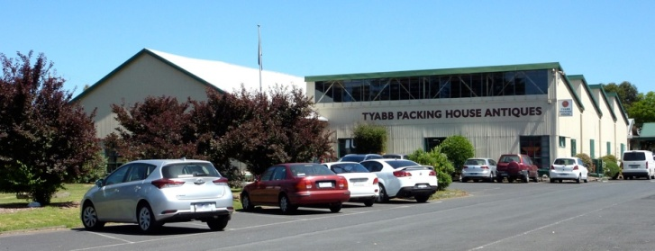
When we leave Tyabb we will travel to Mirboo Nth to visit a private motoring museum. It features a private vehicle collection as well as other locally owned classics and provides a history of transport from the early 1900’s to 2000’s.
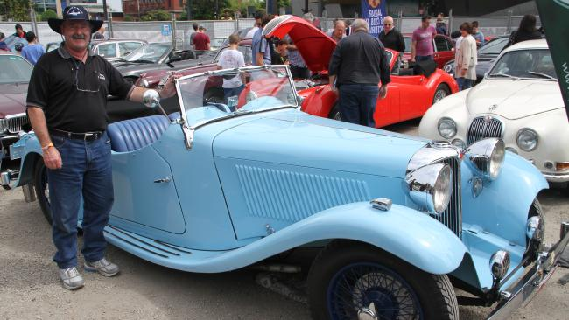

Our accommodation for the Friday night is the Big 4 Holiday Park at Traralgon.

Saturday morning – 9th July. We travel to the old gold mining town of Walhalla. The main street is along the banks of Stringer’s Creek with the homes and business’s built precariously on the sides of the valley. This is an extremely picturesque area, steeped full of history, with a population now of less than 20 residents. You can visit the old gold mine, view the fire station which was built over the creek. See the old Post Office, the Star Hotel and across the road you can climb the stairs to the bandstand. Take a short walk up to one of the most unusual cemeteries which is perched on a steep hillside above the township, and if you are really fit you can climb the track to the famous Walhalla Cricket Ground. We also plan to ride on the Goldfield’s Railway which is narrow gauge, and it takes us along Stringer’s Creek Gorge to the Thomson River Bridge, and then back to the township. We will have lunch in town at the local Hotel or at any of the other eateries, or maybe have a picnic.
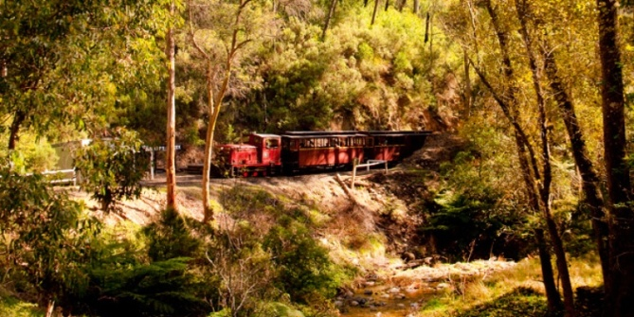
After lunch we will drive to Trafalgar and visit the Holden Museum. They have numerous Holden’s on display, starting from the FX, and even a very rare FJ Station Wagon. There are various other household products and items from saddles to aero engines to pedal cars - all were produced at the Holden workshops and General Motors.
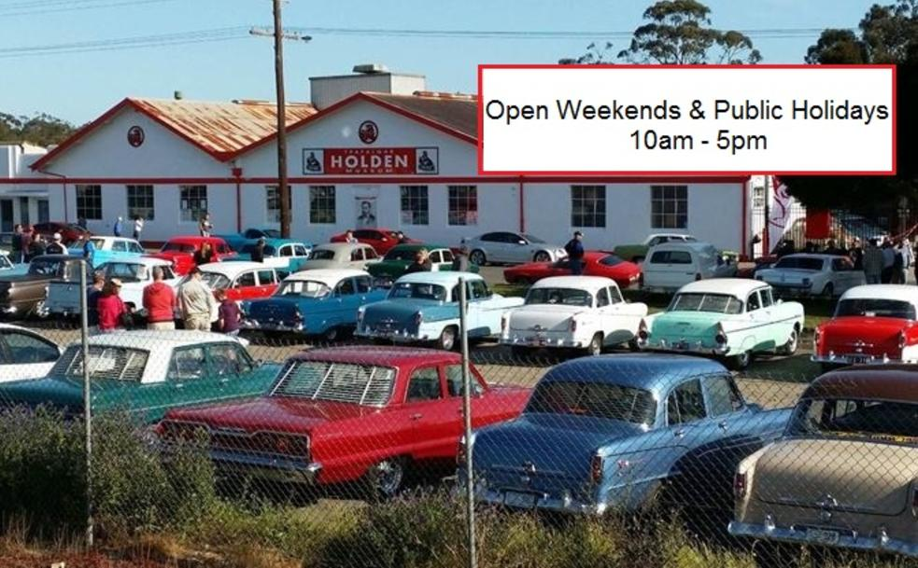
Our accommodation for the Saturday night will be in Heyfield.
Sunday morning – 10th July. We will drive the short distance to the Maffra Shed which is the home of the Gippsland Vehicle Collection. The museum is run by an enthusiastic team of volunteers who are only too willing to share their interest with like-minded people. The display changes 3 times a year and in July they are showcasing ‘barn find’ and ‘un-restored’ vehicles. Morning tea will be available.
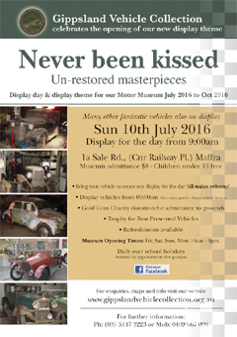
Only 15 minutes down the road we will then visit the ‘Museum of Timeless Memories’ at Sale. On show are Vintage Cars, Tractors, Stationary Motors, Motor Bikes, Farm Machinery, Household Items and ‘Sundries Too Numerous Too Mention’. There should be something interesting there for anyone and everyone. We will organise for a light lunch to be provided, and tea and coffee will be available, during our visit.
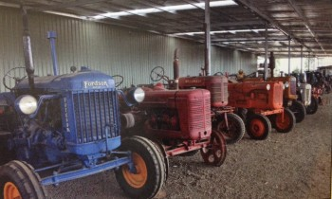
Depending on our time frame, on the way out of Sale, the Gippsland Armed Forces Museum is at the West Sale Airport. You can climb into a Navy Grumman Tracker aircraft, then see how the Australian Light Horseman and his horse were kitted for war, and much more.
While heading home towards Melbourne via the Highway, if you need fuel or food, think about stopping at the Yarragon Village. There are cafés and tea rooms at the far end of the village, and this is possibly the last opportunity to stop before you reach northbound, at Wallan.
We know we have put together a very entertaining schedule for the weekend and encourage you to participate with your fellow car club members, but we do need to know who is joining us, so please contact me as soon as possible. Costs may be altered to accommodate a group discount.
S&SCC Weekend Away – 8th, 9th & 10th July, 2016.
Costs – Friday.
Tyabb Packing House Antiques – Free Entry. Cafe is open for lunch. www.tyabbpackinghouseantiques.com
4 C’s Vehicle Collection – Entry $5 - includes afternoon tea.
Accommodation at Big 4 Holiday Park- Traralgon. Prices for cabins range from $108pn www.big4traralgonparklaneholidaypark.
Friday night dinner – BYO - BBQ at the holiday park.

************************
Costs – Saturday.
Walhalla Goldfield Railway – Entry Adults - $20. Child/U16 - $15. www.walhallagoldfieldrailway.com
Saturday lunch – various prices at cafe, or the Hotel, or picnic.
Trafalgar Holden Museum – Entry Adults - $10. Child U/16 - $2.50. www.trafalgarholdenmuseum.com
Saturday night accommodation at Heyfield Railway Hotel –(Continental Breakfast included) - $140pn
Saturday night dinner – Hotel approx - $20pp? Varied takeaway shops also available.

****************************

Costs – Sunday.
Maffra Shed – Entry and morning tea – Adults $10. Child U/16 – Free.
Timeless Memories – Entry & Lunch $?. www.museumoftimelessmemories.com
Gippsland Armed Forces Museum – Entry Adults - $4. Child U/16 - $1. www.gippslandarmedforcesmuseum.com

