June, 2017 – Newsletter

John Phoenix thanked all the members who attended the General Meeting on Wednesday night. It was one of the biggest meeting attendances we have had and considering how cold the night was, the large attendance was really appreciated. (We may have to light the fire more often.)

Membership Renewals.
Annual Subscription renewal invoices have been posted and emailed out to all members. If you haven’t received your renewal then please contact me and I will rectify the problem immediately. Renewals need to be paid by the beginning of July.
Please remember - If you have a vehicle permitted on the CPS through the S&DCC you need to be financial by the 1st of July, 2017 or your vehicle is deemed to be ‘not permitted’ by Vic Roads and it is illegal to drive it on the road.
We have had a member pay their renewal into our account and they have omitted to list their name in the reference area. If you paid your renewal on the 2nd June, 2017, could you please contact us so we can list you as a current 2017/2018 member.
Past Events
41st Historic Winton Weekend.
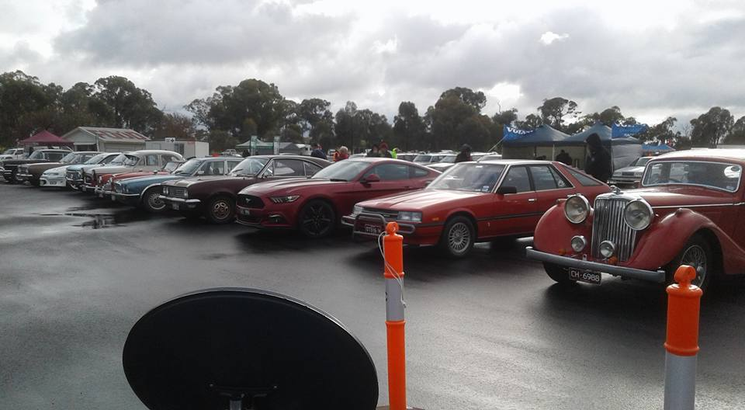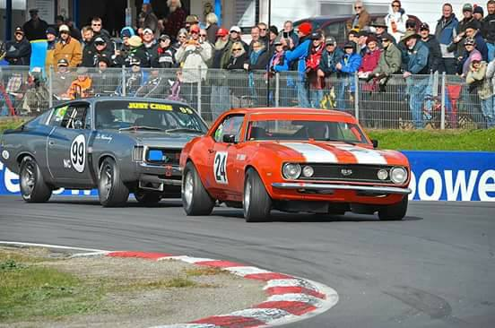
Unfortunately, the Saturday night was a wild and woolly night with rain, hail, thunder and lightning, therefore we had numerous members who chose not to attend or if they did, chose not to bring their classic cars. For those who did attend, Sunday proved to be clear, until about 3 o clock anyway. Quite a lot of very nice classic cars were on display in two separate display areas. The bad weather did nothing to dissuade some very enthusiastic drivers from competing in their cars and on their bikes though. The organisers chose to use the shorter track during the day as they were able to offer more races. Unfortunately the shorter track proves a limitation to the big Historic V8’s and the ‘little’ Mini Minors, really gave them a run for their money.
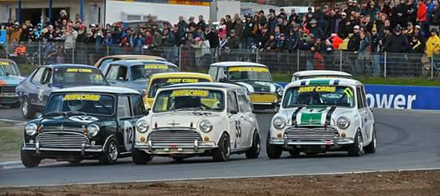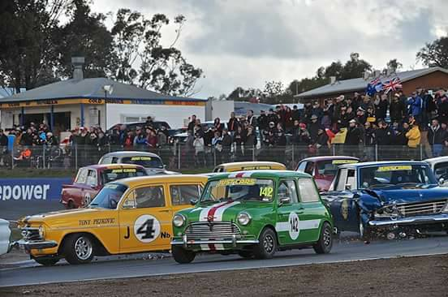

Future Events

Saturday 10th & Sunday 11th June, 2017 – Queens Birthday Weekend.

Don’t forget - The Annual Alexandra Truck and Ute Show.

Saturday, June 24th, 2017. Fox Classic Car Collection at Docklands. 10am to 1pm.

www.foxcollection.org.au.
Come along and join us for a very informative visit. If we have 20 or more members interested then we can have a guided tour of the collection which includes some very interesting vehicles and well worth the visit.
The address is, the corner of Batman’s Hill Drive and Collins Street, Docklands.
If you wish to drive, then Free parking is available for the duration of your visit.
This venue is conveniently located and available by public transport, if required.
(Train to Southern Cross. Exit via Collins Street, then a short walk to Docklands.)
Cost is $12 adult or $10 concession. $5 for children under 12 years.
Please contact me if you are going to join us. We will meet at the venue in Docklands, at 10am.

Sunday 2nd July, 2017 - Tocumwal

We have had an invitation from the Mild to Wild Rod and Custom Club to join them at the Tocumwal Winter Swap Meet and Show & Shine. Tocumwal Footy Ground. Gates open at 7am. $5 Car entry.

Wednesday ? July, 2017 – Guest Speaker – More details to follow.

Saturday 22nd & Sunday 23rd July, 2017 – ‘Travelling the Old Hume 31 Highway.

This weekend should prove to be very enjoyable. A time to relive your memories, travelling along the ‘Old Hume Highway’ and remembering what it was like to drive through the townships that have now been ‘passed by.’ It was a time when having to slow down to 35mph for the towns caused us all to think that we were going so slow that we could all ‘get out and walk.’ I can hear you reminding yourselves, where you stopped to get fuel, or the occasional ‘pie and coke’ at the ‘little cafe’ or ‘service station,’ en route.

Each vehicle participating will receive a route map. We plan to leave the Vietnam Veterans Walk, High Street Seymour, at 9am. We will stop for morning tea and lunch along the route. You can buy supplies along the way or you are welcome to pack a thermos and a picnic basket.
The weather may dictate this decision.

Accommodation will be at the Secura Lifestyle Borderland Big 4 Holiday Park. There are numerous styles of cabins available. Phone Rebecca on 02 6024 3906 and book whatever suits you best.
They have a BBQ area which we can utilize for our BYO evening meal. Breakfast will be BYO as well.

On Sunday morning we may visit the Bandiana Army Museum. This is a very comprehensive museum and well worth a visit. Unfortunately, due to added security at this time, we do need to book our visit to the Museum 30 days prior, so I need to do this by June 23rd. They need to have names and photo id, so if you are wanting to join us for the weekend, then please contact me so we can arrange all the documentation.

On our way home, if time permits, we will stop in Yackandandah and Beechworth. Both these towns are quirky and very interesting.

Check your calendars now - Don’t miss out – Hopefully the weather ‘north’ will be kind to us and we can have an enjoyable trip.

Sunday ? August, 2017. Our visit to the Noorilum Historic Home at Murchison will have to postponed as they have closed over Winter, but we still may be able to take a river trip on the Goulburn. More details to come.

Sunday 17th September, 2017 – Nagambie Cranksters.

Saturday 23rd & Sunday 24th September, 2017 – Wangaratta.

We received an invitation from the Vintage & Veteran Car Club of Wangaratta asking if any of our members wish to join them on their 47th Annual Spring Rally.

Highlights of the Rally will include meals at the Historic Vine Hotel. Viewing an impressive collection of Early Model Holden’s and a visit to Winton Motor Raceway, with a lap of Honour around the track.

These weekends have proved very popular in the past with approximately 100 cars involved.
Entries close on the 1st September, 2017. Contact me and I can provide you with all the details.

Sunday 1st October, 2017 – Euroa Show and Shine.

Wednesday 1st November, 2017 - will now be our Monthly Meeting, as well as our Annual General Meeting.

Sunday 24th November, 2017 – EJ/EH Holden Nationals at Shepparton.

Sunday, 3rd December, 2017. - Christmas Party at the Clubrooms.

Next Meeting.

The next meeting of the S&DCC is a Committee Meeting, to be held on Wednesday 5th July, 2017 at 7.30pm, in the clubrooms, lower end of Howe Street, behind the tennis courts. All members are welcome to attend. Tea and Coffee will be available.

Safe Motoring - Judi McGrath - Secretary – 0407 562003.

*******************
An elderly Irishman bought a sports car to recapture his youth and drove at 120mph. Then he saw a police car behind him, blue lights flashing.
“I’m too old for this nonsense,” he thought, so he pulled over.
The police officer said “Sir, my shift ends in 10 minutes. If you can give me a good reason why you were speeding, I’ll let you go.”
The old man said “Years ago my wife ran off with a policeman. I thought you were bringing her back.”
“That’ll do.” said the policeman.

