June 2018 – Newsletter

Club Membership Renewals

In the next few weeks all members will receive their annual membership renewals.
The cost is $40.00 and payment details will be included on the invoice.
Please be aware that your renewal is due by 1st July, especially if you have a vehicle permitted on the Club Permit Scheme. If you do not pay your renewal by this date then your vehicle is classified as ‘not permitted’ and it is illegal for you to drive the vehicle on the roads.
Please contact us if you do not receive your invoice by the end of June.

Vic Roads
We have been advised to remind members to be very careful and make sure you have received your renewal forms for your vehicles whether they are fully registered or on the Club Permit Scheme.
Also, be aware when your renewals are due, as the onus is on you, and it is your responsibility. Vic Roads do not accept responsibility if you do not receive your renewal.
Past Events

Historic Winton - May, 2018.
Some members participated during the weekend and it was a very well attended event. The weather was perfect. Terry Dawson reported on the varied vehicles that were on display as well as the vehicles and bikes competing on the track. The cavalcade of historic vehicles during the lunch break was quite a spectacle and it was stated that it was well worth attending this event and a must for next year.

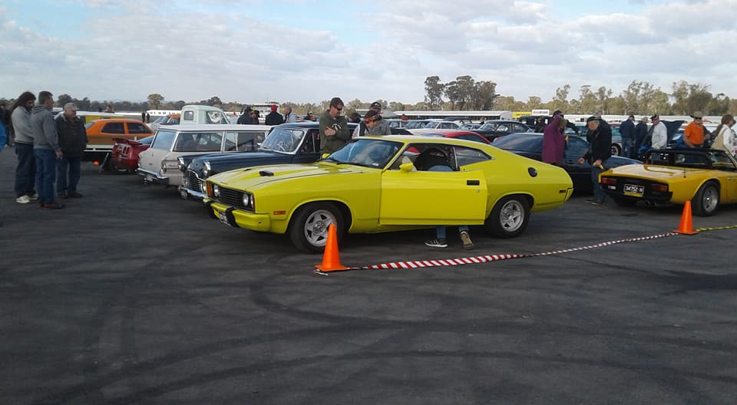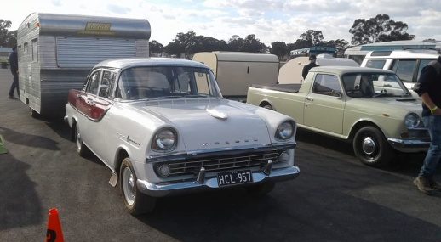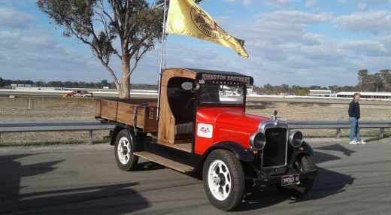
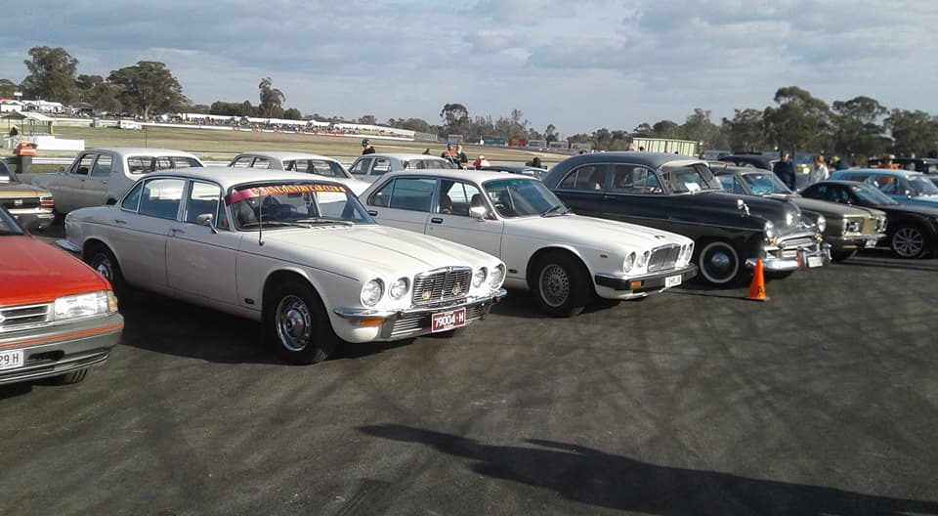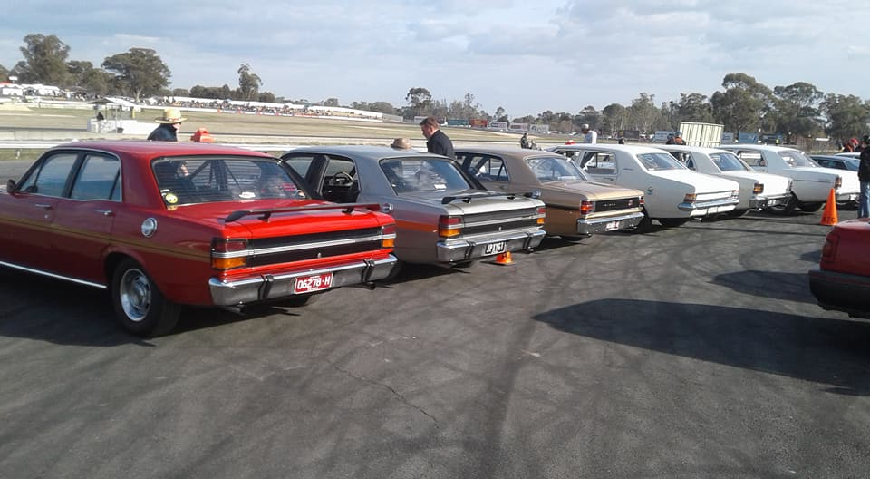
National Heritage Motoring Day at Kilmore Racecourse – May 2018.
The weather wasn’t pleasant which may have affected the number of people attending, although we did have some very hardy members venture out for the day.

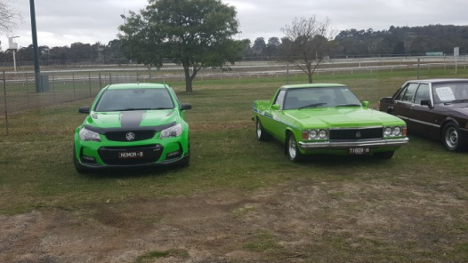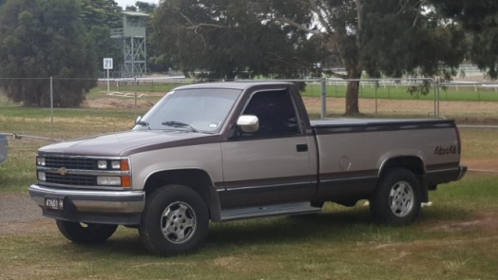
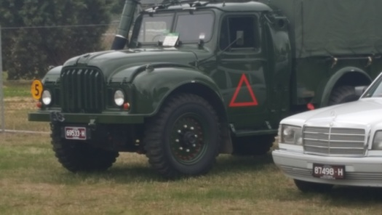

Future Events
June - Guest Speakers.

Sunday 24th June, 2018 has been organised for our next event where John Phoenix and Michael Street have kindly volunteered to be our Guest Speakers.
John Blackwell will also display the Centurian Tank he has been helping to restore.
We will meet in the car park at the main gate at Puckapunyal at 10am.
Lunch will be provided. Please advise us of any dietary requirements.

As both John has served, and Michael is now serving in the same unit, it will be very interesting to hear the differences that have occurred during the ensuing years.
This tour/presentation will be held at the museum at Puckapunyal. As it will be held in a military area we therefore need to have all members details listed and submitted to the base, prior to the visit.
This information is needed by Sunday 17th June, so if you want to join us for the day, please fill in the following information for every person attending, as soon as possible.
Name,
Contact phone number,
Vehicle registration,
Driver’s licence number.
Photo ID.
Any underage family members also need to have their names and ages listed.
Annual Club Run – Weekend Away – 25th & 26th August, 2018
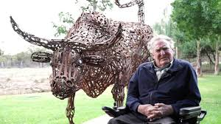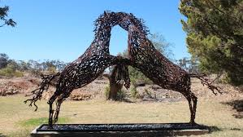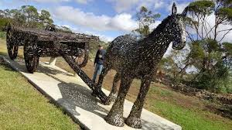

Our weekend away will have to be postponed until the end of August as we have been advised the ‘Spannerman’ is closed during July.

This display is well worth a visit as you cannot possibly understand how spectacular these sculptures are until you stand beside one.

At this stage we will make arrangements for Saturday the 25th and Sunday the 26th of August, staying at a motel in St.Arnaud on the Saturday night.
If you want to join us then please register your interest so we can make arrangements.
Next Meeting.
The next meeting of the S&DCC will be a Committee Meeting, to be held on Wednesday 4th July, 2018 at 7.30pm, at the Clubrooms, at the end of Howe Street, Seymour, behind the tennis courts. Tea and coffee will be available.
Happy Motoring.
Judi McGrath – Secretary.
---------------------------------
A cabbie picks up a nun.
The nun gets into the cab, and notices that the VERY handsome cab driver won’t stop staring at her.
The nun asks him why he is staring.
He replies: “I have a question to ask, but I don’t want to offend you.”
The nun answers, “My son, you cannot offend me. When you’re as old as I am and have been a nun as long as I have, you get a chance to see and hear just about everything. I’m sure that there’s nothing you could
say or ask that I would find offensive.”
“Well, I’ve always had a fantasy - to have a nun kiss me.”
The nun responds, “Well, let’s see what we can do about that.
One, you have to be single, and two, you must be Catholic.”
The cab driver is very excited and says, “Yes, I’m single and Catholic!”
“OK” the nun says. “Pull into the next alley.”
The nun full-fills his fantasy with a kiss that would make a hooker blush, but when they get back on the road, the cab driver starts crying.
“My dear child,” said the nun, “why are you crying?”
“Forgive me, but I’ve sinned. I lied and I must confess, I’m married and I’m Jewish.”
The nun says, “That’s OK. My name is Kevin and I’m going to a fancy dress party!”

(from Murray).

