**March, 2017 – Newsletter**

John Phoenix would like to take this opportunity to thank everyone who attended the ‘Working B’ last Sunday (26th February). Most jobs were completed and we were able to socialize afterwards while having lunch, supplied by the club.

**T/Shirt & Winter Jackets.**

T/shirts at $55.00. Winter Jackets at $110.00. Caps at $25.00.

Please contact me if you would like to order any of these products. We do have some sizes in stock,

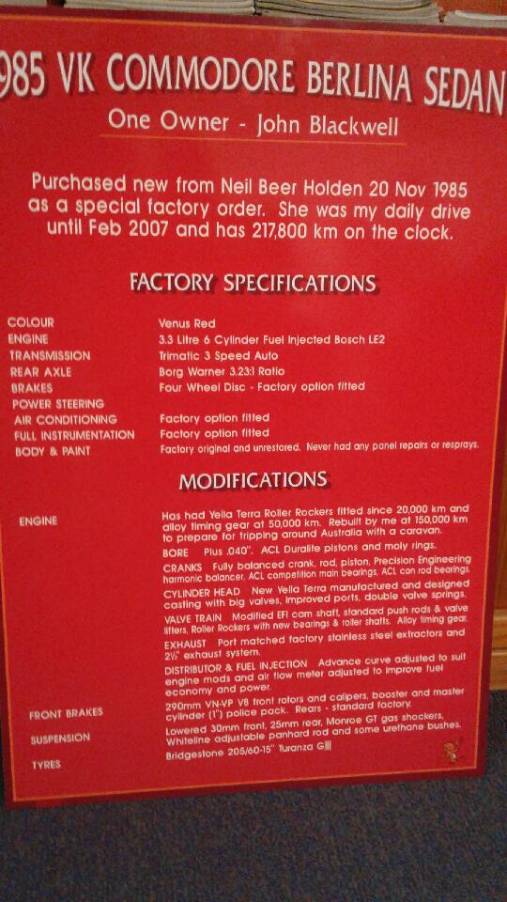**Vehicle Information Boards.**

John Blackwell brought along the information board he has and uses when he displays his vehicle at a show or event.

The information on the board can be as descriptive and involved as an owner wants. It can be invaluable as a means of showcasing interesting facts about the vehicle. John’s board is of a composite material with a vinyl laminate, and was provided by Burgess Signs. Depending on content, these boards can be purchased for approx $120.00.

**Past Events**

Hanging Rock Car Show – February.

No contact was received from any members who wanted to attend this event.

The weather prior to the weekend was very hot, which could have influenced whether to attend or not.

Special Guest Speaker – John Blackwell – February.

About 20 members attended the evening at the Vietnam Veterans Walk where John spoke on the Centurion Tank on display, as well as the Centurion Tank he is helping to restore at Puckapunyal. This particular tank is complete but needs to have the engine etc, restored. John’s talk on the hardships they have had to endure in sourcing the engine and all the components that were needed, was very informative and the members present thanked him for this contribution.

**Future Events – 2017**

Saturday 11th March, 2017 – ‘Travelling the Old Hume 31 Highway.



Two members made the trip to Wodonga last week to finalise the details for this trip.

After consultation, it was decided to postpone the trip at this time, as obtaining accommodation in Wodonga for the Saturday night, over a long weekend, was virtually impossible.

It is also potentially a long day, to call into each town along the route, as well as visit Yackandandah and Beechworth, so it would be best to use both the Saturday and Sunday, to visit all these places.

Most replies the Secretary received, showed the Labour Day Long Weekend to be very busy for a lot of members, who could maybe commit to one day, but not to the whole weekend.

Therefore, the trip along the Old Hume will be postponed to another weekend, during the year.

Sunday 12th March, 2017 – All GM Day at Apex Park in Wangaratta.

Even though the trip to Wodonga on the Saturday has been postponed some members have shown an interest in attending the All GM Day in Wangaratta on the Sunday.

It is free entry and should be interesting and well worth attending.

We will meet at Seymour Industrial car park in Emily Street at 8am and proceed to Wangaratta.

Vehicles will be on show in the order of their arrival so please let me know asap if you are joining us for the day.

If you are interested in entering your FE or FC in the competition for the State Titles then please let me know and I can forward to you the entrant details, or provide you with further details.

Sunday 12th March, 2017 – Yarra Glen Swap Meet – Armstrong Avenue, Yarra Glen.

Show and Shine vehicle entry is between 8am and 10am. Cost $15.00 per vehicle (2 occupants). Public entry from 8am. Cost $8.00. Children free.

Sunday 19th March, 2017 – 7th Annual Yea Bushrodders Picnic. Racecourse Reserve, Yea.

The S&DCC have attached the required addition to the Perpetual Trophy, and it has been returned to the Yea Bushrodders so they can present it to the winning car club in 2017. Members from Seymour will meet at the IGA car park, Anzac Avenue, Seymour at 8.30am to travel to the event together. This is also a great day out with lots of entertainment for the whole family. If you wish to attend then please let me know so we can be sure to wait for you. If anyone is coming from another direction then contact me as well, and I can arrange another meeting point, somewhere on route.

Sunday 30th April, 2017 – Marysville Motoring Expo.

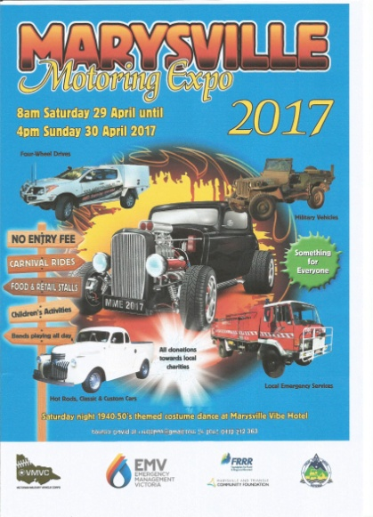

We received an invitation to attend this expo in Marysville to help the town which is still recovering from the disastrous fires that affected it in 2009.

The Expo is a weekend event but the members present at the meeting thought that we could just attend on the Sunday.

It will be a family event with activities for everyone.

**Saturday & Sunday – 27th & 28th May, 2017 – 41st Historic Winton Weekend.**

We have applied to have 20 tickets available for members who wish to attend this event and showcase their vehicles. Members can participate for one day or the whole weekend. It is your choice. Camping is available at the track, or Motel and cabin accommodation is available in Benalla.

This has been known to be a great weekend in the past and with the resurgence of the Touring Car Masters racing vehicles, there will be something interesting to entertain everyone.

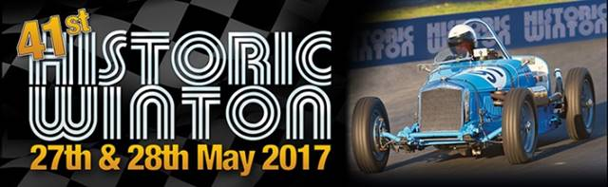

Sunday 21st May, 2017 – Cavalcade of Transport – National Motoring Heritage Day.

Bellarine Estate, 2270 Portarlington Road, Bellarine.

Gates open at 10am for display vehicles – 10.30am for spectators. Entry is by gold coin donation.

Restaurant meals available: Food vans, BBQ’s: Cellar Door Wine/Beer Tastings:

Live Music – Kids Entertainment.

Free bus to the Drysdale Community Market, Drysdale Steam Train.

Sunday 17th September, 2017 – Nagambie Cranksters.

Sunday 1st October, 2017 – Euroa Show and Shine.

Safe Motoring

Judi McGrath

Secretary – 0407 562003.

**************************

Liam had left Dublin to go up to Belfast for a bit of skydiving. Late on the Sunday evening he was found in a tree by a farmer.

“What happened?” asked the farmer.

Liam replied “The parachute failed to open.”

“Well,” said the farmer, “If you had of asked the locals before you jumped, they would have told you nothing opens here on a Sunday.”