March 2018 – Newsletter

Welfare Report.
Janine Hubbard advised us that Colin has had a hospital visit. Also, Fiona Paine has advised us that Darren is in hospital as well. On behalf of the S&DCC we have sent them our best wishes and hope that all procedures went well and they will be up and around again very soon,
CPS Vehicle Photographs.
The S&DCC have been in touch with members who have vehicles permitted through the CPS, who still need to have the obligatory photographs of their vehicles added to our data base.
These photographs are required as per our obligations with Vic Roads.
Over the past week we have emailed these members and caught up with some, but there are still a few that need to contact us, so we can arrange a favourable time to have these photographs taken.
Please remember, it is a privilege to be able to use our classic vehicles on a system that is a less expensive option so we therefore need to abide by the rules that are in place.
Past Events

Hanging Rock Vehicle Display at Mt Macedon in February.

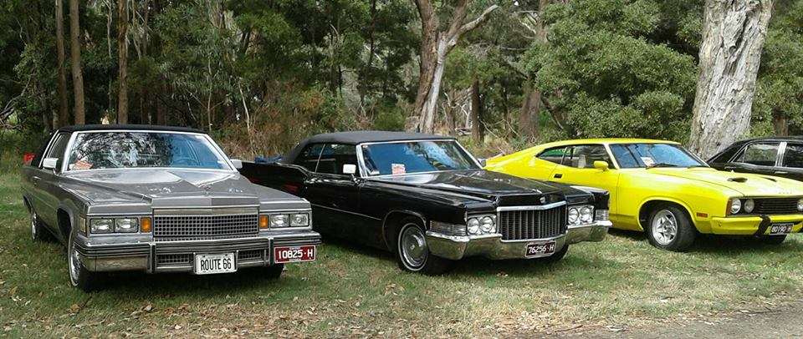

As always, the attendance from the public at this event is magnificent. Lots of lovely well maintained vehicles ranging from motor bikes, classic cars, hot rods, chrome bumpers to trucks and buses.
There was something of interest for everyone.

Spirit of the Hume Truck Show in Broadford in February.

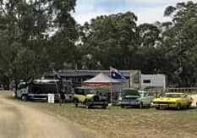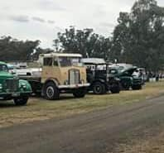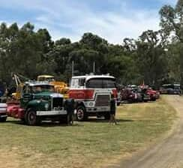

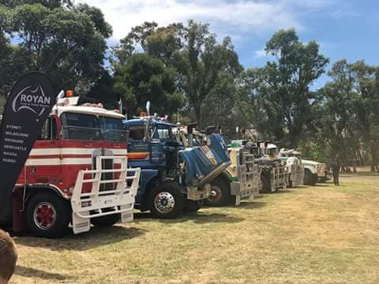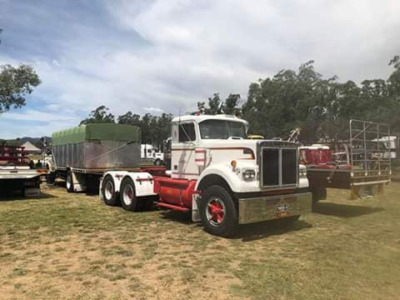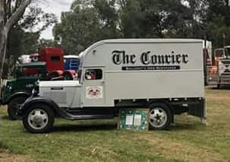

The S&DCC Committee wish to thank everyone who attended the 2nd Annual Spirit of the Hume Truck Show held in Broadford. The support provided by the club members was most appreciated and knowing everyone’s time is valuable, we were thanked for making the effort to display our vehicles.
It was an enjoyable and successful weekend and will be on again in 2019.
Yarra Glen Swap Meet, All GM Day at Wangaratta and the Seymour Lions Bush Market.
Run reports and photographs for these events will appear in the April Newsletter.
Future Events
Saturday 31st March, 2018 – Easter Sunday – Heritage Train Tour to Echuca or Bendigo.

A S&DCC member has brought to our attention this Heritage Train Tour.
It is a special vintage diesel haul heritage train tour to Echuca or Bendigo, to enjoy a family day out at Bendigo’s Easter Festival travelling the freight only tracks. The magnificent 111 year old Yarra Carriage will also be on your train with a viewing platform and original Spirit of Progress Dining and Parlour Carriages. Phone Bookings – 0412 124 659. Limited seats available.

Sunday 15th April, 2018 – Lancefield Show, Shine and Swap Meet.

This event is hosted by the Lancefield Football and Netball Clubs. We have attended this event in the past and it has proved to be an enjoyable social day. Entry is $6. Canteen facilities will be available.
You can travel over individually or we can meet in Lancefield, and enter the ground as a group.
More details in the April Newsletter.

Historic Winton Saturday 26th & Sunday 27th May, 2018.
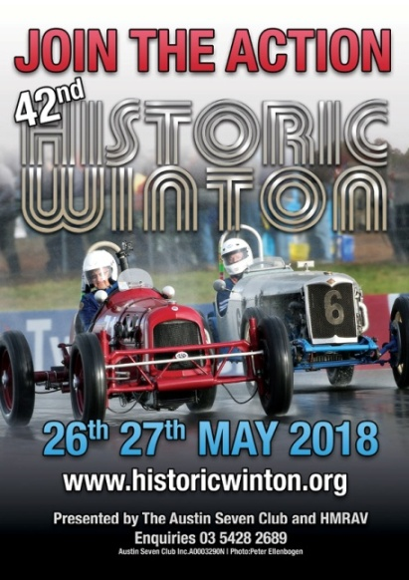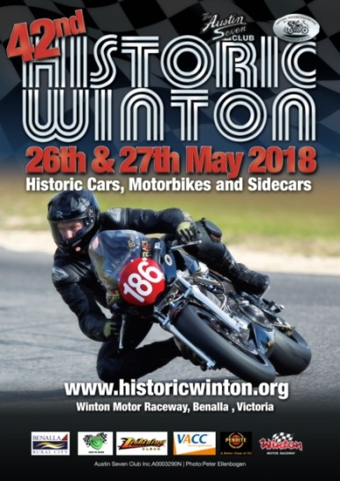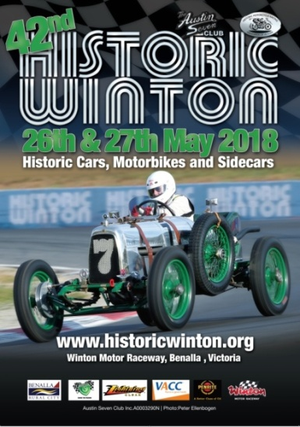
Complimentary tickets may be available for any members who have a vehicle they wish to display. (Is 2018 an anniversary year for a vehicle you own?)
If you wish to stay the whole weekend there is accommodation available in Benalla, or there are camping facilities at the track.
Next Meeting. The next meeting will be a Committee Meeting, to be held in the clubrooms. Lower end of Howe Street, Seymour, behind the tennis courts, on Wednesday 4th April, 2018 at 7.30pm. All members are welcome to attend. Tea and coffee will be available.
Safe Motoring - Judi McGrath - Secretary – 0407 562003.

**********************
No dictionary has ever been able to define the difference between ‘complete’ and ‘finished.’
However, during a recent linguistic conference, held in London, a linguist was asked to make that very distinction.
The question by a colleague in the audience was this:
‘Some say there is no difference between ‘complete’ and ‘finished.’ Please explain the difference in a way that is easy to understand.”
The linguist’s response was:
“When you marry the right woman, you are ‘complete.’
‘If you marry the wrong woman, you are ‘finished.’
‘And, if the right one catches you with the wrong one, you are ‘completely finished.’

