May 2016 – Newsletter

Recent Events
Sunday - 10th April, 2016.

Our run this month was to the Castlemaine Rod Shop and Rod Hadfield’s private motoring collection. It was a great success with about 12 cars and 30 members participating. Members met at Seymour then travelled through Kilmore to the rod shop in Castlemaine where we were welcomed by Mark Waddington, one of the owners. He explained the history of the vehicles on display as well as some of the components that are made there.

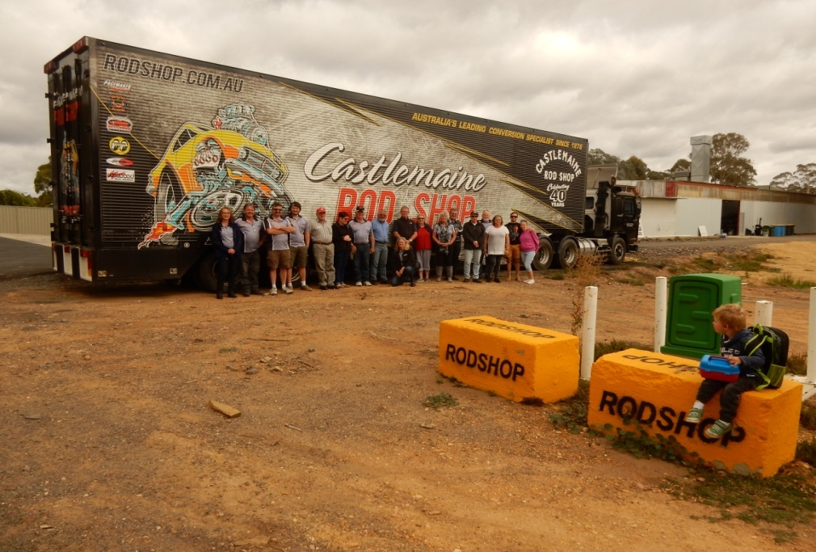

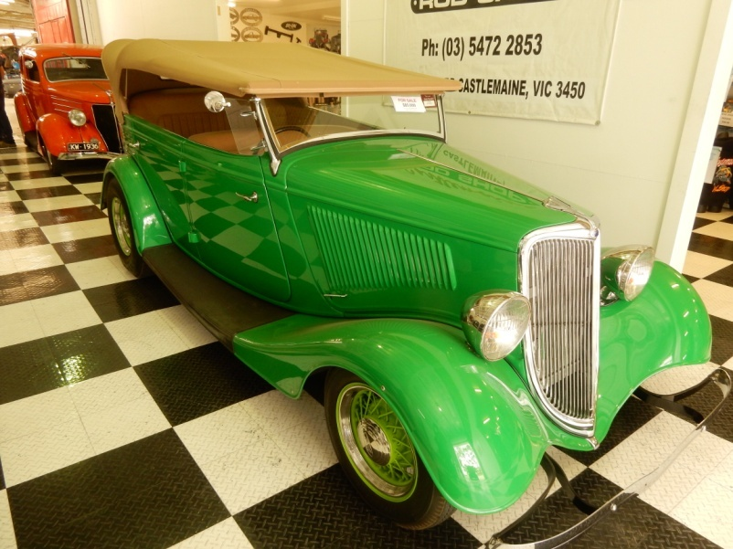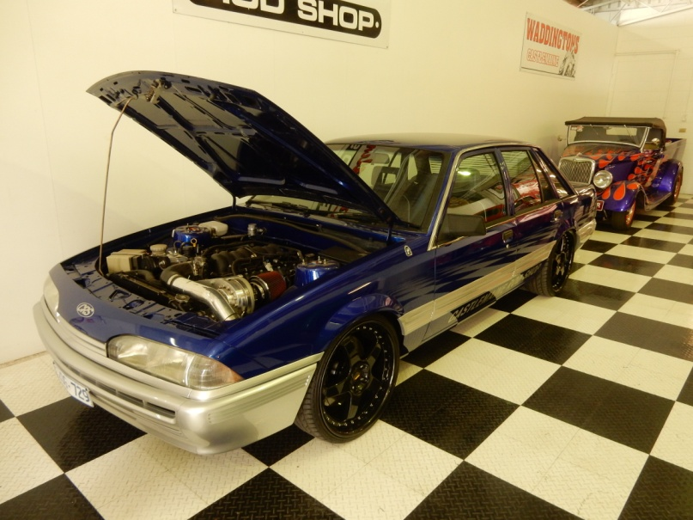

After our picnic lunch in the park, the members then drove onto Rod Hadfield’s Private Motoring Collection. Again there were quite a few remarkable vehicles on display – some in different stages of assembly, like this ‘slightly modified’ Fiat Topollino, while others were vehicles Rod has owned for some time.

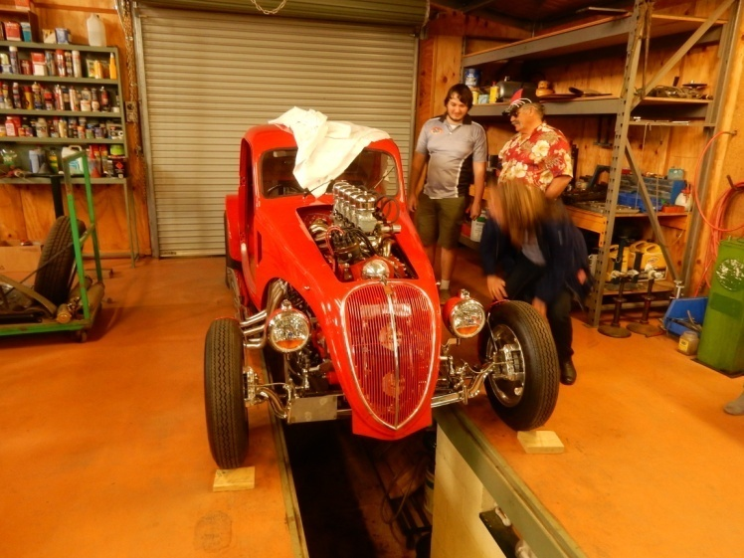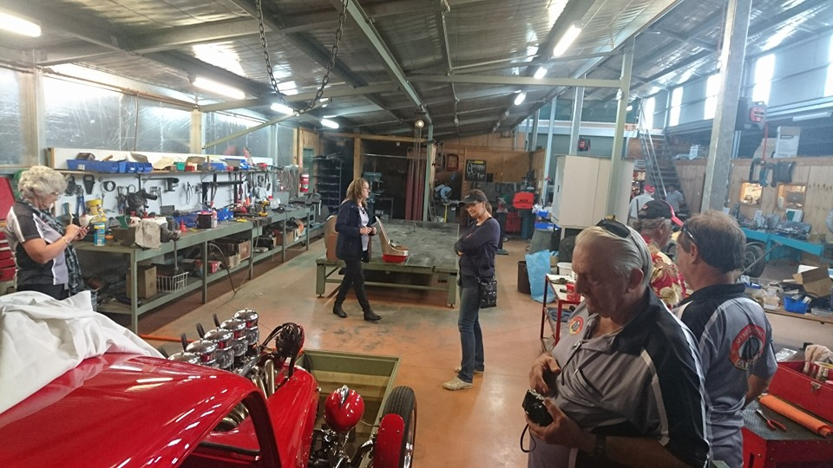

Saturday - 30th April, 2016. - Working ‘B’ at the clubrooms.
About a dozen members attended the Working B. Thank you to all the members who helped out on the day. Numerous jobs were completed to make the clubrooms more weather protected as well as fence maintenance and making the 2 sheds more secure. All the members present enjoyed the each other’s company while eating lunch, provided by the club.
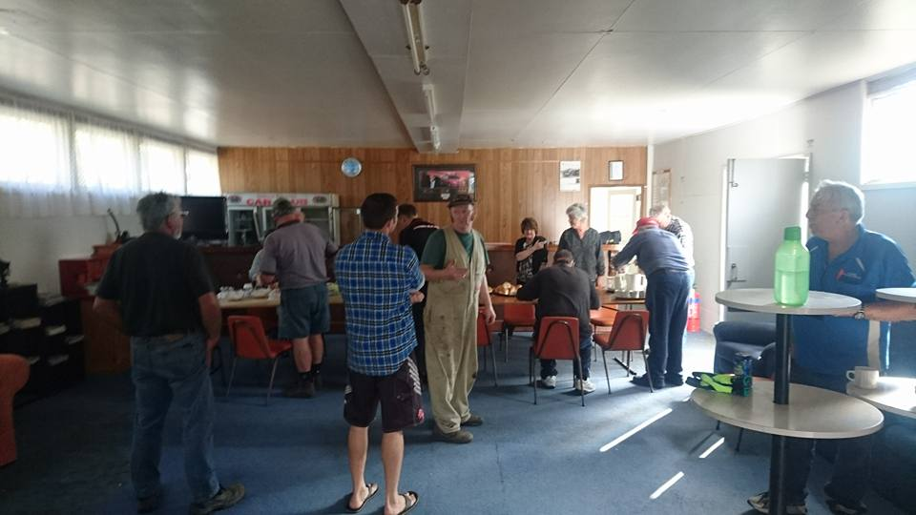

Future Events
Sunday – 15th May, 2016. - Smith’s of Kyneton. *******This coming weekend.******** Our May run will be to Ivan and June Smith’s private motoring collection in Kyneton. This collection is very comprehensive consisting of trucks, tractors, cars and memorabilia, and is not always open to the public. We did have the opportunity to view this collection back in 2014 but there were a few members who were unable to attend at that time, and the suggestion was to organise another visit. As Ivan was the local Chrysler dealer in Kyneton for many years, he has a collection of Valiant’s on display, including the first and last cars manufactured. Our visit is scheduled to start at 11.00am, so we are asking members to meet in the car park, on the corner of Mollison Street and Mollison Place, Kyneton, (north end of the main street, just before the on ramp to the freeway) by 10.45am. Morning tea will be provided at $5.00 per person, which also includes admission. We will have lunch in Kyneton. Please contact me by email, phone or text, if you want to join us for the day. Do not miss this opportunity.
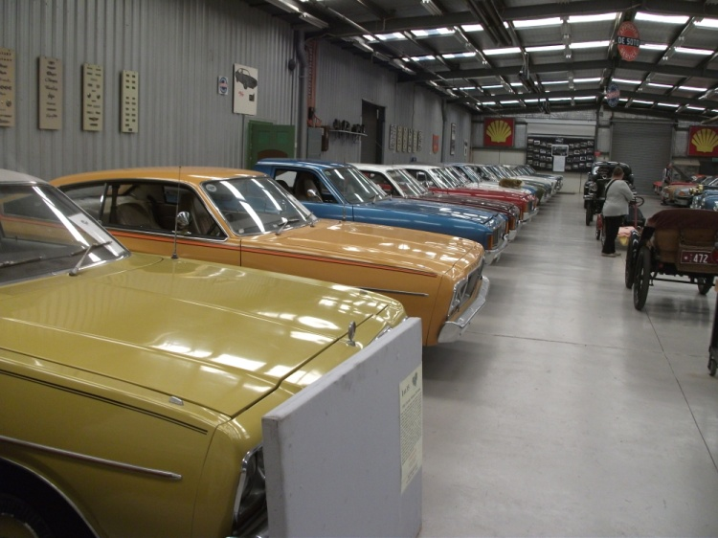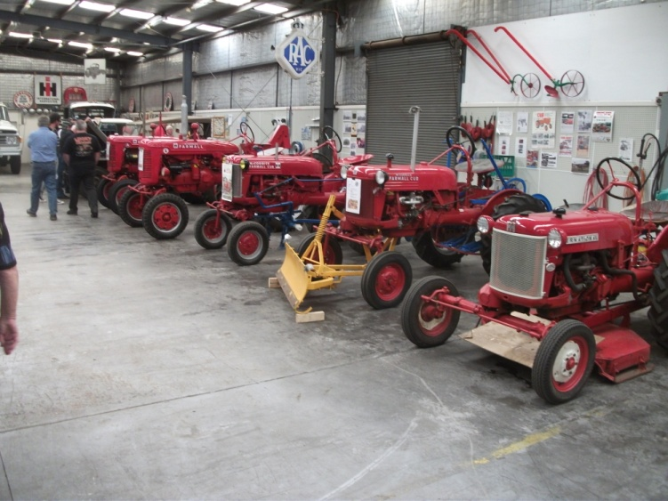

Queen’s Birthday Weekend – Sunday 12th June, 2016.
Our June run is to the Shepparton Motor Museum and then onto the Shepparton Go-Kart Complex.
The museum is focusing on the ‘Legends of Bathurst’ so plenty of Holden’s and Ford’s on display
Saturday is a ticketed day and all tickets have been sold, but the Sunday is open to the general public and there will be some of the famous driver’s of the era there to sign autographs. It is expected to be a very busy weekend but there is plenty of parking at the rear of the museum.
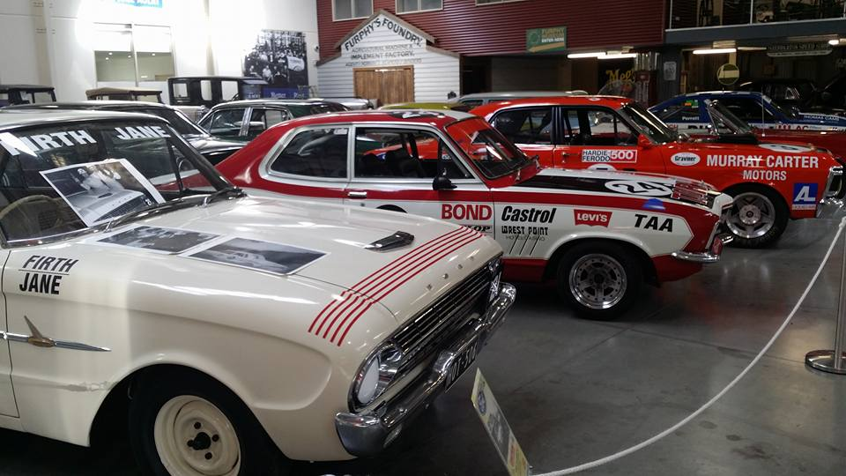
Early July 2016 – Weekend Away.- Dates to be confirmed.
We are currently trying to organise a weekend away in Gippsland. There has been a large focus on the display at the Trafalgar Holden Museum recently, and the Maffra Shed also has a collection of vehicles that are remarkable to the area. We are planning to run a 3 day, 2 night trip but do understand that not all members are available to do the whole time so, with this in mind, we are looking at viewing a collection each day and then if members are only able to join us for a specific day, then they will be most welcome. More details will be available at the next meeting.

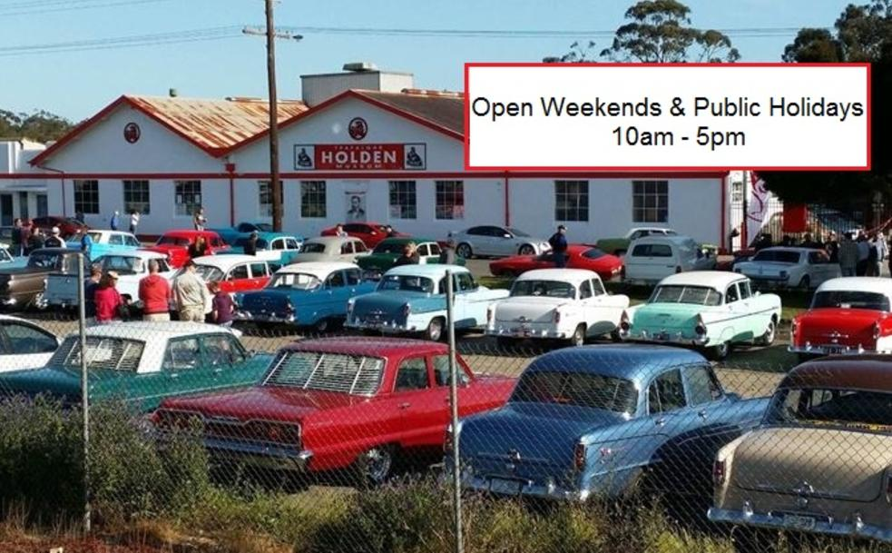

CPS Handbooks
The updated Club Permit Scheme Handbooks are now available from the AOMC. The S&DCC are obtaining bulk copies so if members with a car on the CPS would like a copy, they will be available from the clubrooms.

Next Meeting – The next meeting of the S&DCC is a Committee Meeting to be held on Wednesday, 1st June, 2016, at 7.30pm at the clubrooms, lower end of Howe Street Seymour, behind the tennis Courts.
All members are welcome to attend. Tea and coffee available.
Safe Motoring
Judi McGrath - Secretary – 0407 562003.
************************
Three sisters aged 92, 94 and 96, live in a house together.
One night the 96year old runs a bath. She puts her foot in and pauses, then she yells to the other sisters, “Was I getting in or out of the bath?”

The 94year old yells back, “I don’t know. I’ll come up and see.”
She starts up the stairs and pauses, “Was I going up the stairs or down?”

The 92year old is sitting at the kitchen table having tea, listening to her sisters.
She shakes her head and says “I really hope I never get that forgetful, knock on wood.”
Then she yells, I’ll come up and help both of you as soon as I see who’s at the door.”

