**May, 2017 – Newsletter**

**Past Events**

**Guest Speaker - Wed 19th April, 2017 – Tim Sheather**.

We thank Tim very much as this was an extremely interesting talk, given to approximately 30 car club members. Tim’s experience in the racing car industry gave us all a first-hand look at the way racing cars are managed so as to get the best possibly result on a race day. The ‘behind the scenes’ knowledge and the video presentations were excellent.

Afterwards, the car club members were able to socialize and then enjoyed a pizza supper.

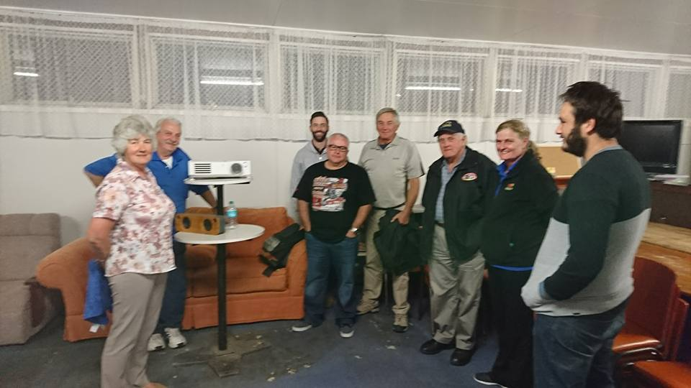 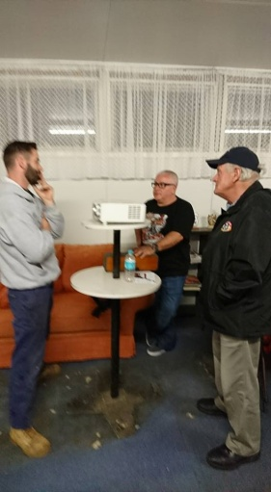

Marysville Motoring Expo. – Sunday 30th April, 2017. Unfortunately only a small contingent of members were able to participate on the day. The members who did attend were very impressed and mentioned, if it is to be held again next year, we should plan to include it on our events calender. Marysville is still recovering from the horrendous experience the residents endured during the 2009 fires which devastated the area. The local Museum has a photographic display as well as many relics which can be viewed and as our members reported, made for an extremely sobering experience.

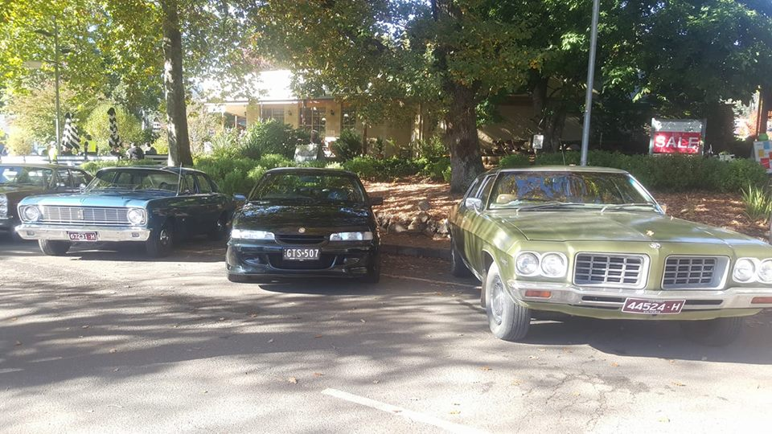 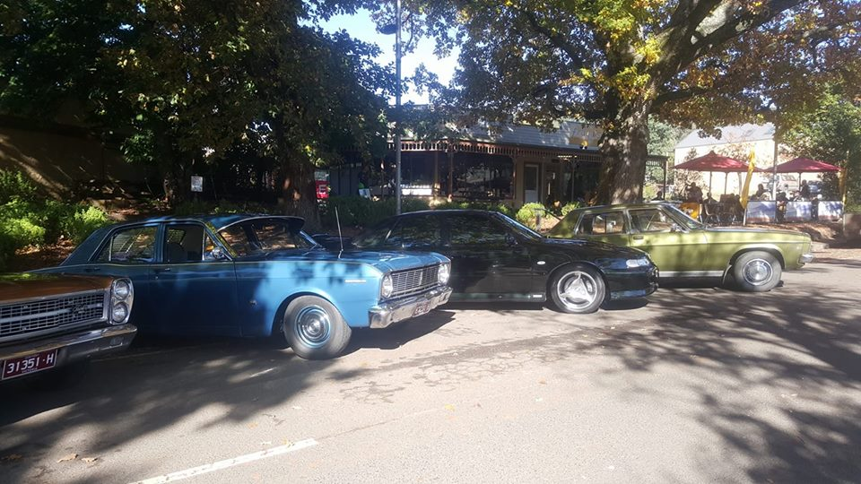

**Future Events**

**Saturday & Sunday – 27th & 28th May, 2017 – 41st Historic Winton Weekend.**

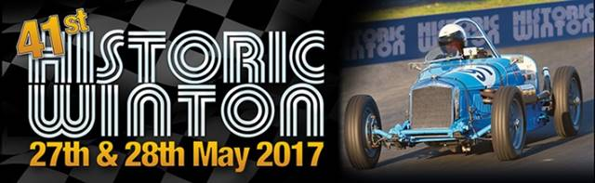

This weekend should prove to be a very entertaining event. It is always a good experience to go to Winton when all the Historic cars are racing. We have ordered some free tickets from the organisers and these will be given to any S&DCC members who choose to display their vehicles at some stage over the weekend.

If you are participating and displaying your car at this event, please contact me.

**June, 2017 – Fox Classic Car Collection. Docklands.** – More details to come.

**Saturday 22nd & Sunday 23rd July, 2017 – ‘Travelling the Old Hume 31 Highway.’**

Come and join us for this weekend. We plan a relaxing drive along the ‘Old Hume’ travelling through all the towns that have been bypassed over the years. If time permits, we will also visit Beechworth and Yackandandah. Accommodation on the Saturday night will be at a caravan park in Wodonga (to be advised), where we can socialize while having a BBQ tea. On Sunday morning we hope to visit the Bonegilla Migrant Experience and/or the Bandiana Military Museum, before heading back home down the ‘new’ freeway.

Again, we need you to contact me please, if you will be joining us.

**August, 2017. – Noorilum Homestead and Goulburn River Cruise.**

**Sunday, 17th September, 2017 – Nagambie Cranksters**.

**Sunday, 1st October, 2017 – Euroa Show and Shine.**

**Wednesday, 11th October, 2017 – S&DCC Annual General Meeting. *(2nd Wednesday in October.)\***

**November, 2017 – Kerrisdale Mountain Railway and lunch at Trawool Valley Resort.**

**Sunday 24th November, 2017 – EJ/EH Holden Nationals in Shepparton.**

**Winton Fun Days.**

We received an email from a car club member who advised us that Winton hosts a number of ‘Fun Days’ throughout the year. These events are a casual track day – no timed laps, no demolition derby style driving, and no pressure on drivers to go outside of their capabilities.

2017 Fund Day Dates are September 7th and December 9th.

A flyer from Winton reads :–

‘Come along and experience a Fun Day at Winton Raceway. Our Fun Days give you the chance to drive your own vehicle around the ‘Nation’s Action Track’ for a small fee of just $65 for the day per driver and $50 per passenger. One of the highlights for the day is allowing drivers to take passengers out on the track, making it an awesome experience to share with your family and friends.

Fund day Rules – Gates open at 8am with scrutineering commencing at 8.15am and a compulsory driver’s briefing held at 10am. The activities will then commence on the track, immediately after the driver’s briefing.

Speed Restriction – All drivers will be limited to 80% of the potential of both the car and the driver. This is not a race. There will be large differences between the speed of each vehicle so be careful. Anyone exceeding the 80% rule or overdriving will be flagged off the track and warned. A second offence will mean that it is home-time for you.

Scrutineering – All cars must have a safety check and receive an ‘OK’ sticker before going onto the circuit for the first time. Vehicles must be roadworthy or race worthy. Please remove spare wheels, jacks and all loose items before taking the car to have a safety check.

Sessions – Activities will be conducted in sessions of 20 minutes, Driver only, followed by 20 minute session for driver and passenger. Sessions maybe shorter than 20 minutes, depending on track problems with cars etc.

Noise – All vehicles must have an effective muffler fitter to the vehicles exhaust system in a manner which will reduce the engine noise. Maximum noise level permitted is 90dBA.

Carports and lockable Garages – Carports are also available to hire before the event for a cost of $20.

Contact the Winton raceway office on (03) 5760 7100 to reserve a spot. Lockable garages are also available to hire for a cost of $50.’

**General Business.**

**Annual Subscriptions.**

The Seymour and District Car Club’s annual subscriptions are due by the **1st July, 2017**, and you will then have **14 days** to pay your subscription. The annual subscription is $40 per year. Invoices will be emailed and posted out to all members by the beginning of June. If your subscription is not paid by that date, your membership becomes ‘lapsed’ and you will have to re-apply.

**Please Remember.** If you have a vehicle permitted on club plates with the S&DCC, you must be a financial member by **1st July, 2017** or your vehicle is classified as ‘non-permitted’ by Vic Roads, and it is illegal for it to be driven on the road.

**Old Photographs**.

Does any car club member, or their families, have any old photographs of old motoring establishments in Seymour? Please contact us if you can help.

**Next Meeting.**

The next meeting of the S&DCC is a General Meeting, to be held on Wednesday 7th June, 2017 at 7.30pm, in the clubrooms, lower end of Howe Street, behind the tennis courts. All members are welcome to attend. Tea and Coffee will be available.

Safe Motoring

Judi McGrath - Secretary – 0407 562003.

*******************

After the British Beer Festival in London, all the brewery directors decided to go out for a beer.

The man from Corona sits down and says, “Hey Senor, I would like the world’s best beer, a Corona.” The bartender dusts off a bottle from the shelf and gives it to him.

The man from Budweiser says, ‘’I’d like the best beer in the world, give me ‘The King of Beers’, a Budweiser.” The bartender gives him one.

The man from Coors says, “I’d like the only beer made with Rocky Mountain spring water, give me a Coors.” The bartender gives him one.

The man from Guinness sits down and says, “Give me a Coke.”

The bartender is a little taken aback, but gives him what he ordered.

The other brewery directors look over at him and ask, “Why aren’t you drinking a Guinness?”

The Guinness Director replies, “Well, I figured if you fellows aren’t drinking beer, neither would I.”