May 2018 – Newsletter
CPS Vehicle Photographs.
We still have a couple of members who still need to provide us with photographs of their vehicles permitted through the CPS scheme. I know that in our busy lives spare time is precious but please remember, it is a privilege to be able to use our classic vehicles on a system that is a less expensive option, so we therefore need to abide by the rules that are in place.
Past Events

2ndAnnual KW Car and Bike Show – Whittlesea – 7thApril, 2018.
Kym and Tim took their vehicles to support this charity event.
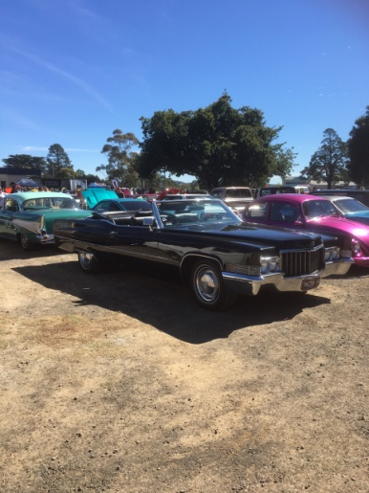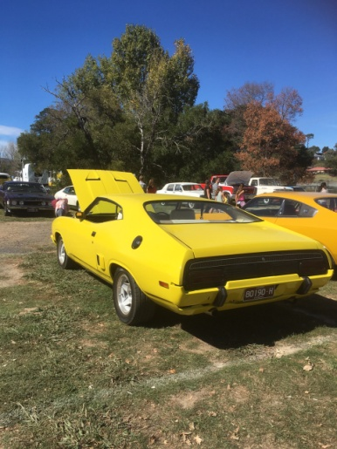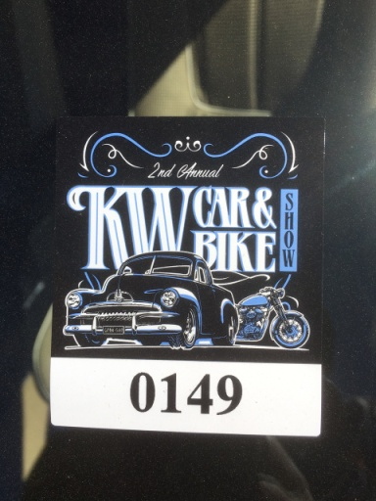
Sunday 15th April, 2018 – Lancefield Show, Shine and Swap Meet.

Even though the weather on the Saturday wasn’t ideal, a small group braved the conditions and participated on the Sunday display.
Unfortunately for the organisers, there were a lot of people who chose not to attend, which is very disappointing for an annual fund raiser. The football ground was wet underfoot but not as bad as we thought it might have been, given the amount of rain that fell on the Saturday.
Maybe, because of the conditions, there were lots of bargains to be had at the swap meet for any canny buyers.
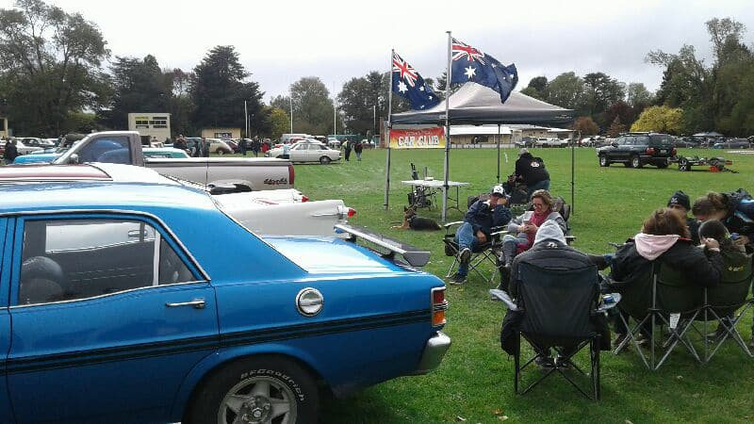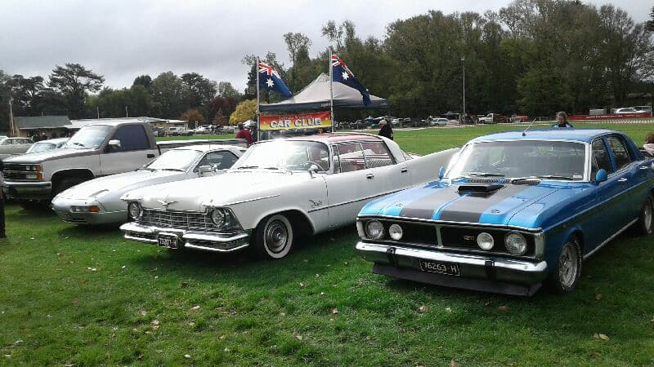

Future Events
Historic Winton Saturday 26th & Sunday 27th May, 2018.
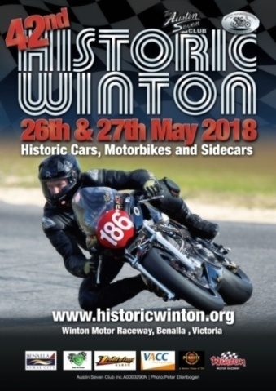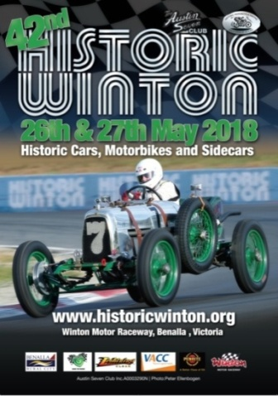
If you intend to participate over this weekend at Winton, then please make your own arrangements.
Queen’s Birthday – 9th 10th & 11th June, 2018.
There are numerous events on over the June Queens Birthday Weekend.
Steam Rally in Echuca.
As a reminder, Kathy Mills mentioned the Echuca Steam and Paddle boat Rally in Echuca.
Also, don’t forget Seymour Heritage Rail have a train trip to Echuca for the weekend as well.
Alexandra Truck and Ute Show 2018
To be held on Sunday June 10th in the main street at Alexandra.
Annual Club Run – Weekend Away
After initial feedback from members, we are looking at visiting the ‘Spannerman’ over at Boort for our annual weekend away. As to the time of the year, maybe the middle of July would be a convenient time, as later in the year gets pretty busy. More details will be available in the June newsletter.
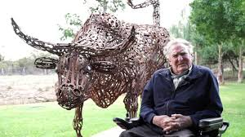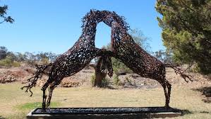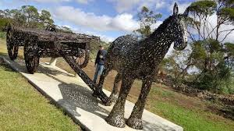
Guest Speakers.
John Phoenix and Michael Street have agreed to be our Guest Speakers for June where we will meet out at the Museum at Puckapunyal for the day. Also, John Blackwell hopes to have the CenturianTank he has been helping to restore, also available to view. The date is yet to be confirmed. Further details will be in the June Newsletter.
Scrapping Craft Day at the Clubrooms.
After the May meeting Peter approached Christine saying his wife Robyn, was keen to come to the craft day, which had been mentioned as an idea at a previous meeting, but we had had no response to. Bernadette and Christine then arranged the ‘craft card making day' on the following Saturday. Christine was able to email all members and notify them of the day, where we had a few more responses. Christine also arranged morning tea and craft supplies. Cheryl, Robyn and Peter, Jessica and Celeste, Bernadette and Christine enjoyed a fun morning exploring different art techniques, and made 40 cards (20 were made by Celeste with Jessica's help).
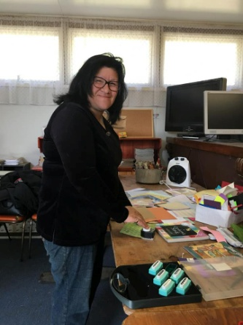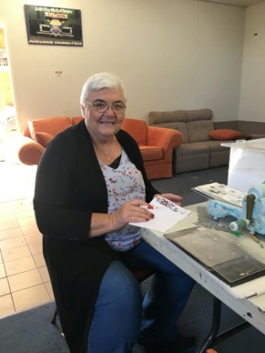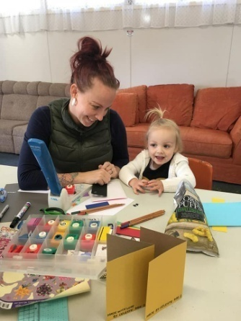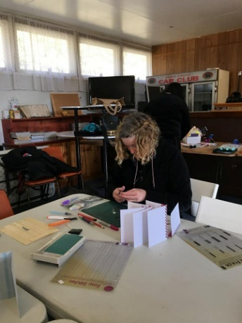
We then arranged to hand deliver the cards to the lovely ladies at Karingal Nursing Home. Jessica, Celeste, Harriett, Bernadette and Christine spent a wonderful morning talking to the ladies and watching their joy, opening the envelopes and seeing the art work. The entire process from making the cards to delivering the cards was wonderful for all involved.
Maybe we could do the same for Father's Day, and if agreed, maybe set a date so we can give members more notice. Christine was very grateful to Bernadette for her support in helping to make the craft event a success.
Next Meeting.
The next meeting will be a General Meeting, to be held on Wednesday 6th June, 2018 at 7.30pm, at the Clubrooms, at the end of Howe Street, Seymour, behind the tennis courts. Tea and coffee will be available.
Happy Motoring.
Judi McGrath – Secretary.
********************************
A father buys a lie detecting robot that slaps people when they lie. He decides to test it out at dinner one night.
The father asks his son what he did that day.
The son says, "I did some schoolwork." The robot slaps the son.
The son says, "Ok, Ok. I was at a friend’s house watching movies."
Dad asks, “What movie did you watch?"
Son says, “Toy Story."
The robot slaps the son.
Son says, “Ok, Ok, we were watching porn."
Dad says, “What? At your age I didn’t even know what porn was."
The robot slaps the father.
Mom laughs and says, “Well he certainly is your son."
The robot slaps the mother.

Robot is now For Sale.

