**May 2019 – Newsletter**

**Membership Renewals**.

S&DCC annual membership renewals are due on the 1st July, 2019, so expect to receive your renewal invoices during June.

At the November Annual General Meeting it was moved to increase the annual membership to $50.00 per year. New membership joining fees will stay at $30.00.

Please note, if you have a vehicle permitted on the Club Permit Scheme through the S&DCC, you need to renew your membership by the 1st of July, 2019 or your vehicle is deemed ‘not permitted’ and it is an offence to drive it on the road.

**Car Club Library**

Ernest Nicholson (Nico), has donated numerous books and magazines to the car club, which we appreciate. These reference books and magazines are available to borrow for car club members.

**HSV Workshop Visit.**

As has happened in the past, there is an opportunity for us to visit the HSV Workshops in Clayton South. We understand the sessions available are during the week, so if there is interest from car club members we will endeavour to obtain further information.

**Past Events.**

Lancefield Swap Meet and Car Show. A couple of members attended this event. The weather for the day was unpredictable but turned into a lovely Autumn day. There were many vehicles on display, swap meet stalls were plentiful and some bargains were obtained.

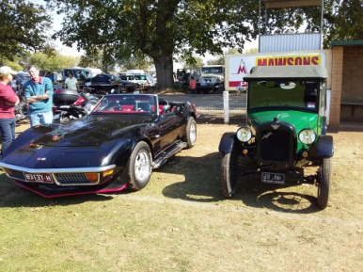 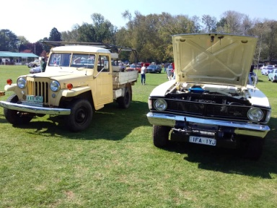 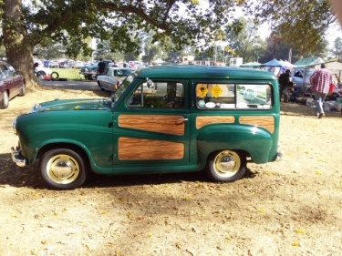 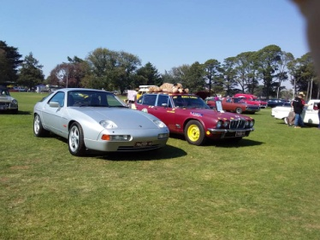

Broadford Swap Meet. Members reported they were a bit disappointed with the stalls at the swap meet as well as vehicles on display. This was thought to be attributed to Easter Monday being within the school holidays as well as Anzac Day falling, in the following week.

**RACV Florence Thomson Tour**

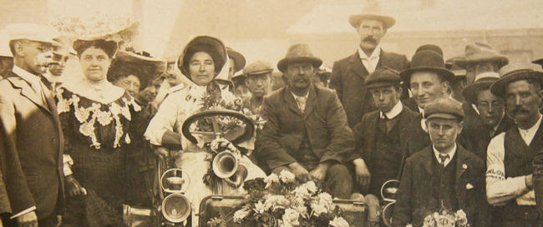

This tour celebrates the indomitable Florence Thomson, who was the only female entrant in the 1905 Dunlop Reliability Motor contest from Sydney to Melbourne; a 920km journey over what was then essentially a horse track between the two cities. She was one of only 17 contestants to finish the five-day trial.

This year the tour was centred in the Cobram area. There were 72 vehicles entered, with emphasis on older vehicles. All vehicles had to be driven by women. This is a very memorable tour and well worth participating in. In 2020 the tour will be in the Torquay area.

**Future Events**

Friday, 17th May, 2019. Historic Winton.

Benalla Historic Vehicle Tour. Starting at the Benalla Gliding Club. Entry is $10 per vehicle.

Saturday, 18th May, 2019. Seymour Community Market.

Kings Park, Seymour. Please support your local market.

Saturday and Sunday, 18th & 19th May, 2019.

43rd Historic Winton. Sponsored by the Austin Seven Club. Featuring Historic Touring Cars. Tickets available on line or at the track. Camping available at the track.

Saturday and Sunday, 25th & 26th May, 2019.

Nagambie Speedway presents The Nagambie 55 Lap Gold Rush 2019.

This being a local event please support it if you can. The track is 8kms out of Nagambie on the Heathcote Road. Canteen facilities and camping available.

Sunday 26th May, 2019. Cavalcade of Transport.

Yarra Glen Racecourse. Celebrating National Motoring Heritage Day. Gates open at 10am, Entry is a gold coin donation.

Sunday 25th August, 2019. RACV Aussie Classic Car Show.

Yarra Glen Racecourse. Gates open at 9am. Entry is $15 per vehicle.

Saturday 6th July, 2019, is the Yea Railway Market Day. We will need some volunteers, to help out during the morning please.

**Next Meeting.**

The next meeting will be a Committee Meeting, to be held in the clubrooms, on Wednesday 5th June, 2019, at 7.30pm. All members are welcome to attend. Tea and coffee will be available.

Happy Motoring,

Judi McGrath – Secretary – 0407 56200

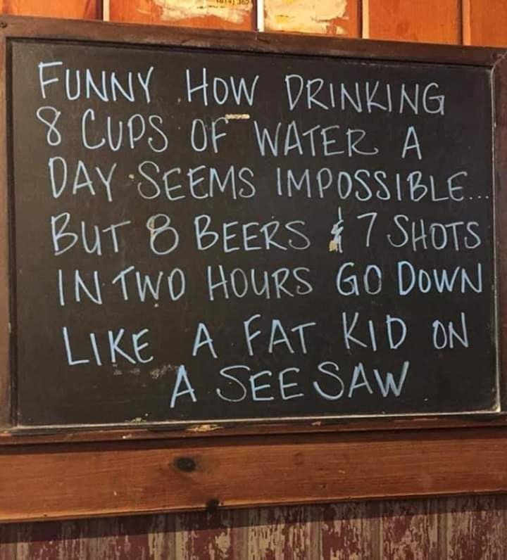

(Thank you Murray)