**November 2016 – Newsletter**

At the Annual General Meeting of the S&DCC, held on Wednesday, 2nd November, 2016, at the Clubrooms, the following members were elected onto the Committee –

President – John Phoenix Committee Person – Rob Collyer

Vice President – David Bell Committee Person – John Blackwell

Secretary – Judi McGrath Committee Person – Colin Hubbard

Treasurer – Bernadette Bell Committee Person – Brian Weaire

Assistant Secretary – Christine Sheather Committee Person – Hayden Phoenix.

Committee Person & Safety Officer – Rob Phoenix.

John Phoenix thanked the old Committee for all the work performed during the past 12 months, and then thanked the new Committee for accepting their nominations for the next 12 months, and said he looked forward to all members enjoying the events that will be planned.

**Future Events**



**Sunday 4th December, 2016 – S&DCC Christmas Party at the Clubrooms.**

The Committee would like to invite all members and their families to the Annual Christmas Party, to be held at the Clubrooms from 12 midday, with lunch being provided by the S&DCC. Please BYO drinks.

As this will be a catered event, please contact us as soon as possible if you are able to attend.



**Calendar of Events – 2016**

Sunday 20th November, 2016

Would any members like to join us for ‘Brunch’ this coming Sunday. We are planning a short run to a venue in Nagambie, leaving Seymour Industrial Car Park, Emily Street, Seymour, at 10.30am. If you already have something planned, then join us early and then you can proceed onto your next activity. We do know how busy this time of the year is, so please let me know if you are interested in attending.

Sunday. 20th November, 2016 – Wangaratta Swap Meet & Collectibles Market - Wangaratta Showgrounds. 10 Evans Street, Wangaratta. 6am till 1.00pm. $8.00 per adult. Children under 16 – Free.



25th to 27th November, 2016 – EJ-EH Holden Nationals – Shepparton Showgrounds.

If any members wish to attend this event as a group, then please contact me and I can advise you of a meeting time and place.



27th November, 2016 – Wallan Classic Vehicle Club. 3rd Annual Show and Shine. Kilmore Football Ground. Kelly’s Road, Kilmore. Vehicle entry from 8am. Event is from 9am to 3pm. $5.00 per adult. Children under 15 – Free.

If any members wish to attend this event as a group, then please contact me and we can advise you of a meeting time and place.

Wednesday 7th December, 2016 – S&DCC Committee Meeting – 7.30pm at the Clubrooms.

**2017**

Australia Day 2017 – Kings Park Seymour.

27th & 28th May, 2017 – 41st Historic Winton at the Winton Raceway, Benalla.

Just an idea but we could make it an overnight stay, camping in the camping grounds at the track, or at one of the motels in Benalla. You may even have the opportunity to drive your classic vehicle around this iconic track.

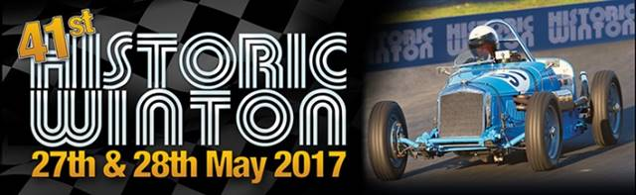

Safe Motoring

Judi McGrath

Secretary – 0407 562003.

**********************

Dan was a single fellow, living at home with his father, and working in the family business. He found out he was going to inherit a fortune when his sickly father died, so he decided he needed a wife with whom to share his fortune.

One evening at an investment meeting, he spotted the most beautiful woman he had ever seen. Her natural beauty really took his breath away.

“I may look like just an ordinary man,” he said to her, “but in just a few years my father will die, and I’ll inherit 200 million dollars.”

Impressed, the woman obtained his business card and three days later, she became his stepmother.

Unfortunately, some women are so much better at financial planning than men.......