November 2017 – Newsletter

At the Annual General Meeting held on Wednesday, 1st November, 2017, the following members were elected as your club representatives for 2018. Kathy Mills chaired the meeting for the election of Office Bearers and Committee Persons.

President: John Phoenix.
Vice President: David Bell.
Secretary: Judi McGrath.
Assistant Secretary: Christine Sheather.
Treasurer: Bernadette Bell.
Committee Person & Safety Officer: Rob Phoenix.
Committee Person: John Blackwell.
Committee Person: Robert Collyer.
Committee Person: David Mills.
Committee Person: Hayden Phoenix.
Committee Person: Murray Potbury.
Committee Person: Colin Hubbard.

John Phoenix thanked the new Office Bearers and Committee Persons for accepting their roles for 2017/2018.

Past Events

Guest Speaker – Hans Plieger.

Our thanks are extended to Hans Plieger for his very informative talk on his passion for motor bikes and the history of many of them. He was able to bring some along and display on the night. The fire was going and we will once again we enjoyed our pizzas for supper. 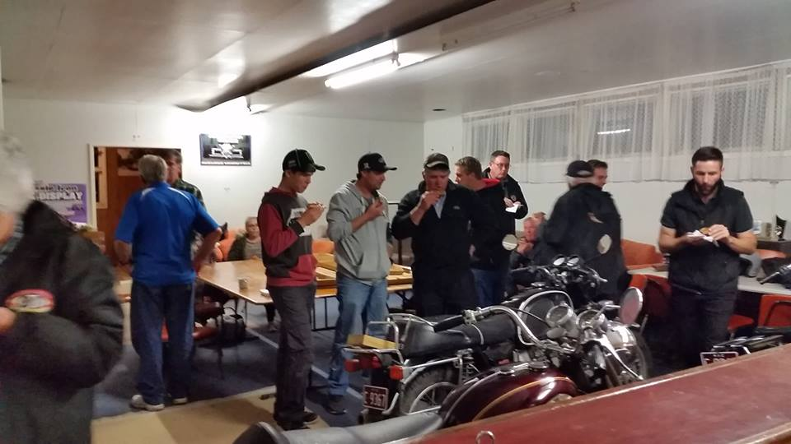 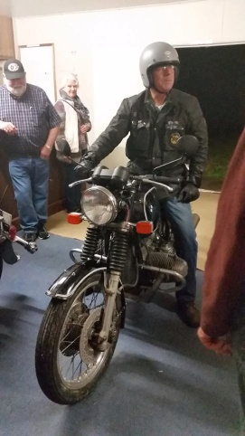 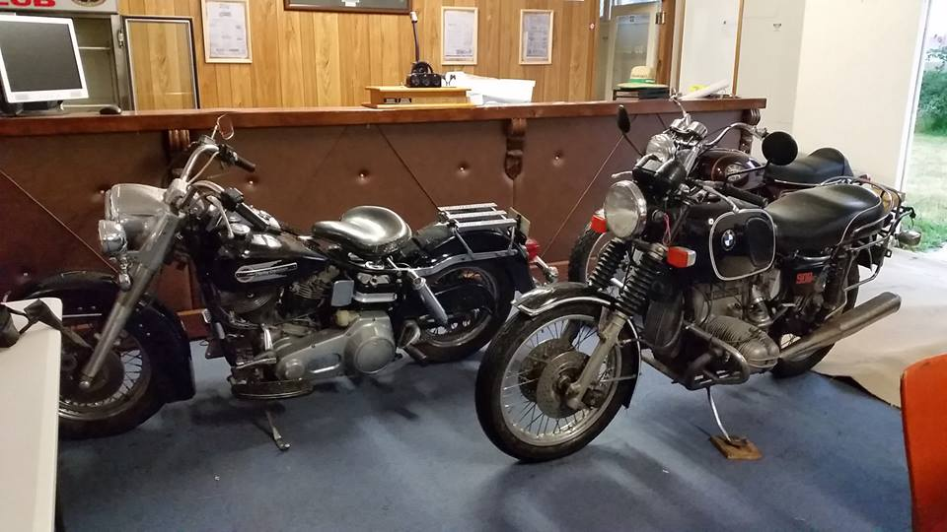

Trafalgar Holden Museum. The Last Cruze.

Tim Sheather travelled down to Trafalgar for the day and participated with the large group of Holden’s that turned up. The organisers always hoped there would be a large group participate but were more than surprised to have an estimated 5000 vehicles involved. The museum and outside sheds were packed with people and every possible car park was full.
The ‘Last Cruze’ left the Museum and travelled 69kms around the district. Sixty-nine being the number of years Holden were manufacturing vehicles. Tim said the involvement of the public was terrific as many people lined the streets and applauded as the vehicles passed by.

Future Events

Saturday 25th November, 2017 – 1pm - Working ‘B’ at the Clubrooms.
We need members to help out with a general clean up before the Annual Christmas Lunch.
There isn’t very much to do and many hands would make it easier.
CPS Vehicle Photographs
Also, some vehicles have fallen through the loop, so the day of the Working ‘B’ can be combined with the opportunity of photographs being taken of members vehicles permitted through the Club Permit Scheme, as required by Vic Roads. The Secretary will contact members and organise a time and place to have these photographs taken.
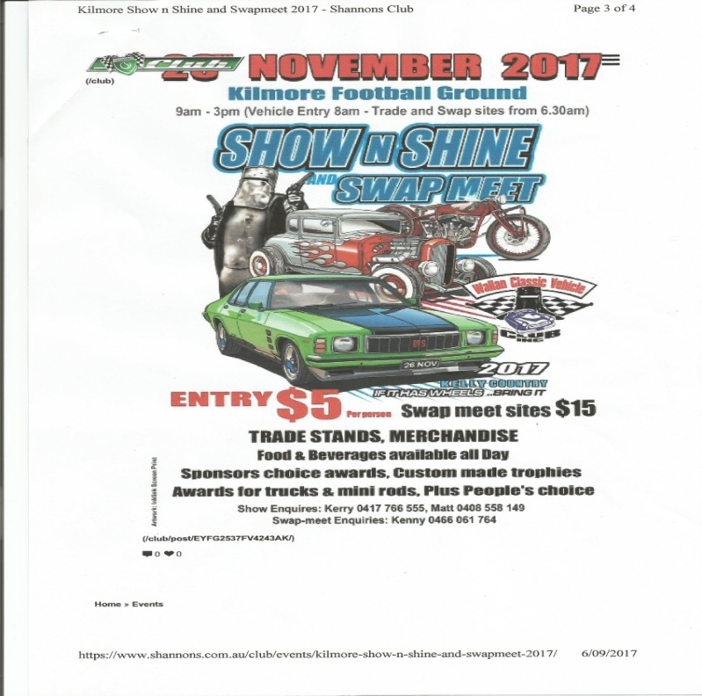
Sunday 26th November, 2017 – 9am to 3pm.
Kilmore Show and Shine and Swap Meet.
Kilmore Football Ground.
JJ Clancy Reserve in Kilmore.
$5 entry per person. If it has wheels – bring it.
Trade stands. Merchandise. Food and beverages available all day. Sponsors choice awards. Custom made trophies. Also, awards for trucks & mini rods, plus people’s choice.
Any members who want to display their vehicles as a group, can meet outside the reserve at 9am.

Sunday, 3rd December, 2017. – 1pm. Annual Christmas Lunch at the Clubrooms..

Please come along and show your support for your club. Lunch will be supplied, so let me know who will be attending. Please BYO drinks.
Events for 2018.

Australia Day - Friday 26th January, 2018. Kings Park, Tallarook Street, Seymour.

Friday 26th January, 2018 – Shannons - Aussie Classic Car Show. Yarra Glen Racecourse.

Saturday & Sunday 17th & 18th February 2018 – Broadford Truck Show. More details to follow.

Sunday 15th April, 2018 – Shannons – American Motoring Show.. Yarra Glen Racecourse.

Next Meeting.
The next meeting will be a Committee Meeting, to be held in the clubrooms, Howe Street, Seymour, behind the tennis courts, on Wednesday 6th December, 2017, at 7.30pm.
All members are welcome to attend. Tea and coffee will be available.
Safe Motoring - Judi McGrath - Secretary – 0407 562003.
****************************
On the appointed day, the Inspector turned up.
“Tell me about your staff.” He asked Paddy.
“Well,” said Paddy, “There’s the farm hand, and I pay him $250 a week, and he has a free cottage.
Then there’s the housekeeper. She gets $200 a week, along with free board and lodging.
There’s also the half-wit. He works a 16 hour day, does 90% of the work, earns about $50 a week along with a bottle of whisky and, as a special treat, occasionally get to sleep with my wife.”
‘That’s a disgrace,” said the Inspector. “I need to interview the half-wit.”
“That’ll be me then,” said Paddy.

