November 2018 – Newsletter

At the Annual General Meeting held on Wednesday, 7th November, 2018, the following members were elected as your club representatives for 2018.
John Blackwell chaired the meeting for the election of Office Bearers and Committee Persons.

President: John Phoenix.
Vice President: David Bell.
Secretary: Judi McGrath.
Treasurer: Christine Sheather.
Committee Person & Safety Officer: Rob Phoenix.
Committee Person: John Blackwell.
Committee Person: David Mills.
Committee Person: Hayden Phoenix.
Committee Person: Murray Potbury.

At the AGM the Treasurer moved a motion to increase the membership to $50 annually, as of the 1st July, 2019. It was explained all expenses are increasing in cost, for example, water rates, insurances, function expenses etc. John Blackwell seconded this motion and after discussion the motion was accepted and passed by all the members present.

John Phoenix thanked the prior Committee for their support, then, thanked the new Office Bearers and Committee Persons for accepting their roles for 2017/2018. John also thanked Bernadette for everything she has done for the club while being Treasurer over quite a number of years.

Seymour’s 175th Anniversary - Saturday the 10th of November, 2018 – Street Parade.
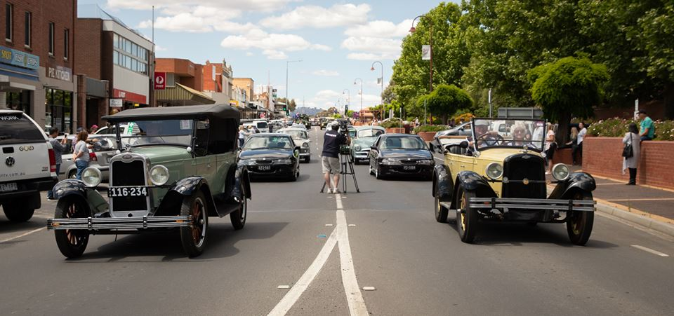
Two of Seymour Car Clubs older vehicles had the privilege of leading the vehicle parade. Kevin’s green Chevrolet is a 1928 Capital Tourer and Judi’s Chevrolet is a 1927 Capital Tourer.
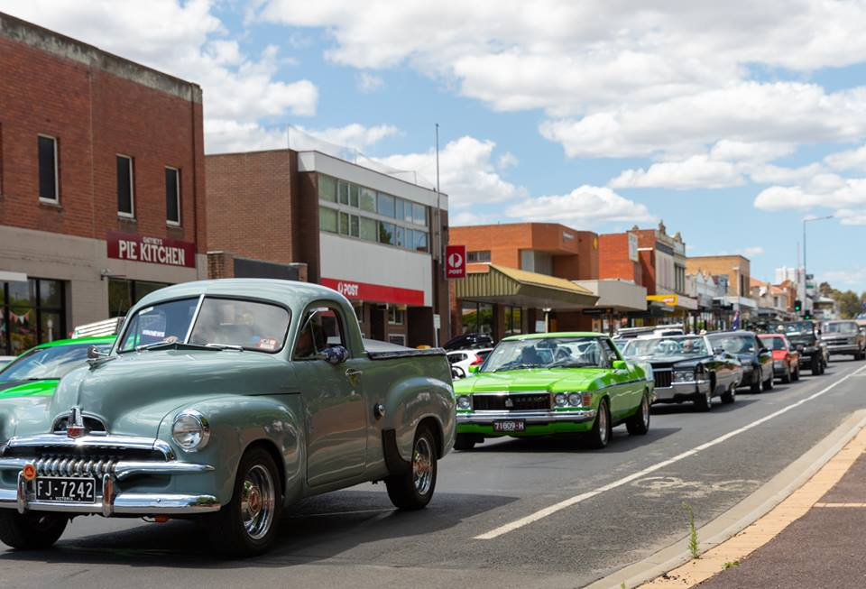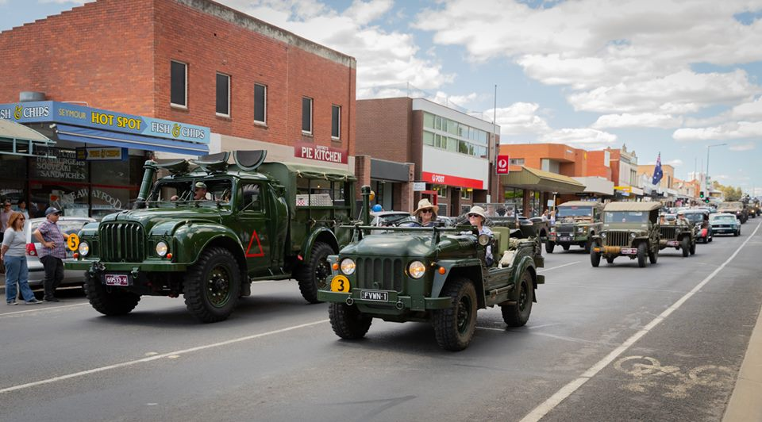
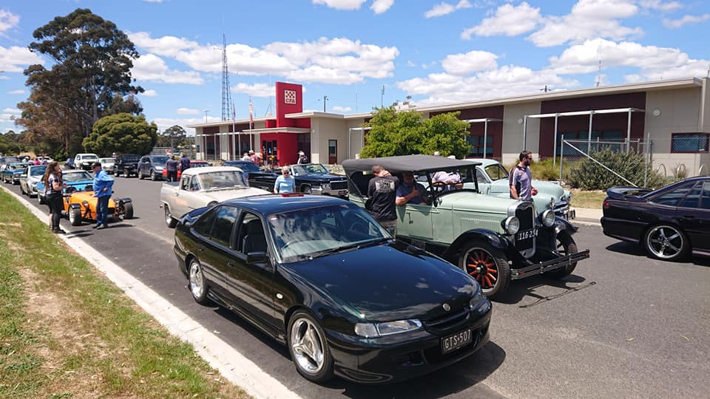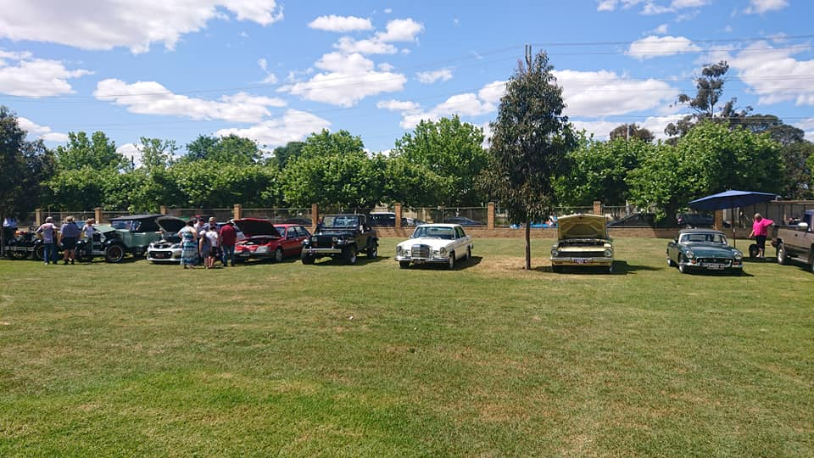
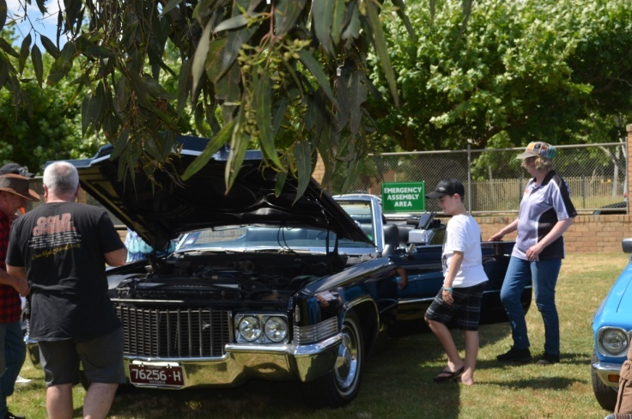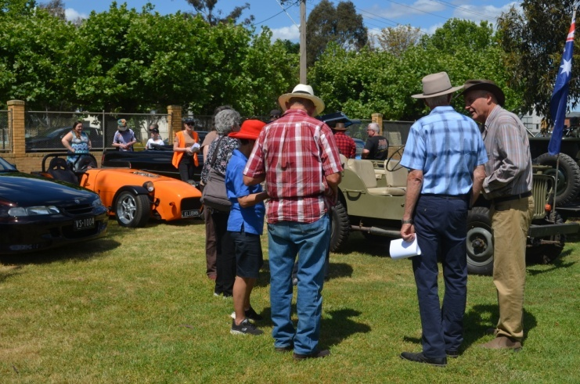
Our contingent of vehicles were in excess of 20 and everyone should be extremely proud of this display. (Photo credits to Mitchell Shire face book page and car club members).
Christmas Lunch – Sunday 2nd December, 2018 – 12noon for lunch at 1pm.
We have secured the use of the Seymour RSL rooms in Crawford Street, and as we are having outside caterers for the day, we do need to know who will be attending. The cost will be $10 per adult and the car club will be subsidising the rest.
As the RSL is a licensed premise, drinks are available, and will be charged at bar prices.
If you haven’t responded as yet, and you are still wanting to join us for lunch, then please contact me by email, phone or text me, as soon as possible. We need to have final numbers to the caterers by Monday 26th November. We also need to know if there are any special dietary requirements.
We look forward to catching up with as many members as possible for our final function of the year.
Future Events.
2018 Kilmore Show and Shine and Swap Meet.
Sunday 25th November, 2018.
Kilmore Football Ground.
9am to 3pm. (Vehicle entry from 8am)
Trade stands. Merchandise.
Food & Beverages are available all day.

Please support this day if you can.

Entry for the day is $5 per person and per vehicle.

Next Meeting. The final meeting of the year will be Committee Meeting, to be held on Wednesday the 5th of December, 2018 at 7.30pm, at the clubrooms, lower end of Howe Street, behind the tennis courts. All members are welcome. Tea and coffee will be available.
Happy Motoring. Judi McGrath – Secretary.
*********************************
It was entertainment night at the Senior Citizens’ Centre.
After the community sing-a-long led by Alice at the piano, it was time for the star of the show – Claude the Hypnotist!
Claude explained that he was going to put the whole audience into a trance.
“Yes, each and every one of you and all at the same time,” said Claude.
The excited chatter dropped to silence as Claude carefully withdrew from his waist coat pocket, a beautiful antique gold pocket watch and chain,
“I want you all to keep your eyes on this watch,” said Claude, holding the watch high for all to see.
“It’s a very special and valuable watch that has been in my family for six generations,” said Claude.
He began to swing the watch gently back and forth while quietly chanting.
WATCH THE WATCH ----- WATCH THE WATCH ----- WATCH THE WATCH.
The audience became mesmerized as the watch swayed back and forth. The lights were twinkling as they were reflected from its gleaming surfaces.
A hundred and fifty pair of eyes followed the movement of the gently swaying watch.
They were all hypnotized.
And then suddenly, the chain broke!!!!!
The beautiful watch fell to the stage and burst apart on impact.
“Sh*t,” said Claude.
It took them three days to clean the Senior Citizens Centre.
Claude was never invited there again. (Anonymous)

