October 2016 – Newsletter

Recent Events

Sunday 18th September, 2016 – Nagambie Cranksters.
Unfortunately for the Nagambie Cranksters the weather this particular weekend was horrendous. Even though the area was really muddy and the wind was cold, a hardy group from the S&DCC spent the morning supporting them.
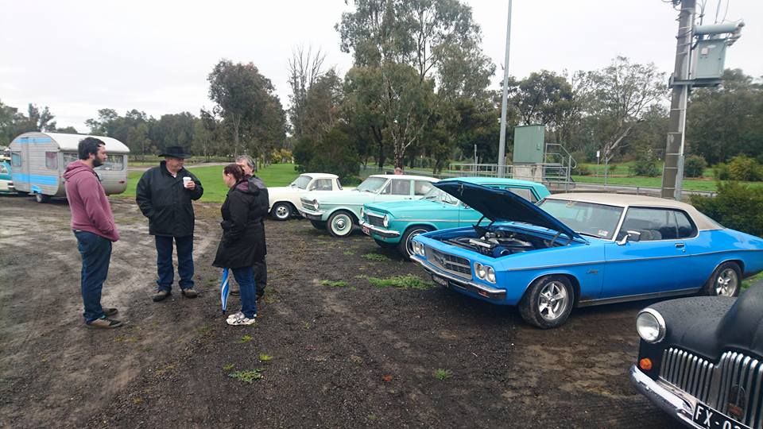

Sunday 2nd October, 2016 – Euroa Show and Shine
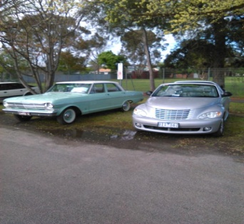
Again the weather was not kind to the organisers of this car show in Euroa. At the last moment they chose to close off the main streets of the township and allowed the cars to be displayed there. This allowed the spectators to view the vehicles from the road. Where the vehicles were displayed in the parks, the grassed areas very soon became muddy and slippery.
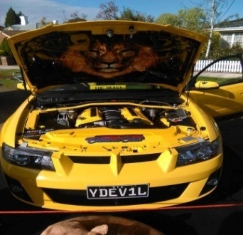
The small group from the S&DCC who supported this event felt the change of venue was of benefit to the owners of the displayed vehicles, as well as the spectators. It was very easy to see the vast array of vehicles on display as well as visit the market stalls.
Parking along the streets also made it a lot easier to leave the venue at any time throughout the afternoon.

Working Bee.
The Committee would like to thank all the members who participated at the ‘Working B’.
Saturday 16th October, 2016 – Joint Club and Family Day at the S&DCC clubrooms.
On Friday morning the Executive Committee made a last minute decision to postpone this social day, until sometime in the future. We had invited the other local car clubs, but when this day was chosen, the Committee were unaware of so many other events, over this particular weekend. Also, early in the week we were made aware of the changeable weather for the Sunday, and no-one wanted to be caught outside in the wind and the rain. Anyway, we do apologise to everyone for the late cancellation.
Future Events
Wednesday 2nd November, 2016 – S&DCC Annual General Meeting – 7.30pm at the Clubrooms.
Included with this Newsletter are the Nomination Forms for the AGM. If you would like to nominate someone for one of the positions on the Committee, or be on the Committee yourself, then please do so.
All Nomination Forms need to be lodged with the Secretary by Friday 28th October, 2016.
This meeting is an open meeting of the S&DCC and will be held at the clubrooms, lower end of Howe Street Seymour, behind the tennis Courts. Tea and coffee will be available.
Sunday 4th December, 2016 – S&DCC Christmas Party at the Clubrooms.
The Committee would like to see as many members as possible attend the Annual Christmas Party, to be held at the Clubrooms. Lunch will be provided by the S&DCC, BYO drinks.
As this will be a catered event, please contact us as soon as possible if you are able to attend.
Calendar of Events - 2016
12th to 13th November, 2016 – Bendigo Swap Meet.
25th to 27th November, 2016 – EJ-EH Holden Nationals – Shepparton Showgrounds.
Wednesday 7th December, 2016 – S&DCC Committee Meeting – 7.30pm at the Clubrooms.
2017
Australia Day 2017 – Kings Park Seymour.

Safe Motoring - Judi McGrath - Secretary – 0407 562003.
**********************
Murphy took his car to the mechanic, who told him he needed a new muffler. He went straight home and asked his wife to knit him one......
Nomination to the Committee 2016/2017
To The Secretary,

Please note that I.....................................................................
(a Financial Family Member for 2016/2017)
Hereby nominate.....................................................................
(a Financial Family Member for 2016/2017)

For the position of......................................................................
Officer roles:-
President ( ) Vice President ( )
Secretary ( ) Assistant Secretary ( )
Treasurer ( ) Assistant Treasurer ( )
*Ordinary Committee Member: ( ) * [5 or 6 positions are available]
*Events Committee: ( ) *(5 or 6 positions are available)

The person accepting the nomination please initial the appropriate box above.

To the Secretary,

Please take note, I.................................................................
(a Financial Family Member for 2016/2017)

Accept the nomination for the position of

..............................................................................

