October 2017 – Newsletter

Past Events

Nagambie Cranksters.
Thank you to those members who attended. A good participation from club members on a thankfully, lovely sunny day.
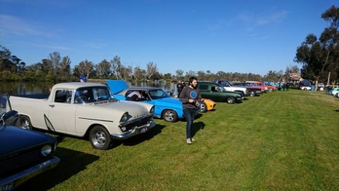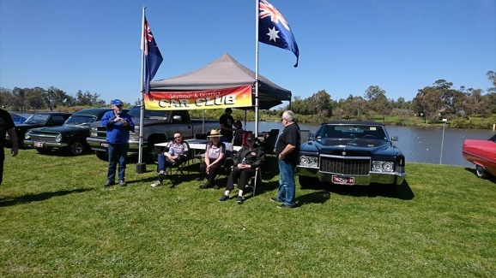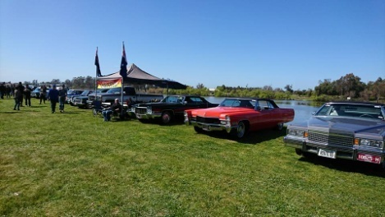

Euroa Show and Shine. Again, thank you to those members who attended where we had another very good participation from car club members. Parking in the street gave all members a chance to view all the cars and vehicles on display, whether they were in the streets or in the park areas.

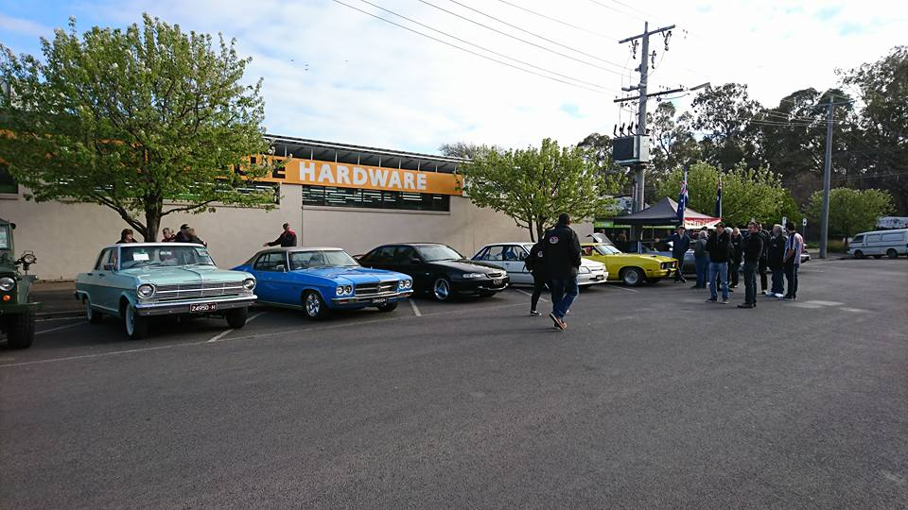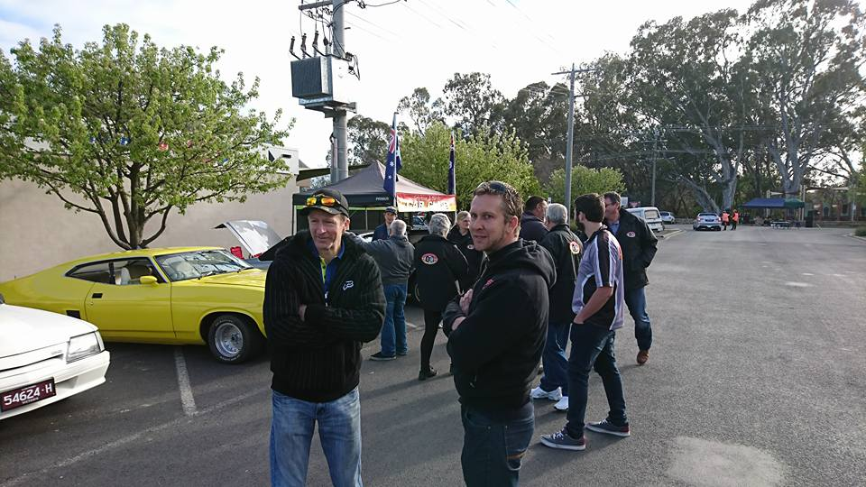

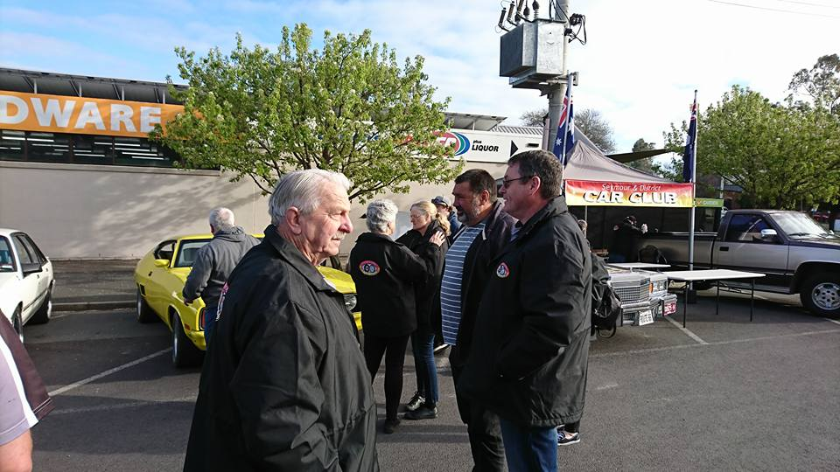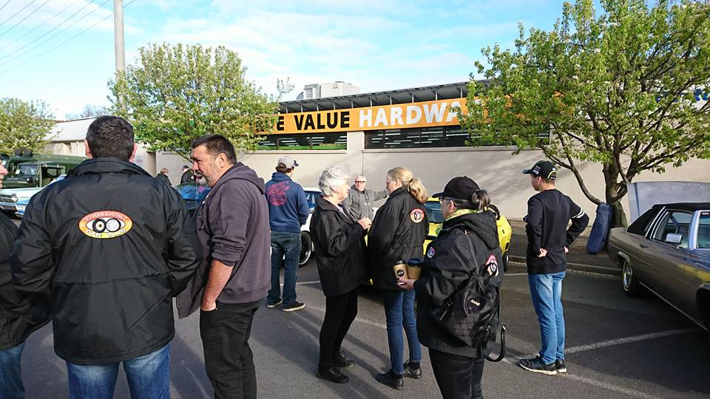

Wanted.

Does anyone have an overhead projector we could buy or borrow please?.

Future Events

Sunday 22 October, 2017 – Holden Trafalgar Museum – Farewell Cruise. Museum opens at 10am.
1pm – Official Ceremony farewelling Holden Production in Australia. 2pm – Largest Holden Cruise Ever, heads out on a cruise through the region.
Wednesday 1st November, 2017 – 7.30pm at the Clubrooms. – Annual General Meeting.

The Annual General Meeting will be at 7.30pm, followed by our monthly meeting.

Nomination forms have been sent out to all members. Completed forms are to be returned to the Secretary by Wednesday 25th October, 2017.

Saturday 25th November, 2017 – 1pm - Working ‘B’ at the Clubrooms, plus CPS Vehicle Photographs
We need members to help out with a general clean up before the Annual Christmas Lunch.
Also, some vehicles have fallen through the loop, so the day of the Working ‘B’ can be combined with the opportunity of photographs being taken of members vehicles, permitted through the Club Permit Scheme, as required by Vic Roads. More details to come.

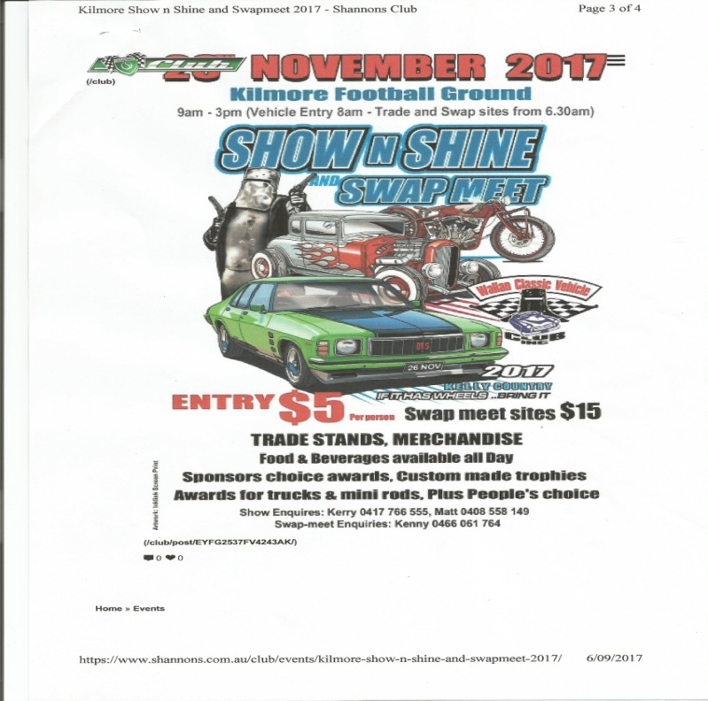
Sunday 26th November, 2017 – 9am to 3pm.
Kilmore Show and Shine and Swap Meet.
Kilmore Football Ground.
JJ Clancy Reserve in Kilmore.
$5 entry per person. If it has wheels – bring it.
Trade stands. Merchandise. Food and beverages available all day. Sponsors choice awards. Custom made trophies. Also, awards for trucks & mini rods, plus people’s choice.

Sunday, 3rd December, 2017. – 1pm. Annual Christmas Lunch at the Clubrooms..

Please come along and show your support for your club. Lunch will be supplied, so let me know who will be attending. BYO drinks.
Other events happening within our area that may be of interest.

10th, 11th & 12th November, 2017 - Lake Mulwala Rod Run .

Events for 2018.

Australia Day - Friday 26th January, 2018. Kings Park, Tallarook Street, Seymour

Friday 26th January, 2018 – Shannons - Aussie Classic Car Show. Yarra Glen Racecourse.

Saturday & Sunday 17th & 18th February 2018 – Broadford Truck Show. More details to follow.

Sunday 15th April, 2018 – Shannons – American Motoring Show.. Yarra Glen Racecourse.

Next Meeting.
The next meeting will be the Annual General Meeting followed by the monthly meeting, to be held in the clubrooms, Howe Street, Seymour, behind the tennis courts, on Wednesday 1st November, 2017, at 7.30pm.
All members are welcome to attend. Tea and coffee will be available.
Safe Motoring - Judi McGrath - Secretary – 0407 562003.

****************************

A man went into a cafe and sat his six children at a table.
A woman asked, ‘Are all of those children yours?’
‘No, I work for a condom company............... these are customer complaints.’

