October 2018 – Newsletter

Fund Raising. One of our members, Kathy Mills, will be walking in a fundraiser for ‘Unite to Fight Cancer for Peter Mac’. The walk is 21 kilometres and will be held on Sunday, 28th October, 2018, around the Melbourne City area. If you are in a position to donate to this wonderful and worthwhile cause and support Kathy, then please contact her on 0409 553054 or email her at Kathryn.mills@defence.gov.au.

Past Events.

Nagambie Kranskers

Again, everyone enjoyed the day at Nagambie and the weather was perfect.

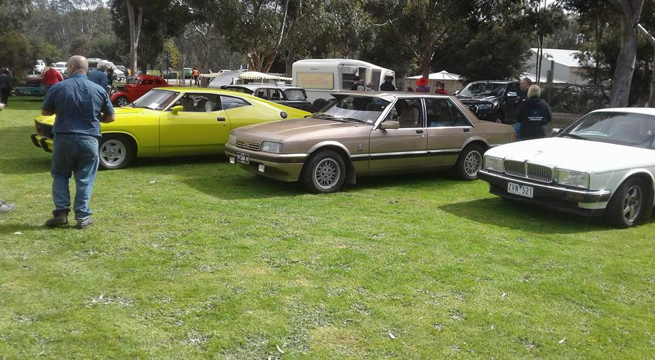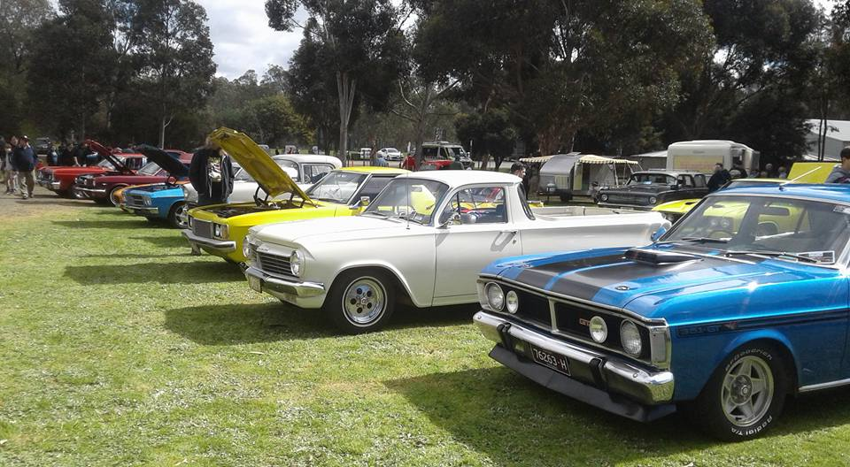

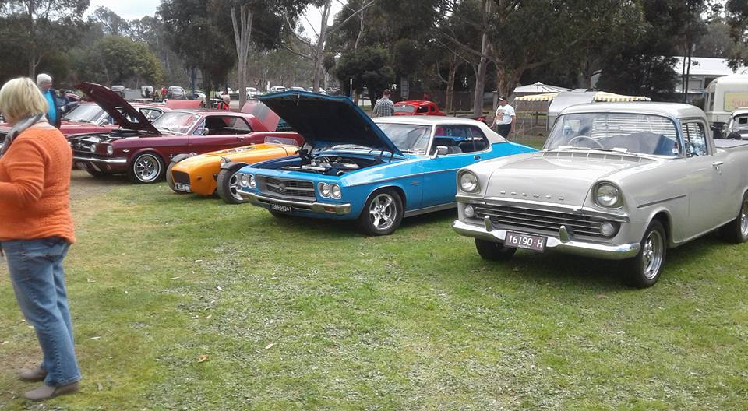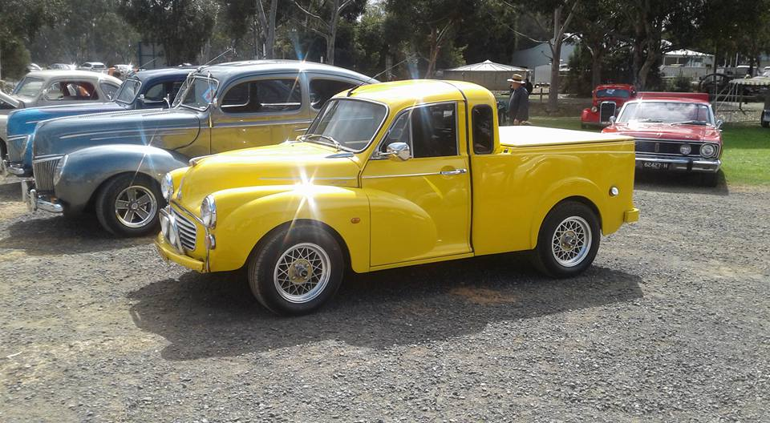

Our Guest Speaker for October was Garry Morris.
Gary presented a pictorial presentation on James Flood. James was one of the first Australian builders of motor car bodies. He worked for Tarrant Motors which were the first major Australian automobile operation, being distributors for the De Dion, Argyle, Mercedes and later, Ford.
The photographs showed many Australian Motor Industry cars of the past.
The presentation created much discussion on the different vehicle models, features and the scenic back grounds of the photos.
An excellent night and a great thank you to Gary for this presentation.
AOMC Centennial Cavalcade of Vehicles – Bendigo.
Rob Collyer spoke about his experience and the day’s events. He stated there must have been 3 – 4000 people and so many lovely vehicles took part.
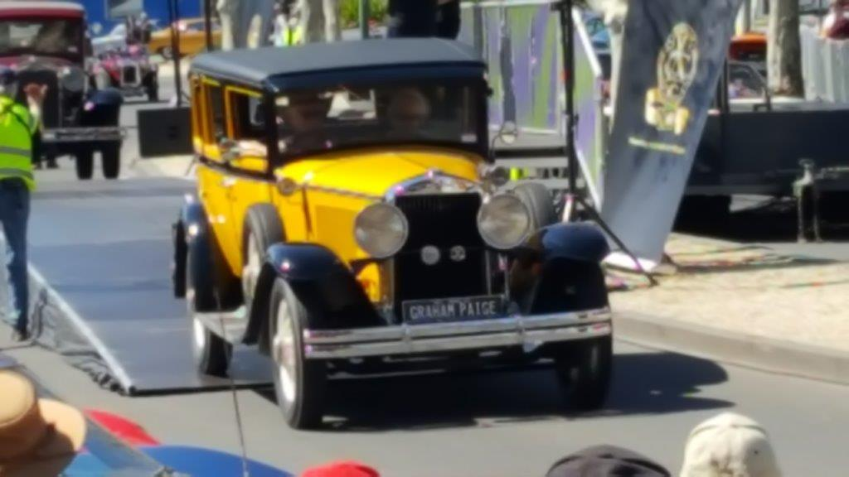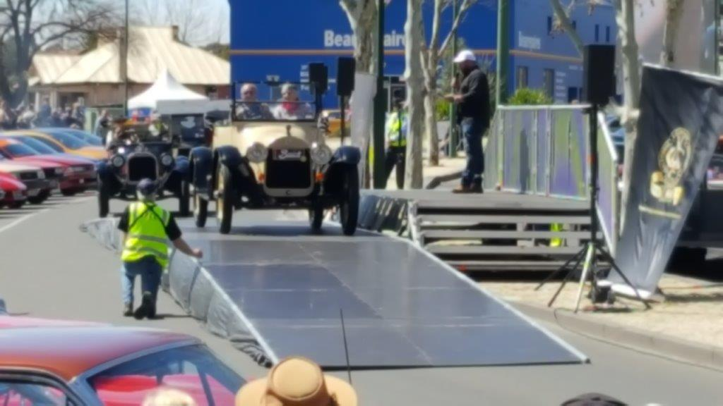
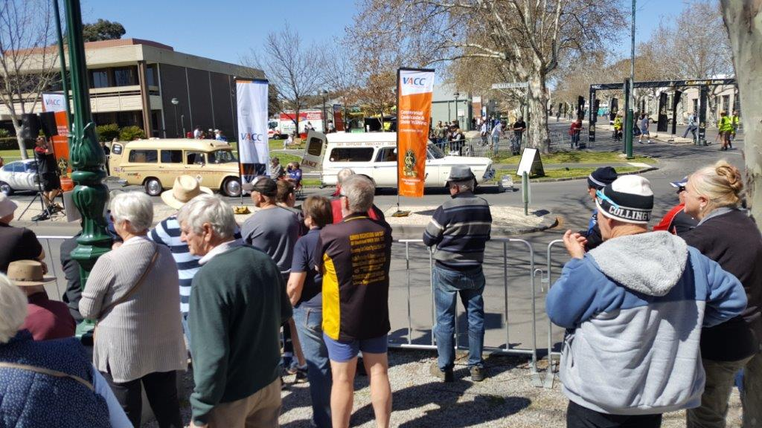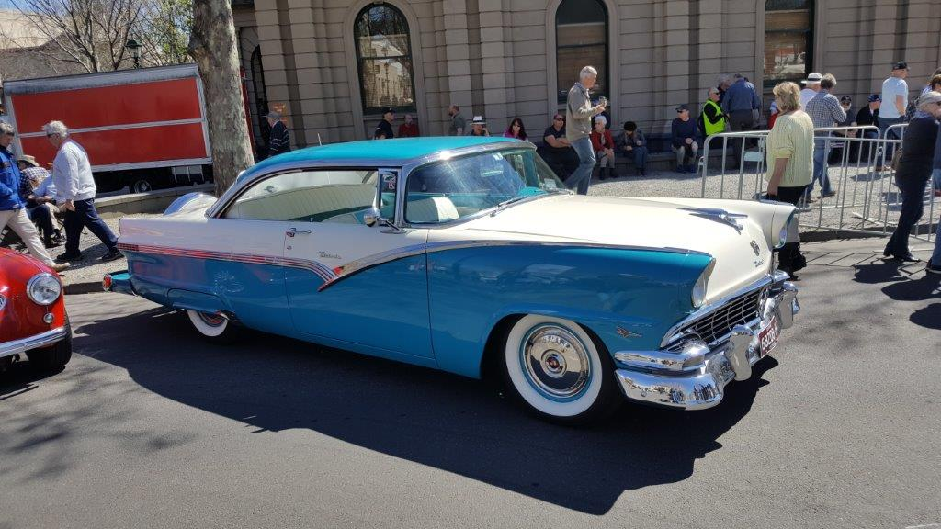
Euroa Show and Shine – October, 201 8.

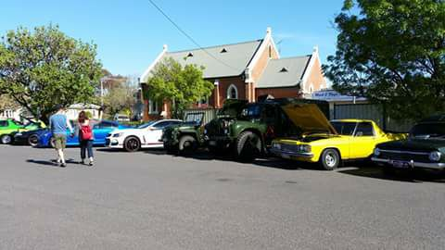
Again, there were a wonderful array of vehicles on display and the weather was perfect.
Even the start of daylight savings didn’t disrupt the enthusiasm of the many visitors to the town.

Pick my Project Funding.

Unfortunately the S&DCC missed out on the Funding Campaign. John thanked all members for their help in participating in the voting process.
Remembrance Weekend and Seymour’s 175th Anniversary.
Saturday the 10th of November, 2018.
John Phoenix advised us the street parade will go ahead on the Saturday at 2pm. S&DCC members vehicles are to assemble in Crawford Street and the parade will move down Station Street to Kings Park. John will attend another meeting of all the relevant groups and will report back to us.
On Rememberance Day, Sunday the 11th November, 2018 at 11am, there will be a service at the Seymour Memorial Hospital gates and then afterwards, refreshments will be available at the RSL, in Crawford Street.
Christmas Lunch – Sunday 2nd December, 2018.
We are making arrangements to have the Christmas Lunch catered for this year and with this in mind, we do need to have the names of members and their families attending. Please email or message the Secretary as soon as possible.
Next Meeting. The next meeting will be the Annual General Meeting, to be held on Wednesday the 7th November, 2018 at 7.30pm, at the clubrooms, lower end of Howe Street, behind the tennis courts.
Nomination Forms are included with this Newsletter. All completed Nomination Forms are to be received by the Secretary, by the 31st October, 2018.
The monthly meeting will then follow on from the AGM.
All members are welcome. Tea and coffee will be available.
Happy Motoring. Judi McGrath – Secretary.
**********************************
A nice, calm, and respectable lady went into the Pharmacy, walked up to the Pharmacist, looked straight into his eyes, and said, “I would like to buy some cyanide.”
The Pharmacist asked, “Why in the world do you need cyanide?”
The lady replied, “I need it to poison my husband.”
The Pharmacist’s eyes got big and he exclaimed, “Lord have mercy! I can’t give you cyanide to kill your husband. Absolutely not!”
The lady reached into her purse and pulled out a picture of her husband in bed with the Pharmacist’s wife.
The Pharmacist looked at the picture and said, “You didn’t tell me you had a prescription.”
(Thank you Murray).

Nomination to the Committee 2018/2019
Annual General Meeting – Wednesday 7th November, 2018 at 7.30pm.
To The Secretary,
Please note that I,..................................................................... (a Financial Member for 2018/2019)
Hereby nominate..................................................................... (a Financial Member for 2018/2019)
Please note that I,..................................................................... (a Financial Member for
2018/2019 second the nomination of ................................................................
For the position of......................................................................
Officer roles:-
President ( ) Vice President ( )
Secretary ( ) Assistant Secretary ( )
Treasurer ( ) Assistant Treasurer ( )
Safety Officer ( )
*Ordinary Committee Member: ( ) * (5 or 6 positions are available)
Events Committee ( )
Web Master ( )
Newsletter Editor ( )

The person accepting the nomination please initial the appropriate box above.

To the Secretary,
Please take note, I....................................................(signed), (a Financial Member for 2018/2019), accept nomination for the position

of...............................................................................

