October 2019 – Newsletter

Vale.

Peter Cox.
Seymour and District Car Club Member – # 127.

It is with sadness we advise our car club members of the passing of Peter Cox.
Peter has been a well respected member of the community and a car club member since 2013.
We extend our deepest sympathy to Peter’s family.

Annual General Meeting.

The AGM is to be held prior to the monthly meeting on Wednesday the 6th of November, 2019, at 7.30pm.
All positions are declared open. Nomination forms are attached to this Newsletter. Completed forms are to be sent to the Secretary, to be received seven days prior to the November Meeting.
Clubrooms.

We have been advised the Shire will be meeting in October, to discuss this topic and advise us of their decision.
Joint Lions Club and S&DCC Show and Shine.

The sale of raffle tickets is going well, with members from both clubs attending the Seymour Show on Saturday and mixing with the community.

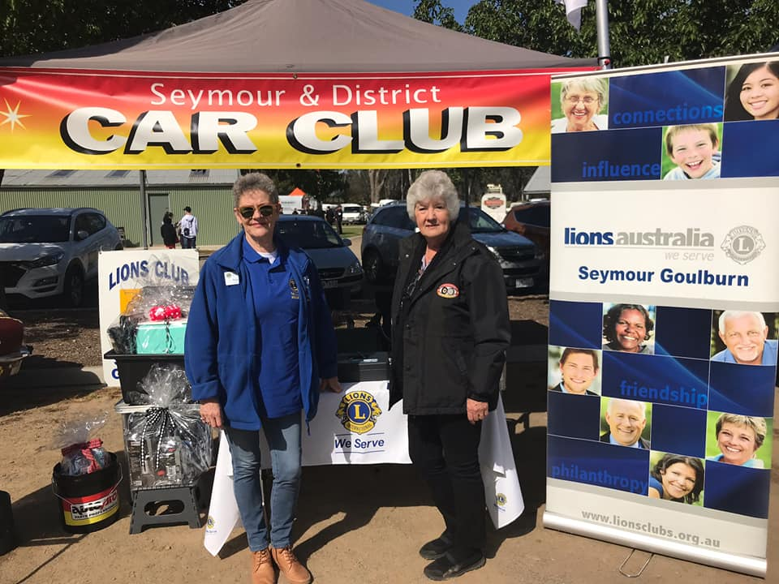

Raffle tickets books and money, need to be returned to John Phoenix, or brought to the November meeting, as the raffle will be drawn at the BBQ at Woollies on Saturday November 9th.

We also thank all Car Club members who have been attending car shows within the area and distributing leaflets advertising our event, to be held on the Monday, March Labour Day weekend, 2020.

Past Events.

Nagambie Cranksters – Sunday 22nd September, 2019.

A great day with lot of lovely vehicles.

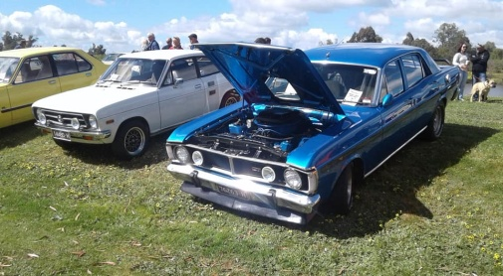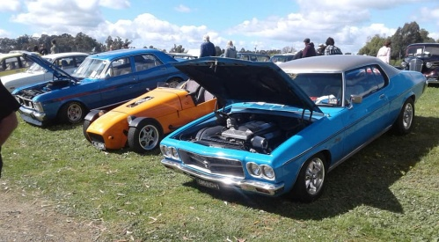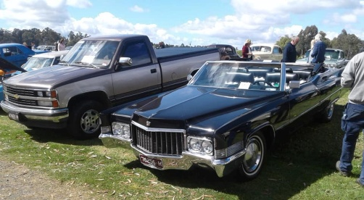

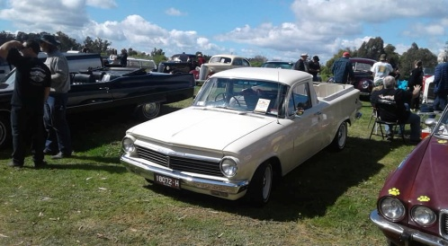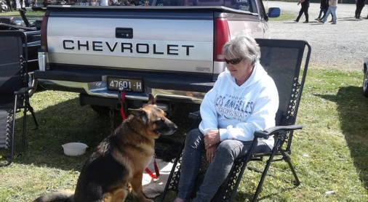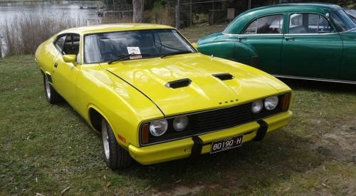

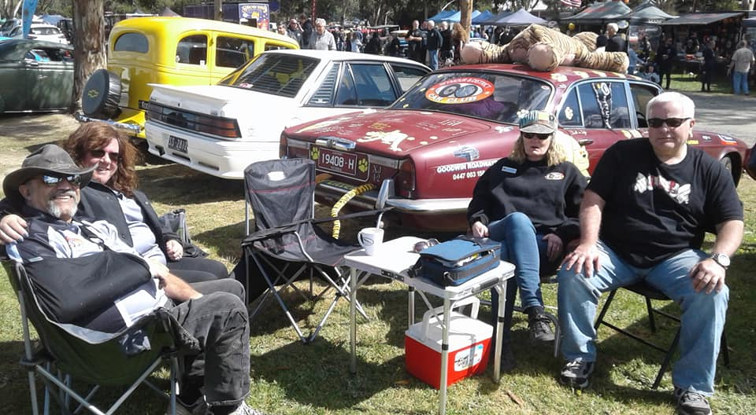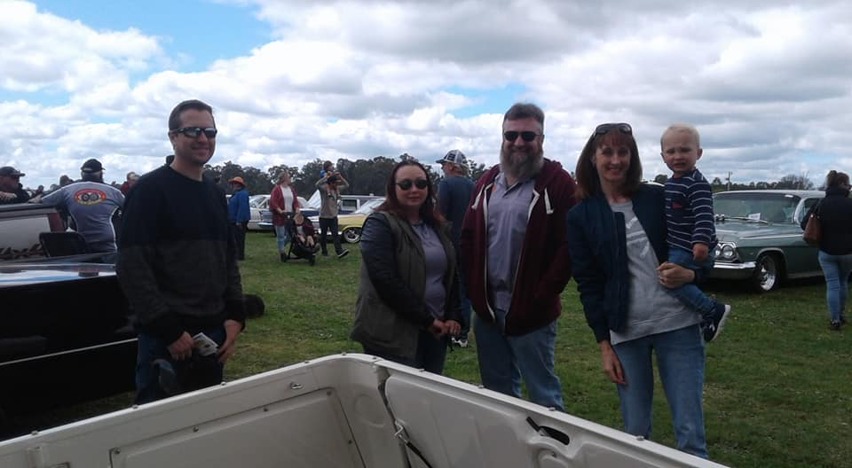
Future Events

Saturday, 19th October, 2019. 1pm to 4pm. Factory visit to Deluxe Rods in Yea.

Jim has extended an invitation to attend his factory for what would be a very interesting couple of hours. There is a cost levelled to the car club, but not to each individual member.
If you are interested, then please contact me or John Phoenix, and we will organise the visit.
We do need to know who is interested so we can advise Jim prior to the event.

Saturday 2nd November, 2019 - The Mad Billycart Derby Festival at the Yea Railway Market.

This is fun for the whole family – big kids or little kids alike. The day involves billy cart racing from 10am. Market and car boot stalls. Included is assorted entertainment for the kids as well as Trophies, competitions, prizes and giveaways. Also, there is a chance to display our vehicles.
Saturday, 2nd November, 2019 – Re advertised - Aussie Show and Shine at Yarra Glen Racecourse.

Wednesday, 6th November, 2019 – Rare Spares Open Night, 6pm to 8pm at the Roxburgh Park Store. Special guests are John Bowe, Australian Motorsport Legend and Adam Majoram, Super 2’s Series Driver. Car Club members need to register their interest in attending.

Saturday 9th November, 2019 – Combined Seymour Lions Club and S&DCC Sausage Sizzle at Seymour Safeway’s. The raffle will also be drawn.

Sunday 24th November, 2019 – Kilmore Show, Shine and Swap Meet at Kilmore Football ground.

Sunday, 1st December, 2019 – S&DCC Christmas Lunch.

The Christmas Lunch will be held at the RSL, Crawford Street, Seymour. Cost will be $15pp and will be subsidised by the S&DCC. As last year, there will be no charge for little children. We are using the same caterers so we already know how good the lunch will be.
As we need to advise the caterers of numbers, we do need to have members acknowledge their interest in attending the lunch. Acceptances and payment can be made at the November Meeting.

Next Meeting.

The next meeting will be our AGM, prior to the monthly meeting, to be held in the Community Room at Chittick Park, between the Seymour Indoor Pool and the Cricket Clubrooms, Pollard Street, on Wednesday 6th November, 2019, at 7.30pm.
All members are welcome to attend. Tea and coffee will be available.
Happy Motoring,
Judi McGrath – Secretary – 0407 562003
*******************************
The head Greenie Tree Hugging Lady Activist, who was responsible for getting horses banned from National Parks and State Forests, was climbing a big tree to have a look out over the forestry when a Tawny Frogmouth Owl attacked her for invading its nesting site.
In a panic to make her escape, she slid down the tree, getting many splinters in the crotch of her designer shorts, In considerable pain, she hurried to the nearest Doctor, told him she was an environmentalist and how she got all the splinters.
The Doctor listened with great patience and then told her to go into the examining room and he would see if he could help her. She waited for three hours before the Doctor reappeared. The angry woman demanded: “What took you so long?”
He smiled and then told her: “Well, I had to get permits from the Environmental Protection Agency, the Forestry service, National Parks and Wildlife Services, Rural Fire Service, and the Conservation and Land Management, before I could remove “Old Growth Timber” from a recreational area........I’m sorry, but they turned me down.”
(Thank you, Hans)

