September 2015 - Newsletter

Membership Renewals
As at the September meeting we have 75 financial members.
We do ask your help though, as a S&DCC member has paid their renewal, but unfortunately forgot to record their name on the deposit slip. The deposit was dated the 25th June, 2015, at the Goulburn Murray Credit Union. If this is you, can you contact me, please. We are able to ask the Credit Union to do a search but that process is very expensive, so we will leave that request as a last resort.
Past Events
The club weekend away in August was enjoyed by all participants. The weather was kind to us for a change. Sunny in Seymour, overcast in Kilmore for morning tea, sunny again in Malmsbury for lunch, and overcast when we reached Bendigo, but no rain. As most members had children, the mine tour, tram ride and go karts were enjoyed by all. Our cabin accommodation was very close to the centre of Bendigo and was very clean and comfortable, and an ideal venue for our group get together and BBQ evening meal, on the Saturday night.
Future Events – September & early October.
Sunday 6th September, 2015 – Emerald Bank Heritage Rally – Fathers Day. We plan to meet at Seymour Industrial car park, in Emily Street, Seymour at 8.00am. We will then travel to Emerald Bank in Kialla. As it is usually a really busy day, display cars arriving early, are parked in the fore court of the complex. This is a great family day with lots of activities to entertain families. There will also be a ‘fly in’ at the local airport.
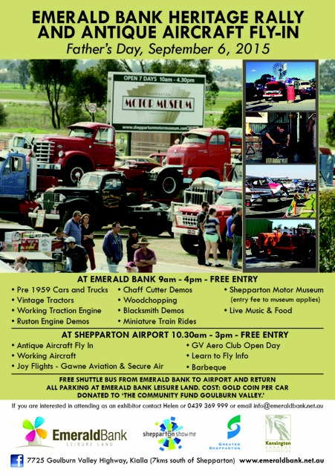
Sunday 20th September, 2015. – Nagambie Crankster’s. If you want to participate on this terrific day then we need to be at the Regatta Centre in Nagambie early. This year the event will celebrate 60 years of Rock and Roll. ‘Sun Rising’ will be playing on the Sunday and there will be a Best Elvis Impersonator competition with a $2000 cash prize. There will also be trade displays as well as food vendors, charity auctions and major raffle prizes. As you can see it will be a big day so we will meet at Seymour Industrial car park, Emily Street, Seymour, at 8am, and proceed as a group to Nagambie. The cost to display your car is $10.00, and display cars need to be in place before 9am while the public will not be admitted until 10.00am.
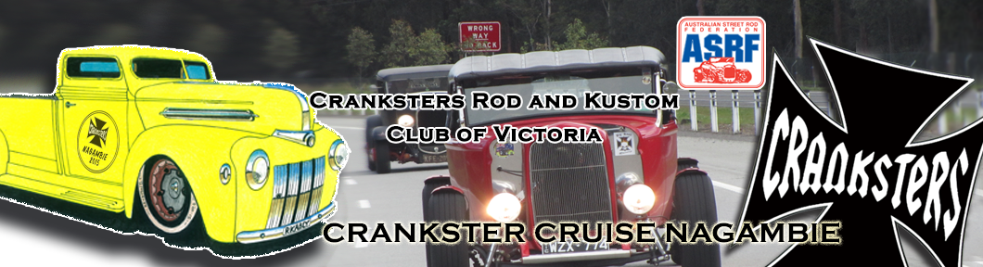

Sunday 4th October, 2015 – Euroa Show and Shine. If you haven’t been to the Euroa Show and Shine then this year is the time to go. All categories of vehicles will be on display. Again, as it is a very well publicised event and good spaces are limited, the S&DCC have been asked to join with the Goulburn Valley Jaguar Car Club, to share their shady area. We need to arrive together to share this space so we intend to meet at the Seymour Industrial car park, Emily Street, Seymour, at 8am and travel up to Euroa together, meeting and entering the park, with the GV Jaguars. As in other years, there will be lots of activities to keep everyone entertained during the day.
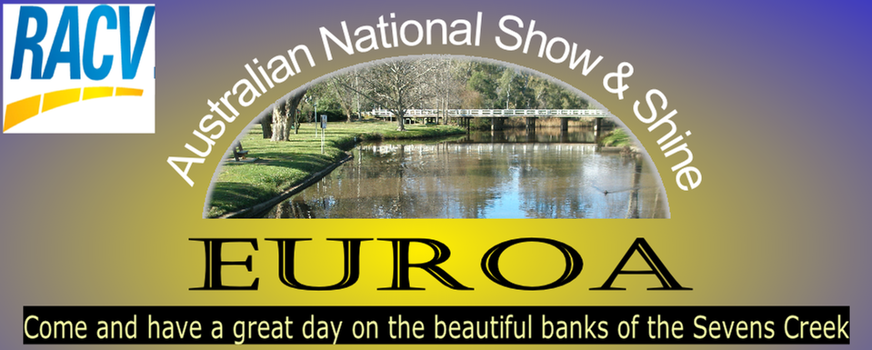
As with all the events we plan for your enjoyment, we do need to know who will be joining us, so please let me know, then we can wait for you at the meeting point, and also know we will have a spot for you to park at the venues.

Special Mention
Yea Community supporting Ebony May – Saturday 19th September, 2015. This is a fundraising effort to support Ebony May Coughlan, who has been diagnosed with a rare cancer. Ebony is one of only 20 youth diagnosed with this type of cancer in the world. This event is to be held in Yea, from 10.00am. The cost to display your vehicle is $20.00. As this will be a very busy weekend for the S&DCC, the members at the September meeting decided to advise all car club members, via the Club Newsletter, of this well worthwhile event but leave it up to them to decide if they want to attend. Please contact Julie for more details on 0427 710 133 or email: fundraiserebony@hotmail.com

Future S&DCC Event Dates. – Please check dates again as we have had a re shuffle
4th October, 2015 Euroa Show and Shine.
18th October, 2015 A visit to The Odd Jug & Sunnymeade, a magnificent garden near Ruffy.

4th November, 2015 S&DCC Annual General Meeting at the Clubrooms.
16th November, 2015 Morning Tea at the Flying Tart Cafe in Kinglake and then picnic lunch at Fraser National Park, Kinglake.
28th November, 2015 Wallan Car Show & Shine – Kilmore.

6th December, 2015 S&DCC Christmas Party at the Clubrooms.

2016
26th January, 2016 Australia Day Festivities in Seymour.

13th -14th February, 2015 Seymour Expo at Kings Park.

20th March, 2016 Yea Bushrodders.

All these places are quite close by, so mark your calendars now and join your fellow car club members
for an enjoyable day out.

Next Meeting. The next meeting of the S&DCC will be a Committee Meeting, to be held on Wednesday 7th October, 2015 at the Clubrooms, lower end of Howe Street, Seymour, behind the tennis courts, at 7.30pm. All members are welcome to attend. Light supper will be provided.
Judi McGrath.
Secretary – 0407 562003

