September – Newsletter

Recent Events

Winton. Bob and Judi attended the Winton Festival of Speed in early August. They enjoyed the weekend’s racing consisting of all historic vehicles who have had a history of racing in the past. Vehicles consisted of Formula V’s , Formula Fords, MG Car Club, Historic Touring Cars and of course the HQ Holden’s, amongst others.
2016 Bald Archy Exhibition at Swanpool.
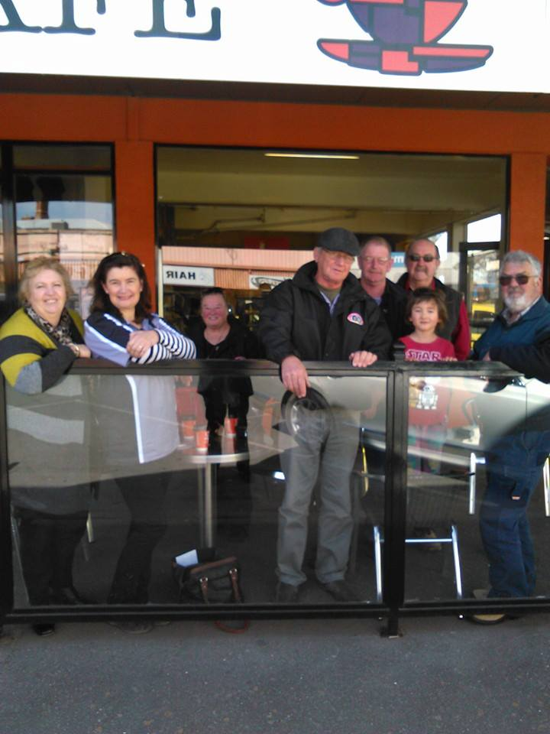
A group of S&DCC members left Seymour and stopped in Euroa for morning tea, on their way to Swanpool for the display. On arrival in Swanpool they met up with members of the GV Jaguar Car Club, then, took advantage of the lunch provided by the organisers, before viewing the exhibition. There were 45 works from a variety of artists and featured a number of diverse subjects. There were the usual smattering of works depicting our politicians, with an array of sporting luminaries, also being the subject of the satirical swipe of the artist’s brush.
All the volunteers did a wonderful job with organising the display and the home made lunches. Over the first 8 days of the exhibition there had been over 2500 people attend.
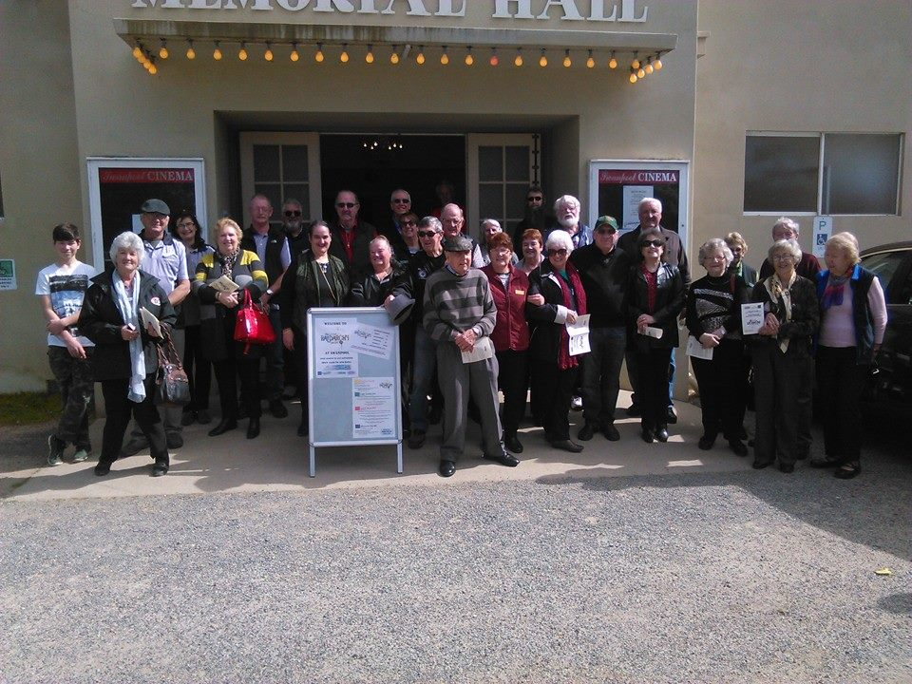

Future Events.

Sunday 18th September, 2016 – Nagambie Cranksters.
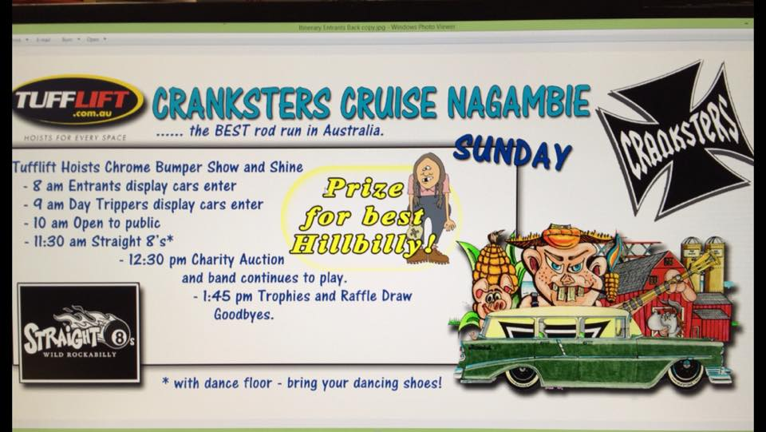
This event is well worth supporting. Members interested in travelling to this event as a group are to meet at Seymour Industrial, Emily Street, Seymour at 8am for an 8.30am departure.
Please let us know if you wish to attend.
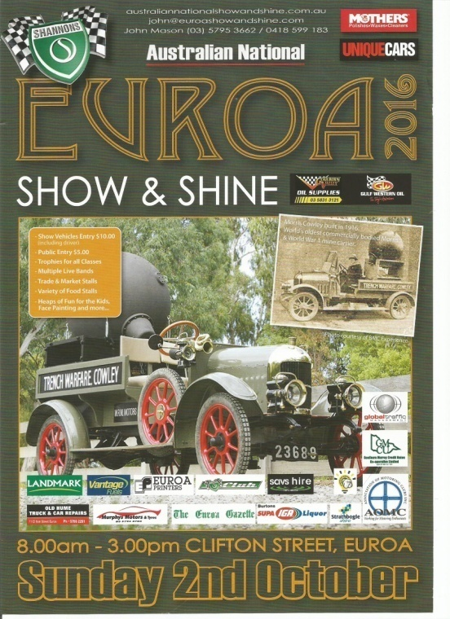
Sunday 2nd October, 2016 – Euroa Show and Shine

As parking is at a premium at this display, if members wish travel up to Euroa together then we will meet at Seymour Industrial, Emily Street, Seymour for a 7.30am departure.
Please let us know if you wish to attend.

Wednesday 5th October, 2016 – S&DCC Committee Meeting – 7.30pm at the Clubrooms.
Saturday 16th October, 2016 – Joint Club and Family Day at the S&DCC clubrooms.
Wednesday 2nd November, 2016 – S&DCC Annual General Meeting – 7.30pm at the Clubrooms.
12th to 13th November, 2016 – Bendigo Swap Meet.
25th to 27th November, 2016 – EJ-EH Holden Nationals – Shepparton Showgrounds.
Sunday 4th December, 2016 – S&DCC Christmas Party at the Clubrooms.
Wednesday 7th December, 2016 – S&DCC Committee Meeting – 7.30pm at the Clubrooms.
2017
Australia Day 2017 – Kings Park Seymour.
S&DCC Jackets, Caps and T-Shirts - Jackets are black in colour, a unisex style with our club logo embroidered on the front left hand side and on the back = $110.00.
Embroidered cap. = $25.00.
T-Shirts = $55.00.
Working Bee. John asked for another ‘Working B’ to be arranged prior to the Joint Family Day to be held at the Clubrooms in October. The working bee is to be held on Saturday 8th October at 12 o’clock. The pieces of concrete posts need to be removed as well as any garden refuse, and also the grass needs to be mowed. Just a general tidy up is needed.
Next Meeting. The next meeting of the S&DCC is a Committee Meeting to be held on Wednesday, 5th October, 2016, at 7.30pm at the clubrooms, lower end of Howe Street Seymour, behind the tennis Courts. All members are welcome to attend. Tea and coffee available.
Safe Motoring - Judi McGrath – Secretary – 0407 562003.

****************

An Englishman, a Frenchman and an Irishman were in a pub talking about their children.
‘My son was born on St George’s day,’ remarked the Englishman, ‘so we obviously called him George.’
‘That is a real coincidence,’ observed the Frenchman, ‘my daughter was born on Valentine’s Day, so we decided to call her Valentine.’
‘That’s really incredible,’ drawled the Irishman,’ exactly the same thing happened with my son, Pancake.

