September 2018 – Newsletter
Club Membership Renewals

We would like to advise we have 88 members in our car club for the 2018/2019 year and we do hope to see you all at the many events we have planned. We also have 74 vehicles, permitted on the CPS, through the S&DCC.

Past Events.

Weekend at Boort - August. A great weekend was enjoyed by all who attended. The weather was lovely and sunny and the conditions for driving were just perfect. The accommodation in the caravan park was very good and looking over the lake in the evening and in the morning, was very picturesque.
After having drinks and nibbles in the afternoon, some of us walked to the pub for dinner.
The next morning we drove the short distance to see the ‘Spannerman’ sculptures. They are just amazing and even more so when you know that John has been in a wheelchair since he contracted polio as an 8 year old. He imagines the sculptures and builds them in his mind over a few days and then proceeds to physically build them, either starting at the tip of the nose or the tail, and all of them are in amazing proportion.
We then drove along some back roads towards Rochester where we viewed the local silo art, and of course took more photos, before stopping at the local pub for lunch.
Thank you to all the participants who made a good weekend, even better.

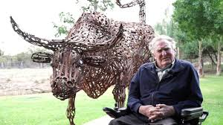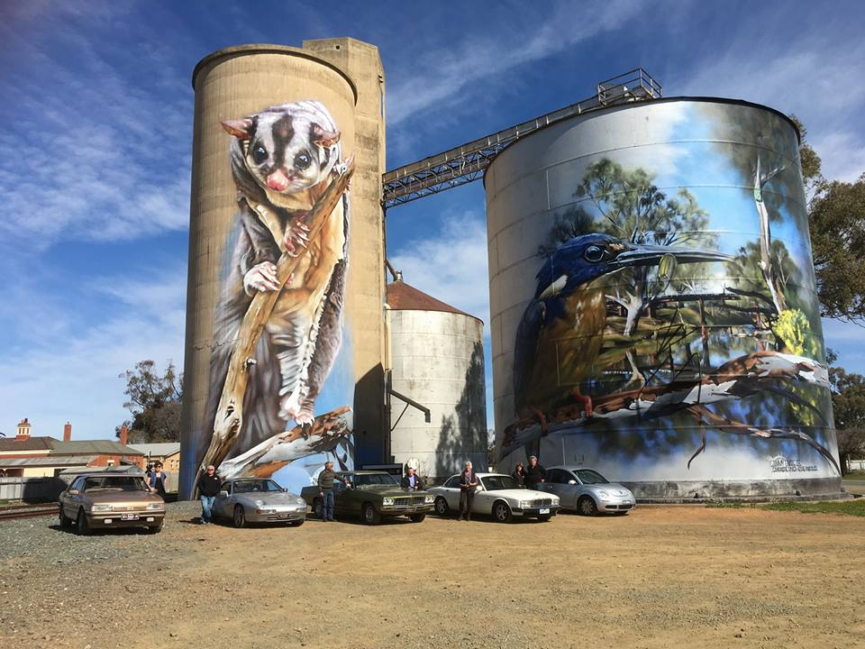

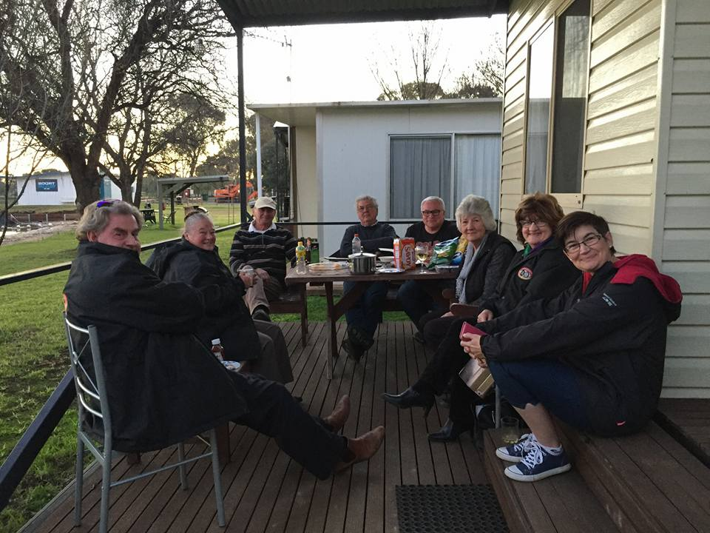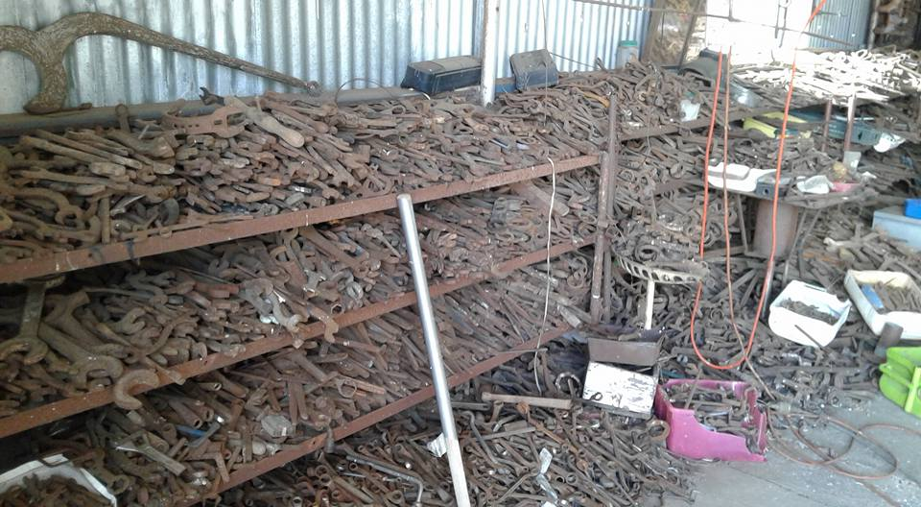

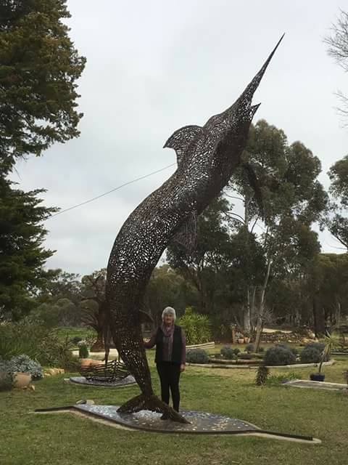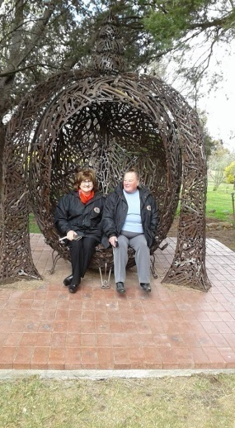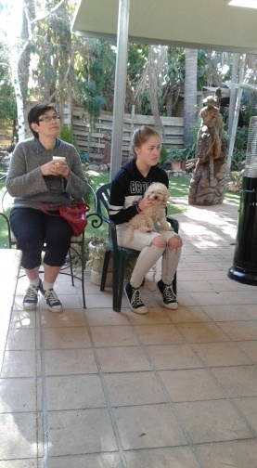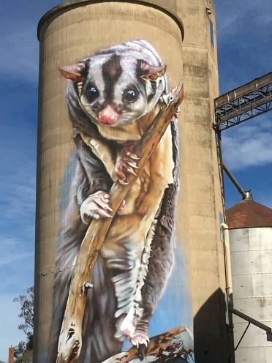

Craft Day – August. A few of the girls were able to attend and made numerous cards. These were then delivered to the men at Karingal who were very appreciative of the kindness and thoughtfulness.
The families of these men were also appreciative of the cards being delivered.
Thank you also to Christine Sheather for providing all the materials and craft supplies.
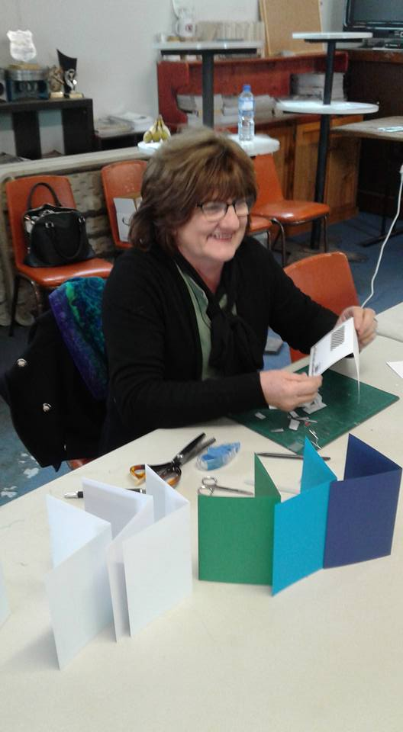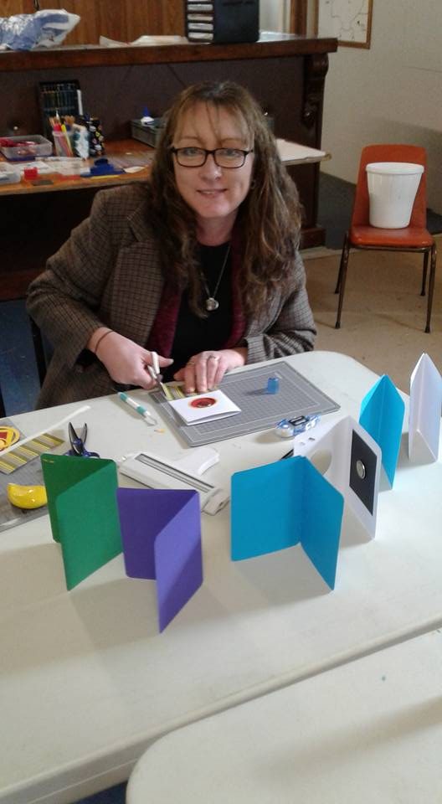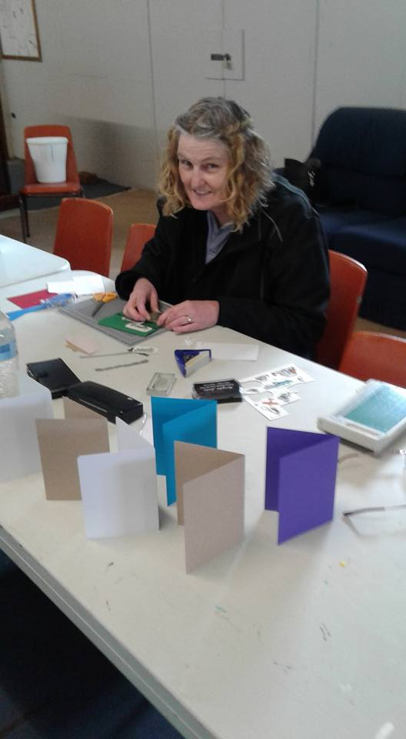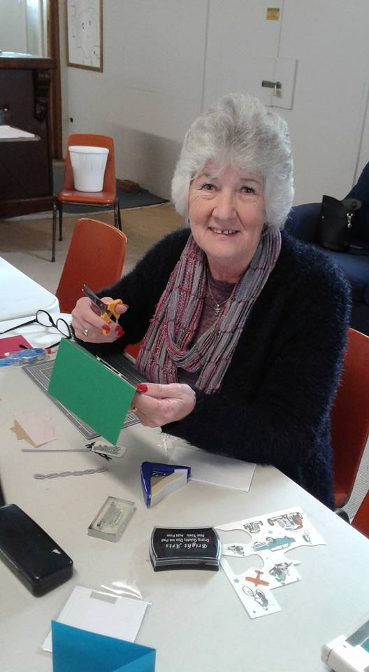

Guest Speaker – Sonia Sharkey - September Meeting.
After our monthy car club meeting last Wednesday night we welcomed Sonia as our guest speaker for the night. Sonia and her daughter, participated on the 2017 Sh*tbox Rally which travelled from Adelaide to Cairns over 7 days, and raised funds for the Cancer Council. Sonia told us of the very rough conditions they all endured but she would do it all again, as the experience was life changing.
Thank you Sonia, you are an inspiration to us all.
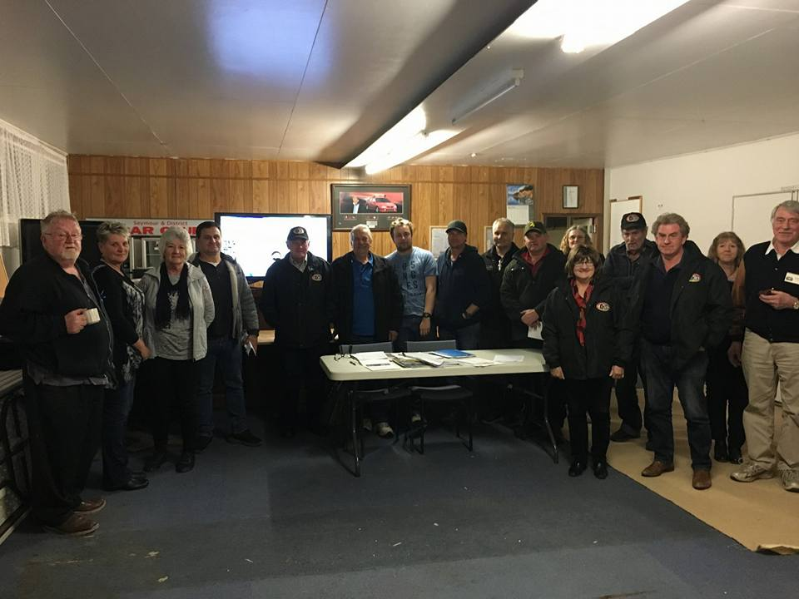
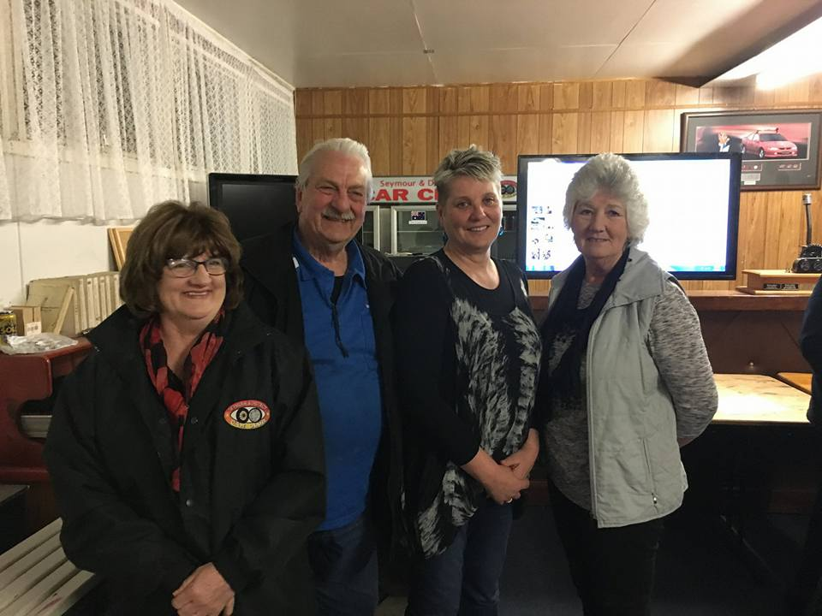

Future Events

Shepparton Swap Meet – Sunday 9th September, 2018, at the Shepparton Show Grounds.

Nagambie Kranskers – Sunday, 16th September, 2018 at the Regatta Centre in Nagambie. We have supported this event in the past and it has always been a good day in lovely surroundings. If you want to attend we will leave Seymour Industrial car park at 8.30am and arrive in Nagambie as a group so we can all park together. Please contact me so we know to wait for you.

Motorfrenz Car Club – Sunday 16th September, 2018. We have been asked us to join them on their run to Castlemaine and they are hoping to include the train trip to Maldon. If you are interested please phone Ross on 0481506716.

Centennial Cavalcade of Vehicles – Saturday 22nd September, 2018. The cavalcade will leave Melbourne and hope to arrive at 12 noon, at the Bendigo Town Hall. It should be a sight never to be repeated for another 100 years.

Wallan Swap Meet – Sunday 23rd September, 2018. 7am at the Greenhill Reserve, Wallan.

***** Seymour Show – Saturday 6th October, 2018. We have been asked by the show committee to provide a display of our vehicles. You will need to be assembled by 8.30am on the grass, between the netball courts and the bowling club. Two free admittance tickets will be provided for each vehicle, but we need to know who will be participating by Wednesday 12th September, as the tickets will be posted out to participants. You can reply to me by email, or contact Murray on 0439495237.

****** Euroa Show and Shine – Sunday 7th October, 2018. Again this year, the cars will be displayed along the main streets in Euroa. The S&DCC is hoping we can have an area set aside for us. At this stage, we plan to have all members meet up in the car park of the Euroa Secondary School at 7.30am, and then we can park in our designated display area together. Entry cost is $10 per car. Again, please let me know if you are joining us, or you can ring Murray on 0439495237.

Pick My Project – The Committee are asking all members to vote for our bid in the Pick My Project Initiative. Voting will close on the 17th September, 2018. Funding will be given to the initiatives which collect the most votes. We did have a link, supplied by a car club member, but at the time of writing, unfortunately I couldn’t get the link to open. (Sorry James). Maybe, go into any of the Shire libraries and ask the staff for help. We are relying on all of you to vote.
Fund Raising. Kathy Mills brought to the attention of the meeting, that she will be walking in a fundraiser for ‘Unite to Fight Cancer for Peter Mac’. The walk is 21 kilometres and will be held on 28th October, 2018, around the Melbourne City area. Kathy needs to raise $750.00 so is holding a movie afternoon at the Cinema Yarraville on Sunday 30th September, 2018 at 2pm. Tea and cake will be provided and tickets are $30.00 per person. Contact Kathy on 0409 553054 or Kathryn.mills@defence.gov.au. (Please see the flyer attached.)

Annual General Meeting – Wednesday 7th November, 2018 at 7.30pm, preceding the monthly meeting. Nomination forms will be sent out to all members with the October Newsletter, and need to be returned to the secretary, a week prior to the meeting.
10th and 11th November, 2018 – Remembrance Weekend and Seymour’s 175th Anniversary.
John Phoenix advised the meeting the organisers are hoping to have a street parade on the Saturday at 2pm and have asked us to participate. Vehicles need to be assembled at the top of Station Street, then, proceed down the street to Kings Park where we will provide a vehicle display. Other attractions will be provided for entertainment during the afternoon and culminating in a fireworks display in the evening. We do need to know who will be participating in the parade so please contact me.
On Sunday at 11am which is Rememberance Day, there will be a service at the Hospital Gates and then afterwards, there will be refreshments at the RSL, in Crawford Street..
Christmas Lunch – Sunday 2nd December, 2018. More details in the October Newsletter.
Guest Speaker – Gary Morris. Wednesday 3rd October, 2018, after the monthly meeting. Gary will present a pictorial presentation on James Flood. To anyone who is interested in the Australian Motor Industry of the past, James was one of the first Australian builders of motor car bodies. He worked for Tarrant Motors which were the first major Australian automobile operation, being distributors for the De Dion, Argyle, Mercedes and later, Ford.
Next Meeting. The next meeting will be a Committee Meeting, to be held on Wednesday the 3rd of October, 2018 at 7.30pm, at the clubrooms, lower end of Howe Street, behind the tennis courts. All members are welcome. Tea and coffee will be available.
Happy Motoring. Judi McGrath – Secretary.
A very cranky old woman was arrested for shoplifting at a grocery store.
She gave everyone a hard time, from the store manager, to the security guard, to the arresting officer who took her away, complaining and criticizing, throughout the process.
When she appeared before the judge, the judge asked what she had stolen from the store.
The lady defiantly replied, "Just a stupid can of peaches."
The judge then asked why she had done it.
She replied, "I was hungry and forgot to bring any cash to the store."
The judge asked how many peaches were in the can.
She replied, "Nine, but what do you care about that?"
The judge patiently said, "Well, ma'am, because I'm going to give you nine days in jail -- one day for each peach."
As the judge was about to drop his gavel, the lady's long suffering husband raised his hand and asked if he might speak.
The judge said, "Yes, what do you have to add?"
The husband said, "Your Honor, she also stole a can of peas." (Thank you Murray)

